CLINICAL MICROANGIOLOGY AND FEIGENBAUM’S NUMBER.
MODELS OF GRAPHICALLY DRAWING ATTRACTORS.

In a non-linear dynamic system can occur periods doublings by modifying energy supply to the system itself, that is to say, by changing the forces acting on the system. As regards microvascular smooth muscle cells, which show cyclic variations of electrolites, ATP, pH, a.s.o., levels, in healty, we observe contractions-dilations, i.e. systo-diastolic movements, with periods varying frm 9 sec. to 12 sec. and intensity (conventional) lying between 0,5-1,5 cm.
HS, always present, come after fluctuations characterized by the greatest period (12 sec.), as already referred.
We have written formerly that these periods “doublings” are ruled strictly by a rate

Rn – Rn-1 / Rn+1 – Rn = 4,66920... M. Feigenbaum’s number. A)

where Rn is the initial stage of dynamic system.

At this moment, it appears interesting the fact that, if we multiply fD values, lying between 1,9 a < 3, as observed in a biological system evolving slowly to disease, even recoverable, under proper treatment, by Feigenbaum’s number, the result is:

fD 1,93 x 4,67 = 9

fD 2 x 4,67 = 9,4 B)

fD 2,56 x 4,67 =11,9

values corresponding to physiological periods of microvessels oscillations.
Analogously, if the periods 9 – 12 sec. (normal extrem values) are divided by the fD of the slow pathological evolution, the results are the follwings:

9 / 1,95 = 4,61538... C)

11 / 2,36 = 4,661016...

12 / 2,57 = 4,66926...

numbers approaching to 4,66920... o Feigenbaum number.
Therefore, we have to underscore that multiplying Feigenbaum’s number by the fD included betwen 2 e < 3, originate periods lying between 9 and 12 sec., typical of physiological fluctuations, of both vasomotility and vasomotion, indicating once again internal and external coherence of our biophysical-semeiotic theory.
In addition, the study of Verhulst’s dynamic, illustrated by us in previous article,

Xn+1 = Xn λ ( X – 1 ) D)

where λ = fD
shows that the trensformation to chaos as well as periods doubling occur at exact points, located in good order.
We term Sn the value of growth parameter, where occurs the nth bifurcation: doubling, quadruplication..........chaos (Fig. 1)

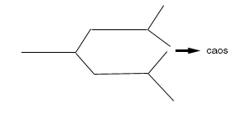

Fig.1.

After a set of subsequent bifurcations the dynamic system evolves to chaos.

The lenght of two subsequent events of bifurcation is like the following:

Sn = Rn - Rn-1 / Rn+1 - Rn E)

if, for example,

Sn = 2,5 – 2,3 / 2,57 - 2,5 = 0,2 / 0,07 = 2,857 F)

Out of curiosity, we referr that in the racemes, which carry the flowes of Clerodendron Trichotonum (Fig.2), a Verbanacea, we observed the same Feigenbaum’s number in the subsequent (2-3 a.s.o) bifurcations : 6,4 – 0,66 – 0,41666...
In fact, based on F), from the data gathered by analysing segments lenght of leaf nervature (Fig. 2), we have obtained the following values:

1,8 – 5 / 1,4 – 1,8 = 3,2 / 0,5 = 6,4

1,4 – 1,8 / 0,8 – 1,4 = 0,5 / 0,6 = 0,66 G)

0,55 – 0,8 / 0,02 – 0,55 = 0,25 / 0,53 = 0,471698.....

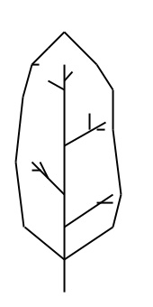

Fig. 2.

The figure shows “schematically” the leaf of a Verbanacea, the Clorodendrum.

If we continue the above-described process, the ratio Sn approaches more and more to an irrational, steady number: 4,66920166, i.e. Feigenbaum’s number, really discovered by Grossmann, an unlimited, decimal, non-periodic number, universal constant, present in the transitions, which occur in the nature and also, therefore, in biological systems, as we demonstrated clinically by Biophysical Semeiotics.
In Clinical Microangiology, as we illustrated in previous article, we observe that, when fD is 1, Fourier’s transformation is of type “at far column” or type IV; when fD is 1,3, the transformation is of type “at far column” or type III and, finally, if fD is included between 2,21 and 2,52, then the transformation coincides with that of type II “at roof”.

Consequently, in base to G), it is easy to reach an interesting result:

1,3 - 1 / 2,21 - 1,3 = 0,3 / 0,18 = 1,666...

1,666... approaches clearly to the golden mean, φ,
as we oulined, as regards the ratio physiological fD/fD sl.ev., i.e. slow evolving to pathology:

fD fis. / fD sl.ev. = 3,81 / 2,36 = 1,614

where (fD fis.) is normal dimensionality
and (D sl.ev.) is the fD of slowly evolving to pathology.

In the transition from deterministic-chaotic oscillations (periods varying from 9 sec. to 12 sec., intensity included between 0,5 – 1,5 cm.), characteristic of the fluctuations in health, to those characterized by a period varying from 9 and 11 sec., i.e biological system evolving slowly to a disorder, at the moment even without clinical phenomenology, we observe a typical ratio dividing the highest period (11 sec.) by the average fD (2,36):

11 / 2,36 = 4,661016... Feigenbaum’s number.

Therefore, at starting of the first bifurcation, we meet Feigenbaum’s number, e.g., changing from “at near column” or “at far column” transformation to “at roof” transformation.
When, moreover, fD increases, both spontaneously or due to efficaious therapy, from 2,36 to 2,57 and higher, and the attractor is becoming a “strange attactor”, i.e. when a disease evolves to the recovery, by the increase of deterministic chaos, also the period lenghtens (9 – 12 sec.) and subsequently the ratio results to be:

12 / 2,57 = 4,6692607...

where 12 is the highest physiological period
and 2,57 the fD of the slow evolution to the disease

which approaches further to the “mitic” number 4,66920166 ...

To summarize our above-illustrated statements, in Clinical Microangiology, the study of deterministic chaos of microvascular fluctuation, autonomous and authoctonous, which bring about those macroscopic of related biological systems, in both physiology and pathology, we meet a superior order, nth expression of internal and external coherence of biophysical semeiotics theory.
Arterial Peripheral Resistance test and Arterial Compliance test (1,2) show clearly the bifurcation of non-linear dynamics of biological systems: intense digital pressure, applied on the homeral artery, induces vascular obstruction and, then, distal microcirculatory activation type I, associated, for example, at the level of finger-pulp, and, ultimately, complete disactivation: peripheral heart decompensation.
Reducing “slowly” the obstructing digital pressure upon the homeral artery, as far as its complete interruption, doctor observe that physiological deterministic chaotic fluctuations arise again in peripheral microvessels: from the strange attractor to that of fixed point crossing the closed loop attractor (See later on).
Analogously to what occurs in chemical and physical systems, dynamic biological systems, dissipative, far from equilibrium point, oscillate according to trajectories only apparently chaotic, but really attracted by diverse attractors, inside of which (sub-spaces of phases space) they are moving without going out or falling in.
Such phenomenon, well-known in chemical and physical world, has been demonstrated for the first time “clinically” by utilizing a simple stethoscope with the aid of Biophysical Semeiotics, during Peripheral Arterial Resistance test as well as Arterial Compliance test.
In a healthy subject, lying down in supine position and psycho-physically relaxed, “intense” digital pressure, applied on brachial artery, to bring about blood-flow obstruction and, consequently, disappearance of radial pulse, causes distally, i.e. at level of tissue-microcirculatory unit, microcirculatory activation type I associated, droping of fD, Fourier’s transformation of type III, “at far column”.
After a variable lt (lt Y in H), fD falls to 1, topological dimension, and Fourier’s transformation becomes of type IV, i.e. “at near column”, so that the attractor is “at fixed point”.
In other words, inadequate energy supply to peripheral tissues, at first, provokes a defence reaction, characterized by Functional Microcirculatory Reserve activation (MFR), which can not be able to counterbalance energy defect, obviously, due to the arterial occlusion, jatrogenetically caused, and, ultimately, it ends in the characteristic equilibrium of thermodynamically isolated systems: swings of pendulum, if the sufficient mechanical energy supply lacks, little by little cease untill the pendulum stops.
However, reducing lightly digital pressure on homeral artery, it is enough that, due to the subsequent energy supply to the system, a small radial pulse appears as well as microcirculatory oscillations, e.g., in finger-pulp, which are actratted by two points-attractors: “closed loop” attractor. That is to say that “distally” the system, before “isolated”, becomes again an “open” dissipative system, whose oscillations are lying away from the equilibrium:
.
At starting point, fD of fingers-pulps.....3,81
Pr. occluding artery.....(lt Y)........> fD 1 ; H)
Pr. non-occluding......(lt Y)..... > fD 2,54

.
Finally, after the interruption of occlusive pressure on the artery, due to physiological post-ischaemic reactive hyperaemia, microvascular oscillations, after a period of type “at far column”, type III, appear as type I, “at saddle”, and the attractor is a “strange attractor”
In case of equilibrium, biological systems are linear, while, if suffient energy is supplied to a linear system, so that it is correctly stimulated, the system becomes again non-linear, i.e. it shows the characteristic behaviour of dynamic system away from the equibrium.
The chaos needs a sufficient quantity of energy in order to realize dissipative mechanisms and the life is the trajectory of an attactor: from strange attractor to point fixed attactor.
Physician’s duty is the early recognizing various state of this life trajectory of patient, so that he can hopefully reverse the dangerous direction of the trajectory itself.

GRAPHS OF ATTRACTORS. SOME BIOPHYSICAL-SEMEIOTIC MODELS.

In order to show clearly, in a visual manner, the different types of attractors, in the mathematical space of phases, in practice are very useful some biophysical-semeiotic models, we have suggested over the last decade. In these interesting models macro- and micro- fluctuations parameters are accurately considered of both biological systems and related microvesels.
A model takes into account intensities of subsequent oscillations: intensity values of these fluctuation are transported, even mentally, on the “spokes” of a cycle, whose diameter is the double of the HS, and moving in clock-wise direction, we obtain geometrical figures, really interesting and useful in bed-side evaluating the dynamics of various organs, glands, and tissues (Fig.3).

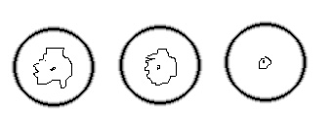

Fig. 3.
The fihure shows at left the graph of the “strange attractor”. Moving to right, follow that of “closed loop and then the actrattor “at fixed point”, according to a model, based on the evaluation of the intensity of subsequent micro- and macro-scopic oscillations of biological systems, geometrically indicated as the “spokes” of a cycle, proceding in clock-wise direction.

A further biophysical-semeiotic model utilizes intensity and period values of following oscillations, transferring the formers on the ordinate and the seconds on the abscissa of a Cartesian axes system. Joining the numerous points, appears the related attractor, in a geometrical way.

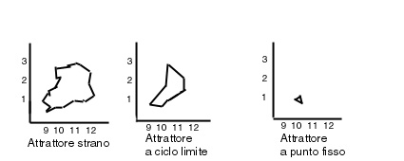

Fig. 4
The figure shows (on the ordinate intenity in cm., while on the abscissa the period in sec. of subsequent oscillations), in a geometrical manner, three main attractors of microvascular fluctuations, under physiological (left), slow pathological evolution (middle) and, ultimately, chronic disorder (right).

The following figures show clearly the usefulness of an other, practical and easy, biophysical-semeiotic model, which geometrically illustrates the attractors, based on the superimposition of subsequent fluctuations (Fig. 5, 6, 7).

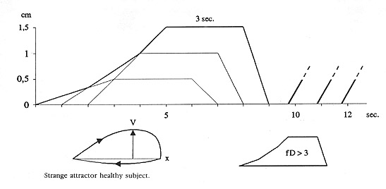

Fig. 5

In healthy, the superimposition of following microvessels fluctuations form an interesting figure, resembling a “strange attractors.

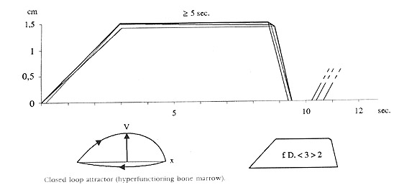

Fig. 6

The same procedure, illustrated above, in case of a biological system in slow evolution to a disease, as the pancreas in slow diabetic evolution, shows a figure , which is like to a cycle, lightly pressed, resembling a “closed loop attractor”.

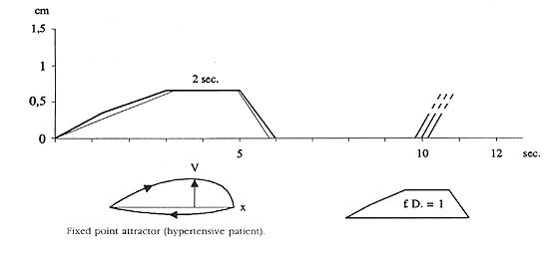

Fig. 7

In a chronic disorder, as diabetes mellitus lasting for a long time, microvessels fluctuations of the biological system involved by the disease, are practically similar; therefore, their superimposition shows a roundish, small figure, which is really like to attractor “at fixed point”.

Bibliografia.

1) Stagnaro-Neri M., Stagnaro S., Il diagramma venoso nelle arteriopatie obliteranti periferiche. Atti Congr. Naz. Soc. It. Flebologia Clinica e Sperimentale. Firenze 10-12 Dicembre 1990. A cura di G. Nuzzaci, pg. 169, Monduzzi Ed. Bologna, 1990.

2) Stagnaro-Neri M., Stagnaro S., Il diagramma venoso nelle arteriopatie obliteranti periferiche. Atti Congr. Naz. Soc. It. Flebologia Clinica e Sperimentale. Firenze 10-12 Dicembre 1990. A cura di G. Nuzzaci, pg. 169, Monduzzi Ed. Bologna, 1990.

