ROLE OF HIGHEST SPIKES IN THE EVALUATION OF BIOLOGICAL SYSTEMS DETERMINISTIC CHAOS. BIOPHYSICAL-SEMEIOTIC FOURIER’S TRANSFORMATIONS. ATTRACTORS.

(From the book, with some modifications, “Semeiotica Biofisica. Microangiologia Clinica”, Stagnaro-Neri Marina e Stagnaro Sergio, in advanced preparation).

ROLE OF HIGHEST SPIKES IN THE EVALUATION OF BIOLOGICAL SYSTEMS DETERMINISTIC CHAOS. BIOPHYSICAL-SEMEIOTIC FOURIER’S TRANSFORMATIONS. ATTRACTORS. 1
BASIC PRINCIPLES OF THE THEORY OF DYNAMIC SYSTEMS. 2
BIOPHYSICAL-SEMEIOTIC FOURIER’S TRANSFORMATIONS. 5
A PHYSIOLOGICAL VARIANT OF BIOPHYSICAL-SEMEIOTIC FOURIER’S TRANSFORMATION TYPE IV. 10

There is evidence that the cyclic variation in the patency of the small arteries and arterioles, according to Hammersen, i.e. vasomotility, plays a major role in both physiology and pathology that involve microcirculation. The nature of the “vasomotion” (our term includes both vasomotility and vasomotion, the latter indicates capillary exclusively venules oscillations) is complex and this complexity may be measured by the fractal dimension.
As a matter of fact, fractal dimension is the measure of dterministic chaos; in particular, fractal dimension (fD) of “vasomotion” represents the degree of complexity of the various diagrams, including those of tissue-microvascular unit, as well as of their respective tachograms. the fD corresponds to the amount of information to provide to computer, or to personal designer, in order to obtain the exact figure drawing. Therefore, fD may be defined also as the level of negative entropy. From biophysical-semeiotic view-point, in calculating fD HS (highest spikes). Physiologically, the intensity of these maximal oscillations is 1,5 cm. If one divides such datum by the intensity of minimal fluctuations (I = 0,5), the result is an important parameter, fractal factor (ff = 3), very useful in assessing fD (65, 69, 72, 78, 81: Bibliography in the site).
In fact, HS devide the space of 120 sec. of a diagram in 4 segment, and subsequently, due to smaller fluctuations, in further three segments (1, and above-mentioned papers):

r = N-(1/D) dove: r = 3 e N = 4 1)

D = log 1 / log N // log 1 / log r ma log 1 = 0, perciò 2)

D = log N / log log r = log 4 / log 3 = 1,27 3)

fD = 1,27 X ff ( 3 ) = 3,81 4)

The calculation of fD is really easy to perform by the value of caecal reflex diffeential latency time, which precisely corresponds to caecal dilation duration of disappearnce: in healthy, “mean-intense” digital pressure, applied,e.g., on a finger-pulp, after a latency time (lt) of 6-7 sec. (age-dependent) brings about caecal dilation, which lasts > 3 < 4 sec., followed by spontaneous reflex disappearing, which persists > 3 < 4 sec = caecal reflex differential lt o fD. Really, this value parallels the efficiency of fulfilment of Microcirculatory Functional Reserve (MFR), indicating the efficacy, both anatomic and functional, of examined biological system. Therefore, these data underscore, once again, the internal coherence of biological theory.
At this point, it appears useful to repeat that ureteral oscillations or trajectories, indicating vasomotility and vasomotion, are chaotic, unforseeable, stocastic, but, in reality, they may be studied by mathematical models of non-linear dynamics, with the aid of iterations of logistic or quadratic equation, in which final value (coming out) is, in turn, utilize as initial value (entry) of following iteration.

Let’s think to a “single” smooth muscle cell contracting. The nature of this movement is complex, therefore, in an effort to obtain an integrated view of the process, it is pertinent to look simultaneously into the oscillation of the upper ureteral reflex, which parallels such movement. In fact, successive series of contraction-decontraction (relaxing) is related to the transport of ions across the vessel wall, the transmural pressure, the wall elastic and smooth muscle stresses, a.s.o.; briefly, it is related to metabolic, chemical, biochemical, physical, endocellular energetic situation, which precedes:

Xn+1 = Xn λ ( 1 – Xn ) A)

where λ = fD e Xn initial space of the system.

As result, iterations lead to actraction basin, represented in the space of phases, which is a mathematical space, ideal, described by variables os dynamic system as its coordinates, from geometrical point of view illustrated in a original biophysical semeiotic way, as follows:
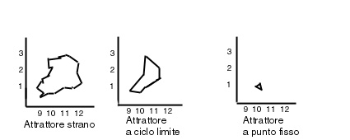

Fig. 1

In a cartesian axes system, both intensity and period of every subsequent oscillation are reported in a clock-wise manner. Clearly, this is an original, simple, and reliable way, among a large variety of others, more sophisticated, useful to show the various attractors.

The trajectories, although starting from points with only a short distance each from other, during the time appear to be separated as fas as they are 10 times away each other after T time or critic time. However, all trajectories are constrained in a sub-space of phases space, termed attractor, as indicates Fig. 1. We will come back to this interesting argument, fundamental in Biophysical Semeiotics (above-cited articles).

BASIC PRINCIPLES OF THE THEORY OF DYNAMIC SYSTEMS.

(We thank Prof.Thomas Elbert, William J.Ray, Zbigniew J. Kowalik, James E Skinner, Karl Eugen Graf, and Niels Birbaumer for helping us by their excellent article (4), illustrating the complex concepts of this theme in a relatively easy way).

By definition with linear systems, the output is proportional to the input. By manipulating an input variable by a certain amount leads to change in the output variable proportional to that amount. These situations can typically be described easily by simple equations. In other words, in the case of linear systems, we always know what comes next.
In non-linear systems things are really different. The equations that describe such dynamical systems may at first appear simple, but the results may not be so. More precisely, unlike linear systems, in which stability is produced, non-linear models produce a variety of outcomes that in the physical world can result in a qualitative different behaviours. We must underscore, in this manner, that this is true not only for mathematical systems, but also for a variety of physiological phenomena (4).
Interestingly Verhulst, in 1845, examined the question of how the population of a single species in a closed well-defined environment might change over generations. Two constrains characterize the model (See A, described above): the first is that the relative number of the individuals (Xn) in the year n should give rise to a proportional number of offspring in the next year. We can think of this proportion as “birthrate”, we refer to as λ (ff). In case λ is 2, then a population of 100 would be followed the next year by a population of 400, then 800, and so on.
The second constraint is a “control factor” (e.g. depletion of feeding grounds), which would restricted unlimited growth. That is, there should be a restriction of the population proportional to the remaning area (1-Xn in A). In the equation X is normalized such that it lies between zero and one. Thus X is expressed as a fraction and represents the maximal number of individuals that the resources could maintain. Given Xn, by A, “logistic” or “quadratic” map, one of the simplest non-linear difference equation, we can calculate the number of individuals in the next generation; in our case, the pattern of subsequent oscillations.
The control parameter λ in A) is determined as ff of the biological system macro- and micro-oscillations. Mathematically, we know that if we multiply Xn times (1 – Xn) , then we arrive at the resultant Xn minus (Xn)², which graphs as a parabola.

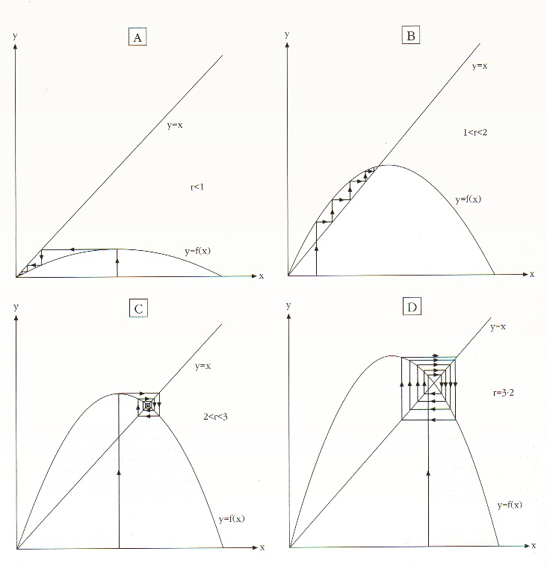

Fig. 2

The figure illustrates, in a refined manner, the construction of different points (1, 2...) according to difference equation A). For chosen parameter (r = λ), e.g. 3,81, time series will oscillate between 4 points (two pairs point located closely togheter), as indicated below at right, which represents a strange attractor. Below at left: closed circle attractor, while above two fixed point attractors, if (r = λ) is 2 or less .
Reproduced for the courtesy of Cambridge University Press, from: “La Nuova Fisica”, Peter Knight, “Ottica Quantistica”, Bollati Boringhieri, 1992.

Depending on the value of λ, i.e. ff (NN = 3), simple non-linear models are capable of producing an astonishing variety of qualitatively different behaviours. In fact, if λ (ff) is < 2, as can be easily derived from A), subsequent X values will become smaller and smaller. In this case, all trajectories are attracted to X = 0, the one stable “fixed point”.
Whatever starting point is chosen (after a transient phase) the number reaches a constant non-zero value only when 1 > X > X₁, with X₁ = 3 for the quadratic map (Equation A). That is to say, if we chose a ff below 3 but above one, we find that the resulting numbers move toward two-thirds of the size of originals numbers, i.e. toward an attractor on our map. Thus, starting at any value that differs from the “fixed point”, the numbers will follow a spiraling pattern with the point of intersection of the parabola with the line Xn = X n+1, which increases with increasing λ or, in our case, ff. For λ somewhat greater than 3 (NN = 3,81), the system loses its stability.
In this case, two initially stable points of period two are born in an act called “pitchfork bifurcation”, i.e. the number quantity oscillates between two different values. Then a cycle of period four is reached, and further slight increase in λ yield cycles of period 8, 16, and so on, i.e. period doubling.
However, we should note that if λ set at about 2,7, from biophysical-semeiotic view-point, the fluctuations (numbers) will increase and decrease alternatively in a predictable manner. Such periods of stability are reerred as “intermittency”, as demonstrate the oscillations of a biological system evolving slowly towards a pathological condition, as we observe by means of Biophysical Semeiotics.. This illustrates an interesting aspect of chaotic systems: the fact that the same system can range in its production from simple order to great complexity

BIOPHYSICAL-SEMEIOTIC FOURIER’S TRANSFORMATIONS.

With the aid of biophysical-semeiotic fourier’s transformations, performed at the bed-side, even in the mind, due to reason of practicality, it is coparatively easy to evaluate and analyse accurately the large number of tachograms of periods as well as intensities of related fluctuations.
At the moment, we have recognized five different types of biophysical-semeiotic Fourier’s transformations, among them one is, really, a variant of type IV. In order to realize these useful transformations, doctor must act, as follows: on cartesian axes system – in the ordinate the intensity in cm. and in the abscissa the time in sec. – are transferred the parameters of subsequent oscillations of upper ureteral (vasomotility) and, the, lower ureteral (vasomotion) reflexes, gathered on the base of the same degree, in practice we consider only the oscillations intensity.
On the ordinate are referred the percentages of fluctuations with the same intensity, and on the abscissa are collected the fluctuations, in according to their intensity, which can vary from the minimal value 0,5 cm to the maximal value 1,5 (HS) ( Fig.2).

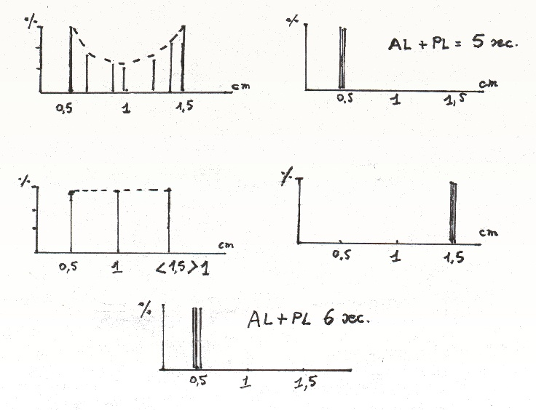

Fig.3.
Biophysical-semeiotic Fourier’s transformations.
Explanetion in the text.

In following, we are going to examine separaely these transformations and to illustrate clinical significance, both physiological and pathological.

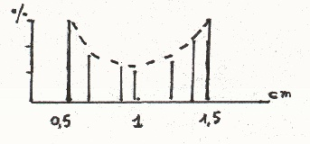

Fig. 4

Transformation type I.
The fluctuations are regularly placed according to their intensity and period. If we joint the top of every whole of oscillations, equal in intensity, we obtain the characteristic aspect, already shown in Fig. 1, above at left, i.e., the saddle type .

1) Type I, saddle type: fD = 3,81 (Fig. 1). It is the physiological type at rest, characterized by AL + PL = 6 sec., to which corresponds the strange attractor. Periods vary from 9 to 12 sec., and HS are present. Briefly, it is interesting to say that in this case, interstitium is < 1 cm., evaluated as “in toto” ureteral reflex, and all oscillation AL are really rapid (1 < 2 sec.): physiological microvessels.

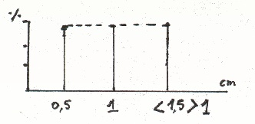

Fig. 5

Transformation type II.
The amount of fluctuations in the three groups, similar in intensity, is identical in this particular transformation roof type, that is way we obtain the typical graph.

2) Type II, roof type : fD = 2,21 – 2,56 (Fig. 5). It is characteristic of biological systems slowly evolving to disease, e.g. Reaven’s syndrom, both classic and “variant”, we described previously (69), during its slow evolution to diabetes mellitus. Periods oscillate from 9 to 11 sec., Intensity (I) between 0,5 and < 1,5, presents HS, but showing a value less than normal (NN = HS 1,5 cm).
In such cases oscillations diagram is characterized by a typical pattern of alternate increasing and decreasinf as regards fluctuation intensity in both vasomotility and vasomotion, indicating less free endocellular energy in arteriolar smooth muscle cells. In fact, AL is slow ≥ 2 sec. The attractor is at closed loop. It appears very interesting to note that the rate fD of transformation type I / fD of thransformation type II is equal to 1,618, when the relative values, are 3,81 e 2,56, that is to say φ or golden mean.
In addition, if we devide the greatest period of type II (11 sec.) for the “average” value of fD of same transformation, roof type, i.e., 2,36, the result is 4,66190 or Feigenbaum’s number.

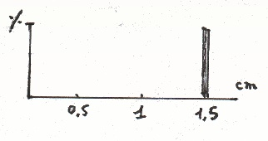

Fig. 6.
Transformation of III.
All oscillations are of highest intensity, showing periods of 10 sec. and intensity of 1,5 cm.: HS.

3) Type III, far column type : fD = 1,3 – 2,2 (Fig. 6). This transformation corresponds to microcirculatory activation type I or associated, in which both vasomotility and vasomotion are increased, AVA type I and II, group A and B, if present, are disactivated and, on the contrary, EBD are intensely activated (= middle yreteral reflex of I ≥ 1,5 cm., D > 20 sec. and closue duration < 6 sec.). Since all ureteral oscillations (upper as well as lower ureteral reflexes) are maximal, i.e. HS, they are collected on the abscissa at point 1,5 (Fig. 6), that is to say distally; therefore, the graph shows a column far way from ordinate and abscissa crossing. Periods dutation is fixed at 10 sec. and PL is the greatest, never seen (8-9 sec.). The attractor, in this case, is once more at closed loop.

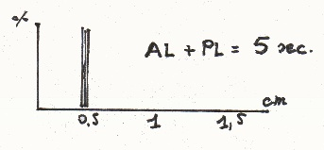

Fig. 7
Transformation of typeIV.
All fluctuations are of minimal intensity with the same period of 10 sec.

4) Type IV, near column type: fD = 1 (Fig. 7. This graph indicates a chronic disease of related biological system and is characterized by small PL (< 5 sec.), lowest intensity of oscillations, all equal (0,5 cm.), and fixed period of 10 se.) (Fig.7).
Therefore, collected very near to abscissa and ordinate crossing, the oscillations represent a “near column”. The attractor of such transformation is at fixed point.
Interestingly, exists a “variant” of the transformation type IV, “at near column” (Fig.8), characterized by physiological D of PL (5 sec.); therefore, AL + PL is 6 sec., expression of functional rest of a biological system, otherwise, “health”. All other parameters are the same of type IV: fD 1, I 0,5 and the attractor appears to be at fixed point.

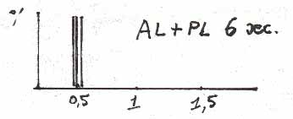
Fig. 8.

The “variant” form of transformation type IV shows a duration of AL + PL of 6 sec., i.e., physiological. In fact, it indicates the functional rest of an “healthy” biological system.

Biophysical semeiotic fourier’s tranformations symbolize in a geometrical way the behaviours of trajectories of microvessel smooth muscle cells as well as capillaro-venules oscillations or ureteral reflexes, both upper and low, oscillations on the base of fluctuations of same “intensity” and period, showing clearly the different behaviour of these two variable (I and PL) under physiological and payhological conditions.
Consequently, appears clearly plain the utility of deterministic chaos analysis also by this efficacious tool of Biophysical Semeiotics, directly related to fD.
We will come back, in next article, to these figure, which provide a lot of information, referring a large variety of diseases, which will be described and understood in a more complete way, due to this precious diagnostic tool.
To conclude this paper we underline interesting morphogenetic transformation at the base of the above-illustrated graphs: oberving accurately all figures, “rising” the lower side of the curve (saddle) of type I, which represents the figure related to physiological type at rest, we obtain the transformation type “at roof”; moreover, “shifting” to the right and, resectively to the left the “material” of the first figure, appear the transformations “at far column” and respectively, “at near column”.
Finally, dividing into two parts the trajectories (contents) of the first graph, folding up them on themselves, from the top toward the bottom, and, ultimately, drawing them nearer to coordinates starting point, we obtain the “variant” form of biophysical-semeiotic Fourier’s transformation type IV, we are going to dicusse in following.

A PHYSIOLOGICAL VARIANT OF BIOPHYSICAL-SEMEIOTIC FOURIER’S TRANSFORMATION TYPE IV.

From the above remarks, at the moment we know four Fourier’s transformations and a “variant” of type IV, which show in geometrical manner the deterministic chaos of both microacopic and macroscopis fluttuations of biological systems, in physiology and pathology.
As a matter of fact, they are related to the fractal dimension of fluctuations, which lie at the base of transformations themselves, and characterizes them from quantitative point of view. At this regards, we remind reader that fD or the degree of enthropy, represents the complexity of fractal figure, to which is referred. In other words, more complex the figure, more large the amount of information to provide a computer in order to obtain te same figure, i.e., greater is incoming energy till to corresponde to outcoming one, in case the omplexity is utmost.

TO summarize, as regards biophysical-semeiotic Fourier’s tranformations, are well-known the type I “at saddle”, physiological, at rest, fD of 3,81; the type II “at roof”, characteristic of biological systems evolving slowly to the disease, whose fD varies around average value of 2,5: the ratio fD type I/ fD type II is equal to 1,618, φ, i.e., golden mean, while dividing highest physiological period of fluctuations (12 sec.) for the fD of type II, i.e., 2,57, we obtain 4,669260 or Feigenbaum’s number (the same results obtained dividing highest period of type II, i.e., 11 sec., for loweghst related fD, 2,36 i.e., 4,66190; the type III, “at far column”, with fD of 1,5 – 1, expression of the activation of biological system, and, finally, the type IV, “at near column”, with fD of 1.

Before examining in detail the “variant” form of transformation type IV, we like to remember that Feigenbaum descovered, utilizing a simple pocket calculator, that in whatever succession of bifurcations there are universal or “magic” numbers.
For instance, if the bifurcations happen in a cycle of order n, when the value is Rn, the succession
(Rn – Rn-1) / ( Rn+1 – Rn)

approaches 4,669201660910299..., if n is almost infinite, and this number does not involve the unique logistic function (2). Such theoretical data aim to underscore, in an efficient way, the strict logic srtucture of our biophysical-semeiotic theory. In fact, many times from the parameters values originate “magic” nummbers, as referred above.
Nowadays, at the beginning of the third millenium, a large number of scientists expert in different fields, demonstrate that the study of chaos is coming out as a third revolution, as relativity and quantum theory, and that there are many individuals who think that it is a precise possibility valid also when applied to other sciences. For example, studying chaos fills the gap between the knowledge of what a thing does – or a molecule of water or a neuron – and what can do millions of them (3).
Clinical Microangiology demonstrates the “truth” of such statement.
The “variant” form of the IV transformation, characterized by D of AL + PL of 6 sec. and oscillations loweghest intensity, all identical to 0,5 cm., is not at all pathological, but it indicates the functional rest of “healthy” biological system, brought about by feed-back negativeaction mechanism, due to exeeding amount of final product.
For instance, in case of myxedema or hypothyroidism, giving excessive substitutive hormonal therapy, which inhibits secretive activity of neuronal TSH-RH centre (See Oncological Terrain in the site Semeiotica Biofisica), restrains the activity of both TSH-RH and TSH centres. In fact, under this condition, interstitial deterministic-chaotic oscillations as well as vasomotility and vasomotion are really smallest (0,5).
However, average period is 10,5 sec., D of AL + PL is 6 sec., caecal reflex latency time (lt) is 6 sec. (= tissue pH), fD is 1,5, and morfogenetic transformation “at near column”, corroborate the real value of Biophysical Semeiotics, in a refined manner.

If V (Variant) indicates the functional rest If V includes Sr
of health biological system Sr and,then, less If Sr includes Rc
microcirculatory blood supply or Rc, i.e. If Rc includes O2tm
tissue O2 in normal lowest ranges or
O2tm thus, sympathetic stimulation
provokes a caecal reflex lt ≤ 6 sec Then lt.caecal reflex ≤ 6 sec., D AL +
e differential lt < 1,5 or fD. PL 6 sec., differential lt of caecal reflex < 1,5
i.e., fD 1,5.

In fact, healthy tissue at rest, of course, needs O₂, but local microcirculation appears reduced to minimal value: as a consequence, a further decreasing, like that caused by sympathetic stimulation in a reflex way, by trigger-points stimulation, from the biophysical-semeiotic point of view, shows caecal reflex lt only slightly diminished or normal, D of 4 sec., indicating a persistent physiological Microcirculatory Functional Reserve (MFR).
However, differential lt of the reflex, i.e. the duration of its disappearing or fD, results smaller, since basal tissue O₂ at lowest range of normal values (Rc), and, thus, without any possibility of oxygen reserve. The subsequent tissue acidosis is able to activate the MFR, normally functioning, which rapidly increases both vasomotility and vasomotion, restoring the microcirculatory normal values, as results from successive evaluations.
At an accurateobservation appears clearly that the fD, correspondent to differential latency time of caecal reflex or duration of its disappearance, indicates the degree of temporal inhomogeneity – physiological – or spatial – pathological – according to Schmidt-Scoenbeim H., former described in the site.
Biophysical Semeiotics allows to assess both circulatory models: in healthy,the pressure, applied on smallest surface (the point of a pen) brings about two subsequent oscillations of ureteral reflex, upper and lower, followed, after about 6 sec intervall, by an intense fluctuation, whose phase AL + PL is > 6 sec.: temporal inhomogeneity. On the contrary, under pathological conditions (e.g. diabetes mellitus of not recent onset) we observe ares without “vasomotion” beside others showing abnormal “vasomotion” temporal inhomogeneity.
In our example, i.e. in the “variant” form of Transformation type IV, Sr, the arrest time or time of microflux reduction in the area, is short (lower fD) since the tissue, although healthy, is at functional rest. However, in case of absolute blod-flow stop (e.g., due to intense sympathetic stimulation), tissue acidosis occurs (due to consequently need of O₂) and, then, microcirculatory activation type I, associated appears, because small arteries and arterioles (vasomotility) increase their systolic-diatolic movements and AVA, including the important EBD, react in proper manner due to the fact that are normally functioning. Therefore, fD normalizes immidietly.
On the contrary, under pathological condition, fD is 1, fixed, stiff, indicating the spatial inhomogeneity: lt of caecal reflex is reduced, D is increased, differential latency time or fD is 1.
It is of interest the following clinical evidence: physiologically, repeated evaluation of caecal reflex parameters, far in time, i.e. > 5 sec.in order to avoid the favorable consequence of preconditioning, allows to observe values varying around the average. For instance, as regards the finger-pulp lt is 6 ± 0,5 sec., which represents the temporal inhomogeneity, from biophysical-semeiotic point of view.
In conclusion, the dimensionality – fractal dimension, enthropy – in the Biophysical Semeiotics and, then, in the Clinical Microangiology, indicates microcirculatory blood-flow in whatever biological system: in case its value is 3,81 we observe temporal inhomogeneity (physiological condition), while the value 1 is expression of spatial inhomogeneity (pathological condition).
Bibliografia.

1) Mosekilde E., Lund O., Mosekilde L. Structure, Complexity and Chaos in Living Systems. In: Mosekilde E. editor. Complexity, Chaos and Biological Evolution. New York, Plenum Press, 12-20, 1991.
2) Knight P. Ottica quantistica. In: La Nuova Fisica, a cura di Paul Davies, pag.323,Bollati Boringhieri, Torino, 1992.
3) Reiter C. The turbolent Nature of a Chaotic World, New Scientist, 31 maggio, 1984.
4) Elbert T., Ray W.J., Kowalik Z.J., et al. Chaos and Physiology: Deterministic Chaos in Excitable Cell Assemblies. Physiological Reviews. 74, 1-47, 1994.

