HISTANGIUM: A COMPLEX, SYNERGETIC BIOLOGICAL SYSTEM.

HISTANGIUM: A COMPLEX, SYNERGETIC BIOLOGICAL SYSTEM. 1
HYSTANGIUM: A CHAOTIC DETERMINISTIC BIOLOGICAL SYSTEM. 2

Human brain allowed us to meet and overcome the environmental complexity, permitting, then, to condense – technically speaking, to shorten the laces – information as essential data, necessary for further and vital reaction.
Afterwards, by science, the greatest and most wonderfull adventure of the mankind – “The science is adventure of ideas (G. Bateson, ibidem) – and with the aid of nature laws descovery, the man delt with its environment by more consciousness. Here originates the “reductionism” by looking for simple “elements”, gathered by resolution of the systems into their components; initiates “western science”, based on the “logical, vertical thought” (De Bono E. Il pensiero laterale. Rizzoli, Milano, 1996).
In a short time scientists meet with the first difficulties, caused by the complex systems, whose behaviour, during the time, one can not forsee and understand knowing the behaviour of single elements, wich form them. In fact, their “co-operation” provides to the “whole” properties not connected with the simple elements.
Rises, then, the necessity of studying such “co-operation”, which is, exactly, the recent “synergetics”, which investigates co-operative effects.
Really, there are general principles ruling the behaviour of complex systems, a part from the difference of related elements. Firstly, a complex system is valid because of the quantity of its elements: for instance, the brain is made from 100-, 1000-millions of neurons, between which there is a large number of connections. The study of such connections net requires, of course, a lot of information. It follows that it is unavoidably necessary to shorten the information, gathered in these systems, so that it coud be received in human mind, both at the level of elements or microscopic level, and of system properties on the whole, or macroscopic level.
An example of complex system, fundamental in Clinical Microangiology, is the hystangium or tissue-microvascular system (27, 36, 39, 63, 59, 86) (Fig. 1): we can deal with the study by an operative approach, which permits us to perform bed-side measures, that, in turn, allows us of “modelling” its behaviour, acccording to the pattern map/territory, conscious that the first parallels the second, without claiming to be the same.

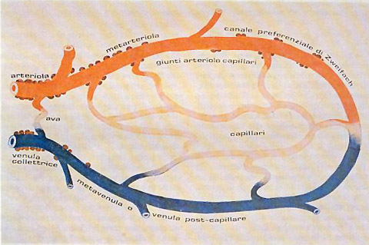

Fig. 1

The figure illustrates an “ideal” tissue-microvascular unit: Zweifach preferential channels are rather reare or seldom present.

The synergetics enables us to study the relation between microscopic level and the macroscopic one, with the principle of “self-organization”. This is possible exclusively if, at microscopic level, complex system can modify in qualitative manner; let’s think about the fluids in Bènard’s cells and the laser. Technically speaking, we define “order parameters” macroscopic observables, which describe the macroscopic behaviour of a system, and “enslavement principle” the behaviour of microscopic elements, according to which it becomes defined when originate “macroscopic observables”.
The laser gives us the best example, that illustrates the general rule: the casual emission of waves, under a defined current supply, becomes coherent; when it is excedeed, however, the emission moves toward a deterministic chaotic behaviour.

The synergetycs, therefore, studies the characteristics of “complex” systems, without considering the nature of their elements, outlining strict analogies between the macroscopic behaviour of the complex systems in spite of the fact that they are really different.

As regrads the histangium, the energy supply, or materials provisioning, necessary to originate behaviour synergism of elements, components microvascular system, is represented by jatrogenic stimulation, both direct or indirect, of numerous trigger-points, which provokes the behaviour coherence of the single tissue-microvacular units, i.e. of the elements of this complex biological system (21, 25, 27, 30, 36, 39, 53, 63, 59, 86), at the base of a possible clinical evaluation, as it is described in following.

HYSTANGIUM: A CHAOTIC DETERMINISTIC BIOLOGICAL SYSTEM.

For the first time clinically, we have described in previous papers (21, 25, 27, 30, 36, 39, 53, 63, 59), the evaluation of both vasomotility, bed-side expression of arteriolar sphygmicity, and vasomotion, which is its manifestation at the level of nutrtional capillaries and post-capillary venules (See later on) (Fig. 1).
The vasomotility causes the vasomotion.
In fact, in both skin and mucosa of lower lip, preputius of penis, cheek, in the skin of rotula, i.e. where vasomotilityis is absent, there is no vasomotion.
However, it seems really interesting that if doctor performs on these areas a rhytmic digital pressure, immediately appears the vasomotion, which shows identical characteristics, observed elsewhere, apart from the rhytm of the pressure itself, as we refer in detail later. In other words, capillary and post-capillary venules is caused by arteriolar sphygmicity, but it shows a behaviour somehow depending on the local structure.
In all tissues, organs, glands – apart from those above-mentioned – the behaviour of vasomotility as well as vasomotion is physiologically chaotic deterministic. Related tissues, organs, and glands, of course, at the macroscopic level shows a chaotic deterministic behaviour, identical to that of microvessels diameter modifications under physiological conditions, because the oscillations or trajectories of single tissue-microvascular units bring about those macroscopic of related biollogical systems.
It follows that studying the firsts is the same that studying the seconds.
This fact is really important, from both theorical and practical point of view, since it allows doctor to evaluate at the bed-side function and structure of biological systema, as the prostate (58), thyroid (65), bone marrow (17), brain (27), supra-renal bodies (3, 43), a.s.o., which otherwise could slip to the direct assessement alone.
In order to evaluate microvascular motor activity are unavoidable three ureteral reflexes – upper, middle, and lower (See Technical Page N° 5 in the site) – which give information, respectively, on small arteries and arterioles, AVA type II, group B (upper ureteral reflex, brought about by “light” and, respectively, “intense” stimulation), Endoarterial Bloking Devices (EBD) AVA type I, and type II, group A (middle ureteral reflex, provoked by light and, respectively, intense stimulation) and, ultimately, nutritional capillaries and post-capillaries venules (lower ureteral reflex) (See Tab. 1).

Cutaneous type Connectival
alfa beta type
(Upper Ureteral Reflex)
AVA type II, group B

Appear. time 2 sec. 2 sec. 2 sec.
Oscillation + + ++
Intensity 2 cm. 2,5 cm. 3 c
Duration 20 sec. 25 sec. 30 sec.
(Mean Ureteral Reflex
AVAI, AVA II, End.Blo.Dev
Appear.time 2 sec. 2 sec. 3 sec
Oscillation + +
Intensity 2 cm. 3 cm. 1,5 cm.
Duration 10 sec. 15 sec. 20 sec.

Tab.1

As regards the important assessement of the interstitium, it is unavoidable the evaluation of mean ureteral reflex and mean ureteral reflex fluctuations during “light” pressure on various trigger-point.
At this regard, very useful are also choledocic, gastric aspecific and caecal reflexes. In fact, notoriously “in toto” ureteral reflex, which appears for the first during the light stimulation, gives information on functional and structural conditions of the interstitium and its matrix: in healthy, reflex intensity is ≤ 1 cm.(variable from tissue to tissue, also and particularly in relation to rest or activity of the local parenchyma), interrupted the stimulation, the reflex disappears in 1 sec., rapidly. Analogously to vasomotility and vasomotion, from which derives, the reflex (= interstitium) fluctuates in a chaotic deterministic manner, in healthy.
In clear contrast to the axiomatical and conventional statements on homeostasis, a large number of biological systems of control, biological and biochemical are laching of stability and function in oscillatory manner.
Our actual aim is that to give to reader some information, hopefully exhaustive, considering the limits of its knowledge of the original semeiotics, on the wealth of new ideas, originated from the interaction between biological system and the theory of complex systems. In addition, we hope that reader also will carryed away by our words, well justified and steadly based, as later scientific developments demonstrate.
From the above remarks, in healthy, organs, glands and tissue, on the one hand, and related tissue-microcirculatory units, on the other hand, oscillate in deterministic chaotic manner. In facts, in earlier articles (21, 30, 60, 65, 72, 78), we described exhaustively, for the first time from the clinical stand-point, the chaotic behaviour of biological systems, and demonstrated that tissues, organs and glands as well as related microcirculatory bed show a typical way in which they function, according to the laws of chaos under physiological condition.
As a matter of facts, as regards the vasomotion, i.e., low ureteral reflex behaviour, the oscillations are unpredictable, non periodical and irregular in both intensity and morphology, with 6 cicles/min. and a period varying from 9 to 12 sec., average 10,5 sec., non entire, but fractal number. Moreover, the intensity of such oscillations, in healthy, oscillates from 0,5 to 1,5 cm. (conventional mesuare).
From the thermodinamic view-point, all these irregularities depend from the fact that the biological systems physiologically are open systems, therefore, they are far way from the equilibrium point, due to energy dissipation. Consequently, biological systems behaviour like dynamic non-linear systems, i.e., dissipating, whose oscillations show a deterministic chaotic behaviour, under physiological condition. In other words, these fluctuations or trajectories are only apparently casual, i.e. happening by chance, since they can be described by mathematical equations, characteristic of non-linear dynamic processes, in which out-put (effect) does not parallels the in-put (cause).
In fact, the real reason of this apparent chaos is our inability to know precisely all initial conditions of the non-linear chaotic systems, phenomenon known as sensibility to initial conditions, according to which two initial states, very near each other, after a critic time (T) show a divergence ten time greater than that in the starting stage.
In an original and satisfying way, we have calculated a number, fractal dimension (fD), obtained by informationn such the ratio maximal/minimal oscillation (HS or highest spikes/minimal fluctuations), i.e. “fractal factor”, and by the division of a well defined space of 120 sec. for 4 segments, in turn sub-divided for 3 parts by normal oscillations: log_{n} 4/log_{n} 3 = 1,27 (above-cited articles) (Fig.2).

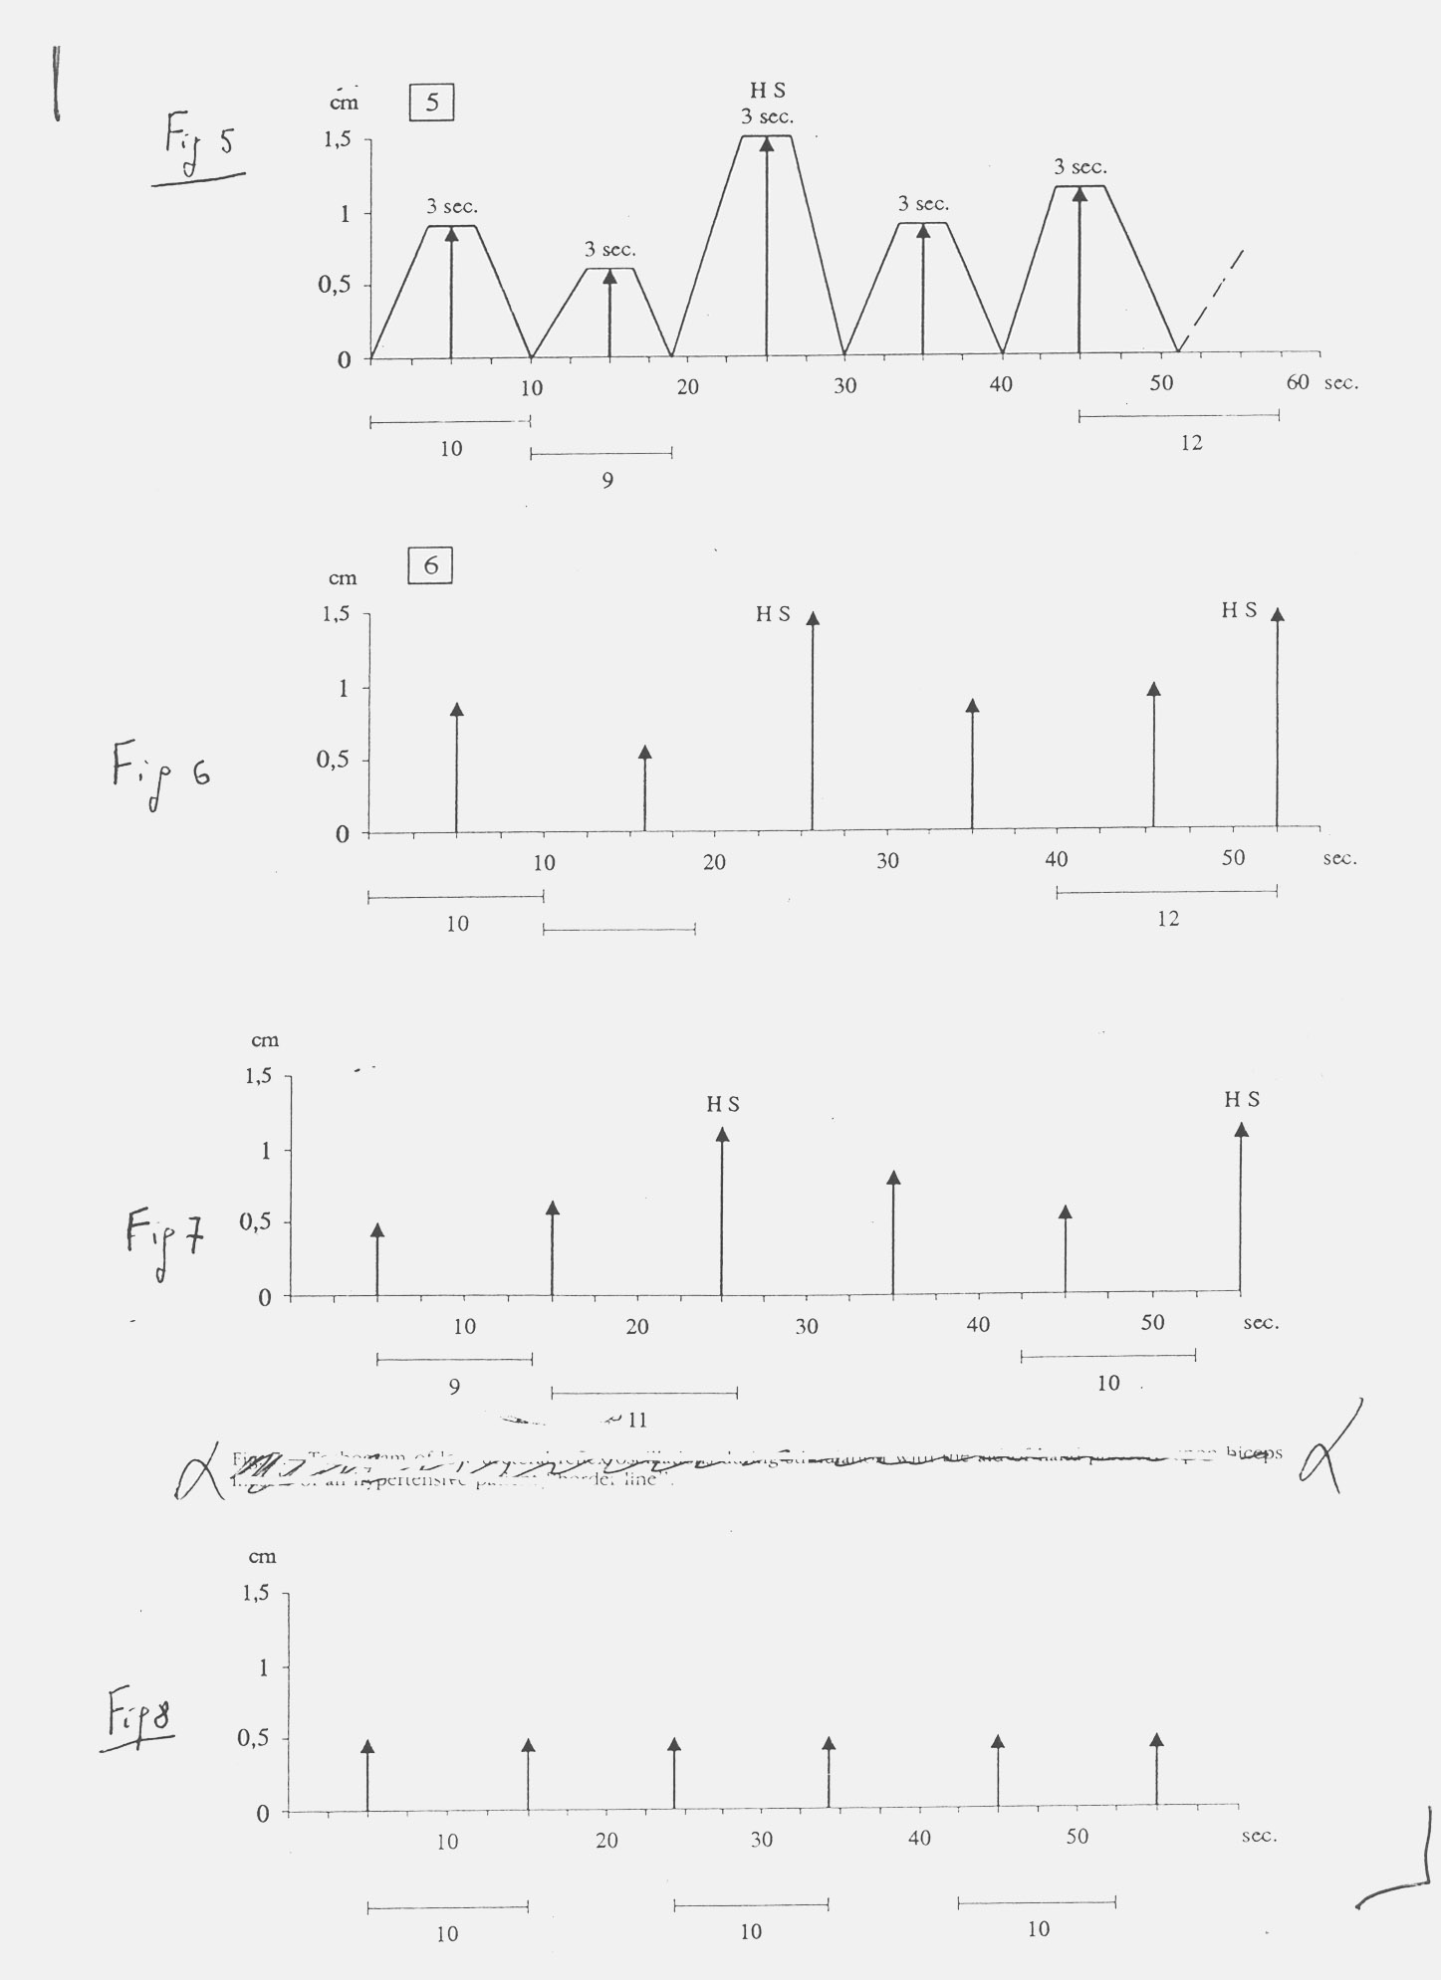

Fig. 2

The figure shows the oscillation of upper (vasomotility) and lower (vasomotion) ureteral reflexes under physiological condition (above), during slow evolution to chronic pathological disorder (middle) and during chronic disease (below). The fluctuation are represented as the related tachograms.

After having considered all auscultatory percussion relevant factors, we arrived at a useful view on the fractal dimension in healthy subject: factor factor (ff) x log_{n} 4/log_{n} 3 (3 x i,27) = 3,81, in diseased tissue (fD = 1) and in people evolving slowly to whatever disorder (fD = 2,54).
In addition, it seems particularly reliable in order to consider properly the chaos in biological systems the logistic equation:

Xn+1 = Xn λ ( 1 – Xn )

where Xn is the state of dynamic system at time n and λ ( 1 – Xn ) is the non-linear fraction.
In other words, physiologically the considered biological system behaviour, like non-linear physical system, evolves, i.e. develops and changes over a period of time, into different behaviour, due to the number of present solutions (trajectories), which rapidly changes when a given parameter, e.g. λ, of its dynamics crosses a critical point.
For instance, Xn can be whatever value included between 0 and 1: >0<1.
A single oscillation, starting from 0, can reach 1 or another point of the trajectory; e.g. low ureteral reflex demonstrates an intensity varying from 0,5 to 1,5 cm. From the value of λ variable depends the type of both oscillations and related attractors, i.e. the trajectories may be attracted to a strange attractor, as in normal, healthy, individual, or to a closed loop attractor, in subject evolving to whatever disease, or finally to a fixed point attractor as it occurs in patholy.
In fact, the deterministic analyses appears to be more sensitive to changes in the biological generators during normal functioning and abnormal pathology then the more common stochastyc analyses.
Interestingly, in case λ is equal to 3,81, i.e. physiological fractal dimension, the trajectories evolve to a strange attractor in the sense that the resolution of logistic equation oscillate unpredictably:
0,35-0,43-0,90 a.s.o.

demonstrating the deterministic chaos in the evaluated biological system.
In case λ is 1, the related attractor appears to be a fixed point attractor. Finally, when λ is, for example, 2,54 the attractor is at closed loop and the trajectories are constrained among well defined values :

0,60-0,68-0,60 a.s.o.

From the above remarks, appears clearly the real importance of fD, calculated by means of biophysical semeiotic data. Furthemore, the above-illustrated mathematical logistic equation, useful in non-linear dynamics, outlines the internal consistence of our theory.
Indeed, to demonstrate internal and external coherence of biophysical semeiotic theory on deterministic chaos, it seems useful the ratio physiological fractal dimension (3,81) and numerous values of dimensionality in case of slow pathological evolution (2,2 – 2,54) oscillates between 1,5 and 1,73, i.e. around the mean value of 1,61, golden mean, present in the frontal of Parthenon, on Francois Etruscan vase, and in the ratio between Fibonacci’s number (Fibonacci, Leonard from Pisa, XII-XIII centurt), a set of number, formed on the following formula:

An+1 = An+An-1

dove A = 0 ed A1 = 1 . (0,1,1,2,3,5,8,13,21,34,55).

At this point, an example illustrates the concepts referred above and which, of course, we shall come back with detailled information later on: at macroscopic level, in healthy, pancreatic diameters oscillate 6 times/min. (in practice, starting from basal value, lower pancreatic margin lowers in 1 sec., persists for 5 sec. due to gland congestion, with an intensity varying from 0,5 cm. to 1,5 cm., returns to initial value; then, the gland decongestions and, finally, pancreas reach the starting, basal value, showing a period oscillating from 9 sec. to 12 sec.
If we transfer on cartesian axes system the values of these fluctuations – on the abscissa the periods in sec., and on the ordinate volume modifications in cm. – we obtaine the interesting pancreatic diagram or “pancreogram” and the related tachogram (Fig.3).

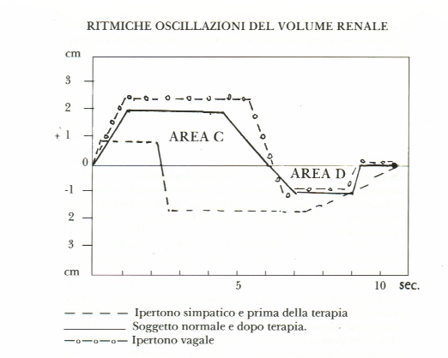

Fig. 3

Renal diagram or nephrogram is similar to that of other organs, as pancreogram.

The highest oscillations, in both macro- and micro-scopic fluctuations, always follow two smaller oscillations: we termed them highest spikes (HS); they are separated each other from 25 sec.
During HS all AVA, functionally speaking, are disactivated, and consequently the blood-flow in local nutritional capillaries is most intense, according to the well-known temporal dysomogeneity of microcirculation, corroborated by Biophysical Semeiotics by means of numerous, repeated evaluations of local histangic pH (= latency time of caecal reflex) (cited papers).
On this subject, interestingly the HS, in healthy, are preceded by longest period (12 sec.) during which, likely, smooth muscle cells are able to polimeraze at maximum level and syntesize the highest quantity of phosphorilated nucleotides (ATP), which produce endocellular free energy.
In case of “acute” disorder, all oscillations are HS and consequently the dimensionality lowers, due to the higher regularity of diagram and related tachogram. Therefore, the highly oscillating behaviour of a biological system indicates physiological blood-flow, due to normal vasomotility, vasomotion, flow-motion, flux-motion and, then, physiological regulation, both local and at distance, of microcirculation and subsequently normal tissue pH, histangic O₂ as well as Microcirculatory Functional Reserve (MFR), as allows to state Biophysical Semeiotics.
At this point it is necessary to remember what already briefly referred above, i.e. that liquid interstitial contents, from the biophysical-semeiotic view-point valuable as “in toto” ureteral reflex, realized in two times, each of them of 3 sec. duration, starting from the begin of “light” pressure stimulation, direct or indirect by related trigger-points (See later on), physiologicallly fluctuates in chaotic-deterministic manner, in realtion to the local vasomotility and vasomotion, which bring it about.
As a matter of fact, the vasomotion is the result of propagation to the capillaries and post-capillaries venules of sphygmicity wave, caused by motor activity, autoctonous and autonomous, or sphygmicity: 6 fluctuations pro minute with subsequent arteriolar diameter lowering of 100% and period physiologically varying from 9 sec. to 12 sec. and an intensity, evaluated as intensity of middle ureteral reflex, of 0,5 to 1,5 cm. Therefore, Biophysical Semeiotics corroborates the Curri’s authoritative statement (Curri S.B. Microangiopatie, Inverni della Beffa, Milano, 1986).
It appears useful as well as interesting for Clinical Microangiology to examine the following biophysical-semeiotics evidences:

1) In both skin and mucose lacking in arterioles, e.g., lower lip, preputius of penis, cheek, the skin of rotula, i.e. where vasomotility is absent, there is no vasomotion. On the contrary, in Campbell de Morgan’s spots, wich are almost always devoted of capillaries, there is present only the vasomotility. However, the rhytmic pressure on these areas carry out rhytmic oscillations (HS) of lower ureteral reflex (capillaries) and those of coledochus (arterioles-venules, showing 6 cicles pro minute apart from the velocity of rhytmic pressure. Indeed, intensity appears to be maximal when the rythm of pressure increases: HS.

2) During “intense” digital pressure (= AVA are closed) in the differential pressure test (= first, doctor applies “light” digital pressuee, e.g. on a finger-pulp or on defined trigger-point, and, then, “intense” digital pressure) after only 1 sec. the local vasomotility enhances, showing oscillations all equal and maximal (HS) and, after 2 sec. (time dependent from the method), also the vasomotion increases: lower ureteral reflex oscillations are maximal in intensity , i.e. 1,5 cm. or HS.
Beside this event, it is interesting to underscore the observation that, if digital pressure from “intense” becomes rapidly “light-moderate”, first (latency time = 1) vasomotility normalizes and, then, (lt = 2 sec.) also the vasomotion shows again the physiological, basal deterministic chaos.
Surely, we are convinced that to reader not jet skill in the original physical semeiotics terms or adjectives like “light”, “moderate”, and “intense” appear scientifically lacking; really, we use these terms due to their simplicity, to avoid others, certainly “scientific”, but difficult, hard to understand: the intensity of a stimulus, applied on microcyrcle, must in the best way be evaluated in relation to the behaviour of Endoarterial Bocking Devices (EBD) and/or arterio-venous anastomoses (AVA), type II, group B, according to Bucciante (cited in Curri).

3) Digital pressure upon humeral artery, causing partial obstruction of the vessel, when subject to examine presses “gently” homolateral forfinger-pulp against that of thumb, after lt of 2 sec. provokes significant increasing of vasomotility, and, after lt of 4 sec., clear-cut enhancement also of local ; in both cases, the fluctuation are maximal, i.e. HS.
Immediately after interruption of arterial partial occlusion, at first the vasomotility returns normal and, after lt of 2 sec. also the vasomotion normalizes.

4) Digital pressure, applied on superficial, lymphatic vessels of the upper, internal region of an arm (= “light” pressure), after a lt of 3 sec. brings about peripheral interstitial engorgement (= “in toto” ureteral reflex); subsequently, after lt of 4 sec., the vasomotility increases and after 6 sec. lt also the vasomotion clearly enhances. Although digital pressure persists, after 7-8 sec. lt, the interstitial engorgement disappears and the “vasomotion” of tissue-microvascular units returns to the basal value. At this point, the obstacle to lymphatic flow is removed.
The above-referred biophysical semeiotic remarks corroborate our actual knowledge on the regulation of production and contents of interstitial liquid. We shall come bach to this interesting subject, i.e. interstitium (interstitial fluid), which is usually very small at rest, but increases in volume during the activity, in disagrement with S.B.Curri, as regards, however, adipose tissue of mamma gland (Curri S.B. Pannicolopatie della mammella, ibidem).
In our opinion, the release of hormone to blood happens more easily if the hormone (and other substances, of course) is suitably “dilute”. On the contrary, in a parenchyma in phase of intense absorption, as the liver, scheletric muscle and adipose tissue in the absorptive state, the local interstitium is smallest.
These facts, we will discuss in detail in further articles, play a primary role in both bed-side diagnose and research.

