ANALYSIS OF “VASOMOTION” DETERMINISTIC CHAOS.
MORPHOLOGICAL MODIFICATIONS OF THE WAVE OF FLUCTUATION.

INTRODUCTION: “VASOMOTION” CONCEPT. 1
PHYSIOLOGY AND PATHOPHYSIOLOGY OF THE MICROCIRCULATION. 6
TEMPORAL (PHYSIOLOCICAL) INHOMOGENEITY AND SPATIAL (PATHOLOGICAL) INHOMOGENEITY. 7
Bibliografia. 10

INTRODUCTION: “VASOMOTION” CONCEPT.

Every single fluctuation of both upper ureteral reflex (vasomotility) and lower ureteral reflex (vasomotion) must be examined accurately in all its components – time, period, intensity of the wave, intensity of “in toto” ureteral reflex (interstitium), AL, PL, DL, a.s.o. – in order to obtain the wealth of information, it can provide doctor at the bed-side. In addition, the assessement of middle ureteral reflex, during “middle” and “intense” pressure, e.g., on a finger-pulp, indicating function and structure of arteriolar-venular anastomoses, type I, and, respectively, of Endoarteriolar Blocking Devices (EBD) (1, 2, 3) ) (Fig. 1 ).

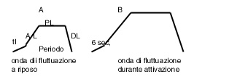

Fig. 1

AL, Ascending Line, and PL, Plateau Line, are related to the opening and, respectively, the duration of maximal opening of stimulated microvessels, in according to the synergetic model. It is advisable to assess altoghter both phases, as a identical paramater: in healthy, at rest, AL+PL is 6 sec.; the value of these parameters can change inversely, in relation to blood request, slightly variable, by related parenchyma, even at rest.
Legend.

tl =latency time: 6 sec.
AL = progressiv microvascular opening (ascending line): 1 sec.- 3 sec.
PL = plateau of the microvascular maximal opening: 5 sec.- 3 sec.
DL = progressive microvascular closure (descending line) :1 sec.

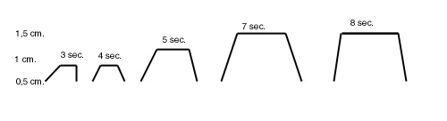

Fig. 2

The figure illustrates the morphology modification of the fluctuation wave during the first stage of microcirculatoy acivation.

First of all, we underscore the fact that HS are always preceded, in health at rest, by a “normal” oscillation, i.e. with an intensity lower than 1,5 cm, which show, however, the greatest period, 12 sec., likely in order to reach the maximal polarization-depolarization of smooth muscle cells and, thus, high endocellular energy, unavoidable to subsequent highest contraction (HS).

1) lt = 6 sec.: in healthy, after the begin of stimulation, e.g. digital pressure, during the first 3 sec. ureter dilates “in toto” rapidly, and, then, for further 3 sec. slowly increases its diameter, reaching an intensity (I) of 0,5 - 1 cm., in all healthy tissue; this reflex gives information about local interstitium and its matrix.
It is well known that there are tissues, as internal secretion glands, adipose tissue of the mammalian gland, lever, skeletal muscle, a.s.o., where the interstitium at rest risults virtual (3), but becomes clearly manifest under conditions of secretion activity (as regards the glands or during releasing of various substrates: FFA and glucose from adipose tissue and, respectively, lever, in the post-absorptive state. To this interesting topic, which allows doctor, e.g., to evaluate, in a refined manner, the sensitivity of insulin receptors, we devoted an entire article (See www.semeioticabiofisica.it e www.microcangiologia.it).
Interestingly, lt of gastric aspecific reflex of tissue-microvascular-unit diagram lowers to 4-5 sec. (NN = 6 sec.) in case of acute inflammatory disorder, diabetes mellitus, malignancies, both solid and liquid, while the intensity of “in toto” ureteral reflex increases to > 1 cm.
These parameters are really important, due to their diagnostic value, as it appears plain from the above-referred remarks: normal assessement of the parameters values – lt = 6 sec. and I = 0,5-1 cm. – during “leight” digital pressure, applied on breast, e.g., allows doctor to exclude the possibility of mamma diseases, including the cancer.
Doctor has to evaluate, of course, the breast by the aid of all other numerous and useful signs of Biophysical Semeiotics (4, 5).
Likely, nervous jatrogenetic reflex and direct stimulation bring about reaction of tissue-microvascular unit (lt and I) in every case more quickly and intense, since the reactivity of suffering biological system is more rapid, as consequence of local nervous, biochemical, metabolic, chemical causes, related to the disease. Consequently, arteriolar smooth muscle cells, which act as pace-makers, change their activity, in the way that the reactivity results more rapid and intense.
In fact, the contraction of vessel is based on three fundamental events: neuronal tone, myogenic tone, and responsivity, on which acts essentially the interstitial matrix.
At this regards, we refer a experimental evidence, corroborating our interpretation: lt of Reticulo-Endothelial-Hyperfunction Syndrome (RESH), which parallels both ESR and proteins electrophoresis, but is clearly more specific ans sensitive, in healthy, is 10 sec. (6, 7, 8), but the apnea test, boxer’s test or both togheter, i.e., Restano’s manoeuvre (= sympathetic hypertonus) provokes lowering of this value in a way directly related to test duration.
In fact, under this experimental condition, the microcirculation of bone-marrow is activated, according the type I, associated, and we observe, in the first time, a rapid AL (Fig. 2) and, then, increasing of intensity of oscillation wave and a prolonged PL.
A further experimental evidence corroborates the above remarks: in healthy, “light” digital pressure on a finger-pulpl, e.g., causes “in toto” ureteral reflex, which appears in two subsequent time (or phases) of 3 sec. each of them, with intensity < 1 cm. However, if the pressure on finger-pulp becomes “intense”, fluctuation wave shows morphological modifications, or activation, illustrated in Fig.2, where the first manifestation is represented by the increases of appearing speed of AL.

2) AL, ascending line of about 1 sec. duration, shows the velocity of opening or of microvessels dilation . As a matter of fact, AL provides information also on the actual state of intersttial matrix. As referred above, under situation of “particular” rest, the value can rise to 3 sec., when the related parenchyma, at least in stimulated area, needs minimal amount of matter-energy-information.
AL of 3 sec. and, therefore, PL of only 3 sec. (AL + PL = 6 sec.) indicate maximal microvessels opening of just 3 sec., due to a slow fulfilment, and, consequently, underscore a normal tissue supplying with energy at the lowest value, even in relation to actual necessity.
This parameter is related to the vessel wall elasticity and relaxing: we observe a more slow fulfilment under pathological conditions, as diabetes mellitus, when the duration increases from 1 sec. to ≥ 3 sec.. The assessement of AL results very useful in bed-side diagnosing hepatic steatosis, since it is performed, by “light” hand pressure upon cutaneous projection area of the lever, results clearly slow in a characteristic way.

3) PL, plateau line of physiological duration (D) of 5 sec.; therefore, AL + PL is 6 sec. PL provides information about maximal microvessel opening. It is well known that PL value can decrease to 3 sec. (and contemporaneously the duration of AL increases) under conditions of “special” functional rest, at least, in very small areas (Fig.2): temporal inhomogeneity, according to Schmidt-Schombein (See later on).
This important parameter appears lowered in case of chronic disorder, as diabetes mellitus, when D decreases to 4 sec. (AL + PL = 5 sec.): spatial nonhomogeneity. We will come back to this topic in further article, due to its positive influences on diagnose, therapeutic monitoring and clinical research.
On the contrary, in the tissue, involved by inflammation, or intensely active, from the metabolic view-point, AL + PL is > 6 sec., and can reach 7 – 8 sec., and intensity is 1,5 cm (HS). Although to this argument we will devote an whole article, it is necessary to underline, from now on, that the microcirculatory activation can be divided in type I, or associated, in type II, or dyssociated, as regards the behaviour of vasomotion, which can appear activated (type I) or, respectively, dysactivated and less functioning (type II): i.e., fluctuation waves activated in the vasomotility, but normal (type III or intermediate) or reduced (type II) in the vasomotion.
In some pathological processes, as in malignancies, the activation appears particularly dyssociated: arteriolar PL of 8-9 sec. and venular-capillary PL of only 4-5 sec., causing consequently histangic acidosis.
As above briefly referred, the activation type III, intermediate, which differentiate, owing to the absence of activation of hemoderivative structures. We will come back to this topic later on.

4) I, maximal intensity of fluctuation, provides information on the microvessel opening intensity. In health, this parameter is directly related to the duration (D) of PL of vasomotility and, of course, of the vasomotion. In fact, in the tissues at rest, functionally speaking, PL is 5 sec., I is 0,5 cm, and the oscillations are all equal, but AL + PL is normal (6 sec.).
On the contrary, in case of myxedema, even under treatment, during stimulation of thyroid trigger-points, PL is 4 sec., and, therefore, AL + PL appears to be pathologically lowered.
Finally, in case of acute inflammatory disorder (active hyperaemia or, speaking in clinical microangiological terms, microcirculatory activation, type I, associated), when PL is 7-8 sec., I of this parameter rises to its maximal value of 1,5 cm (HS).

5) DL, descending line, indicates vessel wall elasticity and contractility; the duration is physiologically of 1 sec.
In health, the difference of microvessels oscillation, mentioned above, brings about the “temporal inhomogeneity” of microcirculation, according to Schmidt-Schonbein (9). In fact, in healthy, if we evaluate tissue O₂ by lt of caecal reflex (lt of caecal dilation, e.g., during “middle-intense” digital pressure, applied on a finger pulp) over and over again, at a distance of > 5 sec. each other, in order to avoid post-ischaemic hyperaemia or, more properly speaking, biophysical-semeiotic preconditioning (microcirculatory activation type I, associated, since the subject is under healthy condition), we observe normal value, but always varying in a chaotic deterministic manner. See the following article.

The normal tachogram of tissue microvascular unit, illustrated in Fig. 3, in our above-described example obtained during “light” digital pressure, applied on a finger-pulp of the individual to be examined, is like to indented coast.
On the contrary, in whatever disorder, acute and chronic, the tachogram appears like sea-shore, although the behaviour of “vasomotion” is different in these cases, i.e. the type of microcirculatory activation. (Fig. 4). In the former case, fractal dimensin is 3,81, while in the latter is 1, i.e. topological dimension.

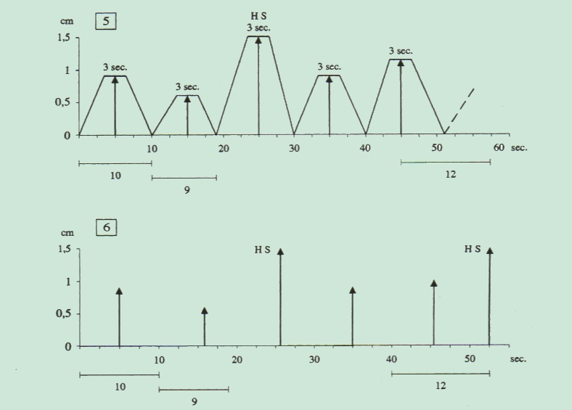

Fig 3.

Diagrams and tachograms of tissue microvascular unit under physiological condition. Its is plain the resemblance to indented coast.The shape is clearly irregular and the figure takes up much space: fractal dimension od 3,81

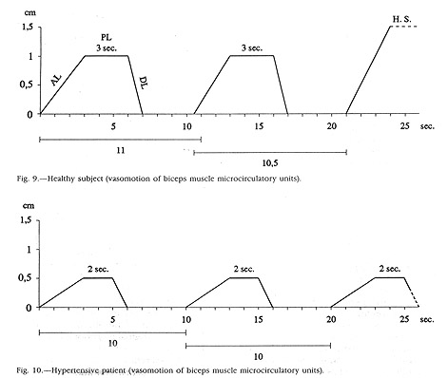

Fig. 4

The figure shows the clear-cut difference between physiological (upper) and pathological (lower) tachogram of tissue-microvascular unit, in which oscillation waves are all identical and smallest: the waves, equal and regular, take up minimal room (fractal dimension = 1).

PHYSIOLOGY AND PATHOPHYSIOLOGY OF THE MICROCIRCULATION.

At present, it is generally admitted that “microcirculatory disorders” are important, sometimes decisive, complication of the degenerative vascular diseases.
We have previously demonstrated that digital pressure on femoral artery at groin brings about immediately microcirculatory distal activation type I or associated (See Bibliography in the site).
In order to understand properly these “microcirculatory disorders”, we must, even briefly, describe before normal circulation on the basis of normal vascular integrity, normal composition of the blood and the interstitial fluid, normal rheological behaviour of the blood cells, in the flowing blood, and normal vascular tone. Actually, it becomes possibile to define and comprehend such abnormalities, which are not only quantitatively, as in hypoperfusion, but qualitatively different from the normal state of the microcirculation.
Therefore, a microcirculatory disorder is defined as a consequence of autonomous and autochthonous abnormalities of the vascular wall, of the blood and of the interstitial cells and fluids, which are basically independent of macrocirculatory abnormalities, but highly effective in complicating them. As a matter of fact, it is generally accepted that many diseases, including those accompanying obliterative vascular disease, are characterized by “microcirculatory diorders”.
In general, such disorders are considered a quantitative abnormality, i.e. a simple defect of gas exchange, metabolite supply and removal, or oher functional insufficiencies.
According to Schmidt-Scoenbein (9), it is necessary to extend this quantitative concept into more qualitative considerations about defective interaction of the components responsible for “normal circulation”. It is known today that a simple quantitative hypoperfusion, such as occurs secondary to macrocirculatory defect located in the heart, the arteries or the veins, is often complicated by peripheral changes , or in other words, a genuine microcirculatory disorder. Here the constituents of the terminal vascular bed and the surrounding tissue are affected, as demonstrates clearly at the bed-side the Biophysical Semeiotics.
Therefore, it is necessary to define the term “chronic microcirculatory disorder”, as follow: “a microcirculatory disorder, in the strict sense of the word, is a disturbance of organ perfusion that is a consequence of a primary and endogenous defect of intracapillary and transcapillary motion of blood components. These disorders are autonomous as well as autochthonous, i.e., they follow specific rules and take place at the site of hypoperfusion. Therefore, they are not just secondary consequences of cardiac, arteriolar, venous defect but are very effective in complicating them. The biological symptoms of chronic vascular insufficiency are ofte highlighted by micorcirculatory defects in the sense that the latter can potentiate the former.
Before discussing these chronic microcirculatory disorders, it is necessary to define the normal microcirculation. Due to reasons of space, only a brief sketch can be given here. The reader is referred to the pertinent literature, for example, in my site, and in Curri S.B. should also be consulted. In this context, it is helpful to differentiate between the microvasculature or terminal vascular bed (one anatomical entity) and the microcirculation of blood constituents that takes place within these terminal vessels and across their walls (functional events) (9).
As a consequence of this behaviour, the viscosity of the blood in the normal microcirculation is not significantly different from that of the plasma alone, and it is only slightly affected by changes in local hematocrit. Expressed in the semantic system formerly proposed to describe coherently all hemorheological abnormalities by Schmid-Schonbein et al. (10), one can say that the normal microcirculation is characterized by a very high fluidity of blood (which is only 42% lower than the fluidity of water as the ubiquitous biological solvent).
Other blood cells, such as the thrombocytes (which have no significant effect when flowing as individuals) or the leukocytes and lymphocytes, have a much more conventional rheological behaviour. It is now clearly established that the flexible white cells are passively deformed during their motion through the nutritive vessels, but much less than the red cells.
Therefore, they produce intermittent flow retardation in passing the capillaries. The work of Schmid-Schonbein GW. et al. (11) has clearly shown how leukocytes contribute to the distribution of flow through capillaries and how their rheological interaction with the much more flexible red cel1s promotes their adherence to the venular wall (margination). Only subsequent to passive margination can leukocytes emigrate by actively passing through slits in the endothelium into the interstitial space where they can fulfi the unspecific defense reaction against bacteria.
The normal microcirculation is, therefore, clearly not affected dramatically by rheological factors but rather is under the control of such classic hemodynamic factors as pressure and geometric conductance. Flow is regulated by the existing arteriolo-venular pressure gradient and geometrical factors as described in Poiseuille's law in the individual vessel and by the rules of Kirchhoff in the vascular network. As the tone of the vascular smooth muscle is variable, this cellular effector actively regulates perfusion. We know today that so-called capillary “recruitment”, ie, the passage of blood into the nutritive exchange capillaries, the driving pressures as well as the transmural pressure, is under vasomotor control (9).
Therefore, arterioles and small arteries, according to Hammersen, control the number of perfused capillaries, the hematocrit and the blood velocity in them, as well as the equilibrium between filtration and resorption. The vasomotor smooth muscles, in tum, are regulated by myogenic, local metabolic, nervous and hormonal mechanisms that are beyond the scope of the present paper. At this point, we underscore the fact that Biophysical Semeiotics corroborates all data referred above, as reader can see in the large Bibliography in the site.
It is well established that in different organs the so-called basal vascular tone is distinctly different but always present as an indicator of the normal “milieu interieur” of the tissue at rest. This basal vascular tone is functionaly equivalent to vasomotor reserve, which can be recruited for various purposes and by different mechanisms, as the biophysical-semeiotic preconditioning.
The physiological recruitment occurs obviously during functional microcirculatory activation type I, associated, i.e., during muscular excercise or inflammatory defense reaction.
In addition, we agree with Scmidht-Schoenbein H. on the fact that in the recovery period from a functional microcirculatory activation tipe I, associated, normal vascular tone is recovered, a response that is more rapid and complete if the reserve is not also used for the compensatory mechanism just mentioned.
As an additional consequence of normal vascular smooth muscle tone, the “derecruitment” of the capillaries, ie, the functional exclusion of capillaries from the traffic of whole blood, leads to a temporal inhomogeneity of perfusion. The blood cells alternately take only a few of the existing capillaries for their arteriovenous passage, a phenomenon first described by Krogh.
It is very likely, according to newer concepts, that there is a residual plasma in the derecruited capillaries, as suggests the presence of minimal residual “in toto” ureteral reflex during the time, which precedes HS (= pressure repeated on smallest surface, e.g., on a finger-pulp), and that complete closure does not occur. This detail notwithstanding, the physiological temporal nonhomogeneity on the basis of “vasomotion” results in a very even perfusion of the tissue, but its real significance will be examined in a original clinical manner for the first time, in following.

TEMPORAL (PHYSIOLOCICAL) INHOMOGENEITY AND SPATIAL (PATHOLOGICAL) INHOMOGENEITY.

Microcirculatory flow-motion and flux-motion, secondary to arteriolar sphygmicity, from biophysical-semeiotic view-point, show a very different and interesting temporal behaviour.
In fact, microcirculatory blood flow, notoriously “intermittent”, depends from the driving pressure brought about by arteriolar systole, wich follows the arteriolar dyastole, characterized by singular behaviour of non-linear dynamic systems.
In healthy at rest, however, such behaviour complexity of both microcirculatory blood flow and interstitial fluid is highly encreased because in a definite tissue-microvascular unit (or in a few adjacent units), after two vasomotility waves we observe a complete interval (arrest) of the sphygmicity lasting 6-7 sec., followed obviously by the arrest of choatic-deterministic interstitial fluctuations as well as of vasomotion, caused by arteriolar spygmicity.
As an indicator of internal and external coherence, the intensity and duration of AL + PL Phase of successive vasomotility wave appear more intense than the parameters of the two former fluctuations: they are HS (Fig.5)

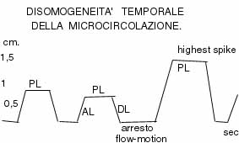

Fig. 5

After two “normal” fluctuation waves, in healthy, there is an arrest of microcirculatory blood-flow of 6-7 sec. in a few tissue-microcirculatory units. Then, follows a maximal wave or HS.

During these 6-7 sec. of local “arrest” of microcirculatory vasomotility we observe the lowest value of histangic O₂, although in physiological ranges: latency time of finger-pulp-aspecific gastric reflex, brought about by pressure on a very limited area, lowers to 5 sec. (NN = 6-7 sec.). Really, it is a “physiological” microcirculatory phenomenon, well-known as temporal inhomogeneity, according to Scmidt-Scoenbein (9).
On the contray, in case of microcirculatory disorders – diabetic, arteriosclerotic, hypertensive, a.s.o., histangiopathy, we observe clinically by means of biophysical-semeiotics examination limited areas, in which both flow-motion and flux-motion are intensely modified in the sense that blood-flow is altered, but not intermittent (there are not the arrests or intervals of about 6 sec. after two “normal” vasomotility waves), while in other areas it is absent completely, i.e. it is not time-dependent. Consequently, under such as pathological condition, HS are absent.
This pathological situation is termed as spatial inhomogeneity, and it is lasting, fixed, unchanged, while temporal nonhomogeneity disapears exclusively during microcirclulatory activation caused by both physiological (activation type I, associated) and pathological (activation type II, dissociated) conditions.
At this point, in order to illustrate, from the clinical point of view, clearly, rapidly, and in a reliable manner, these microcirculatory events, interestingly the reader must know that temporal inhomogeneity and FMR – functional microcirculatory reserve – are directly related, in the sense that the presence and intensity of the former is showed precisely by parameters values of the latter. Such interesting and useful relation facilitates the bed-side evaluation of microcirculatory blood-flow nonhomogeneity, also during the posture tests, two pressure test, and stress tests, which allow to assess the biological systems, which can not be evaluated “directly”.
Temporal inhomogeneity aims to realize a “reserve” of material-information-energy tissue supply, since at rest O₂ supplying is actually sufficient to parallel tissue demand, but a light increase of the pressure on the limited area (the point of a needle, pin, a.s.o.) provokes the rapid interruption of nonhomogeneity and a lasting, deterministic-chaotic rythm of “all” tissue-microvascular units initiates.
At this moment tissue O₂ enhances, as demonstrates the caecal reflex latency time, increased in a significant manner, which persists unchanged and is no more time-dependent, as at rest in healthy. Further increasing of pressure and stress tests bring about microcirculatory activation and, consequently, high enhancement of tissue oxygenation.

Bibliografia.

1) Clara M. Die arterio-venosen Anastomosen : Anatomie, Biologie, Pathologie. 2 Aufl., Wien, Springer Verl., 28,1986.
2) Curri S.B. Le Microangiopatie. Inverni della Beffa, Milano, 1986
3) Curri S.B. Pannicolopatia Mammaria da Stasi, Parte seconda. Inverni della Beffa, Milano, 1984
4) Stagnaro S., Auscultatory percussion of the cerebral tumour: Diagnostic importance of the evoked potentials, Biol. Med., 7, 171-175,1985
5) Stagnaro-Neri M., Stagnaro S., Cancro della mammella: prevenzione primaria e diagnosi precoce con la percussione ascoltata. Gazz. Med. It. – Arch. Sc. Med. 152, 447, 1993
6) Stagnaro S., Sindrome percusso-ascoltatoria di Iperfunzione del Sistema Reticolo-Istiocitario. Min. Med. 74, 479, 1983 [Pub-Med indexed for MEDLINE].
7) Stagnaro-Neri M., Stagnaro S., Appendicite. Min. Med. 87, 183, 1996 (Pub-Med indexed for Medline)
8) Stagnaro S., Polimialgia Reumatica Acuta Benigna Variante. Clin. Ter. 118, 193, 1986 (Pub-Med indexed for Medline)
9) Schmidt-Schonbein. H. Physiology and Pathophysiology of the Microcirculation and Consequences of it treatment by drugs. In: Microcirculation and Ischemic Vascular Diseases. Advances in Diagnosis and Therapy. Proceedings of Congress. Abbott Ed. K. Messmer ed. Munich, 29, 1980)
10) Scmidt-Scoenbein H., Rieger H., Fisher T. Blood fluidity as a consequence of red cell fluidity: Flow properties of blood and flow behavior of blood in vascular diseases. Angiology 31: 301-319,1980)
11) Schmidt-Schoenbein GW., Skalak R., Usami R et al. The interaction of leukocytes and erhytrocytes in capillary and postcapillary vessels. Microvasc. Res. 19: 18-44,1980)

