PHYSIOLOGY OF TISSUE-MICROVASCULAR SYSTEM. CHAOS AND ORDER.

An outline of history.

We agree, in general, with Tischendorf’s concept of Angiobiotopie, considering it essentially valid, but really overcome as regards microvascular dynamics, partially illustrated in the pages dedicated to Biophysic Semeiotics (See later).
Biological tissue-microvascular system, however, for the sake of practice and didactics, can be described as formed by single units: the tissue-microvascular units. In its turn, the tissue-microvascular unit is made up by three fundamental components:

1) microvessels, diameter < 100 μ.,

2) the blood, flowing in them,

3) perivascular connective, periangium, interstitium
or “environment” in which microvessels are placed,
formed by water, free- and bound-water, cells and
connective fibers, and interstitial matrix, glucosamino-glycanes.

From an “ideal” view-point, useful exclusively for sake of practice and didactics, as mentioned above, microvessels can be subdivided, as F. Pratesi suggests (Pratesi F. Microcircolazione e Microangiologia. Fisiopatologia, Clinica e Terapia. Ediz. Minerva Medica, Torino,1990.), as follows:

1) Para-microcyrcle: small artries and arterioles, according to Hammersen,
venules of I, II, III order, shunts or Arterio-Venous Anastomoses (AVA),
functionally speaking (Bucciante L. Anastomosi arterovenose e
dispositivi regolatori del flusso sanguigno. Mon.zool.it.,suppl. 57, 3-10,1949) ;

2) Microcyrcle: nutritional capillaries, post-capillaries venules, “meta”-arterioles.

Really, a logn well established clinical experience by means of Biophysical Semeiotics, allows us to corroborate S.B. Curri’s thought (Curri S.B. Le Microangiopatie. Ediz. Inverni della Beffa, II Ediz., Milano, 1986.), according to which all microvessels structures make up an unit, from the functional point of view.
In fact, during the numerous biophysical-semeiotic stress-tests, all microvessels behave in an articulate, harmonious, unitary manner, and, then, liable to be evaluated from a “total”, “holistic” view-point, according to synergistic pattern (See Bibliography in the site).
In the reality, microvessels adapt, from both functional and structural point of view, to related tissue or parenchyma, according to Tischendorf’s concept of Angiobiotopie.
At this point, it is necessary to emphasize that a biological system, as the tissue-microvessel system, so much highly evolved and well differentiated, as regards anatomy and physiology, can not react to attacks, different in origin, which involve it, by a lot of ways.
As far as tissue-micorvessel unit is concerned, cells, transformed in smooth muscle cells and in ramified smooth muscle cells, when stimulated, eithe contract or dilate, although there is a residual possibility of further response.
On the contrary, smooth muscle cells of the media of great arteries – elastic and muscular – which are less differentiated, react to various stimuli, even, de-differentiating and, then, evolving towards cells with secretory activity (Simionescu N., Mora R., Vasile E., et al.. Prelesional modifications of the vessel wall in hyperlipidemic atherogenesis. Atherogenesis II, NYAS,1-6,1990. Gimbrone M.A., Resnick N., Nagel T. et al.. Hemodynamics, Endothelial gene expression and atherogenesis. Atherogenesis IV, NYAS, 1-7, 1997).
These concepts, plain for those in the know, account for the reason of the restricted number of tissue-microvascular unit reactions, doctor observes at the bed-side by Biophysical Semeiotics and study subject by Clinical Microangiology.
At regard to this topic, reader must think, from now on, the important set of microvascular dynamic events, related to microcirculatory activation, which can be subdivided in three types:

MICROCIRCULATORY ACTIVATION.

type I or “associated” (e.g. during parenchyma work);

type II or “dissociated” (e.g. during pathological conditions);

type III or “intermediate”, when vasomotility is activated, while vasomotion show basal activity, and hemoderivative structures are not activated.

For its significance and important influence on the prevention, diagnosis, differential diagnosis, and therapeutic monitoring, to this topic, i.e., to microcirculatory activation, essential event in clinical microangiology, a large space will be devoted, and of it a large number of quotations will be made in following.
For the first time “clinically”, with the aid of Biophysical Semeiotics, doctor is able to evaluate, in dynamic manner, tissue-microvascular unit of every biophysical system, from both structural and functional view-point, according to a synergistic pattern. Thus, in following, we illustrate in details the essential aspect of this original physical semeiotics, i.e. the clinical evaluation of microvascular dynamics.
Notoriously the microvessels carry on a motor activity, autoctonous and deterministic chaotic, which represents one of the most remarkable manifestations of microcirculatory hemodinamics, characterized by a flow-motion and hematocrit rhytmically fluctuating due to the particular behaviour of both vasomotility and vasomotion.
Starting from the John’s study (1852) (Jones T.W. Discovery that the veins of the bat’s wing are endowed with rhytmical contractility and that onward flow of blood is accelerated by each contraction. Trans. R. Soc. 142, 131-136,1852), the first observations on “vasomotion”, i.e vasomotility ad the subsequent vasomotion, were performed exclusively in animals.
(From now on, with the term “vasomotion” we intend the general dinamycs of microcirculatory vessels; on the contrary, vasomotion indicates capillary-venules dynamics, evaluated by means of lower tirhd ureteral reflex fluctuations).
Due to this reason, author payed little attention to those researches, because performed, e.g., bat-wings, a tissue considered unreliable (Nicoll P.A., Webb R. L. Vascular patterns and active vasomotion as determiners of flow through minute vessels. Angiology,6, 291-310,1955.).
Subsequent investigations of mammalian did not demonstrate clearly the presence of “vasomotion”, because of the utilized anaesthesia (Colantuoni A., Bertuglia S., Intaglietta M. Effects of anaesthesia on the spontaneous activity of the microvasculature. Int.J.Microcirc. Clin.Exp. 3,13-28,1984).
D’Agrosa, in 1970, spoke about “continuous” and discontinuous” movements, while Wedrhielm and Weston, in 1973, described “regular” (meta-arterioles) and “irregular” (small arteries and arterioles) movements (In: Intaglietta M. Arteriolar vasomotion: implications for tissue ischemia. Advances in Vascular Pathology. A. Strano, S. Novo, editors. Elsevier Science Publishers B.V. Amsterdam,1990.).
When quantitative technics were available in studying microvascular hemodinamic, it was clear that macroscopic data often did not parallel those microscopic, assesses in internal organs and tissues (Intaglietta M., Zweifach B.V. Microcirculatory basis for fluid exchange. Advances Biological and Medical Physics.15, 111-159,1973).
This fact suggested that microscopic approach was not completely representative of “in vivo” conditions, particularly as regards vascular tone and “vasomotion”. Subsequently, both Curri S.B. and Intalietta M. described vasomotion and vasomotility with the aid of laser doppler methods and computerized videocamera, although with different interpretations.
The real importance of “vasomotion” become finally plain, when the change in motor activity and its consequences in microvascular disorders was demonstrated.
Nowadays, Clinical Microangiology demonstrates clearly that bed-side study of microvascular motility by Biophysical Semeiotics is a reality and that there is not doubt on the presence of microvascular “vasomotion”, as well as on its importance in both physiological and pathological conditions.

“VASOMOTION”: PHYSIOLOGY.

In all tissues, a part from their local different architecture, micrvessel diameter oscillates rhytmically during time. As we already said, with the term “vasomotion” we intend in following both vasomotility, i.e. small arteries and arterioles sphygnicity , according to Hammersen, and vasomotion, more exactly speaking, which is the subsequent oscillation of capillaries and post-capillaries venules diameter (Fig.1).

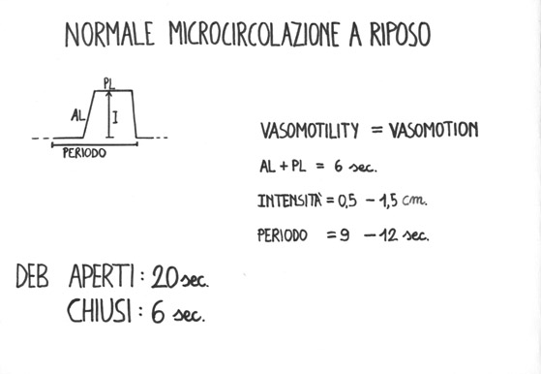

Fig. 1

The figure shows a wave of oscillation at rest of both vasomotility and vasomotion, in which AL (ascending line) plus PL (plateau line) persists 6 sec. and the intensity fluctuates from 0,5 to 1,5 cm. (diameter oscillations of upper amd, respectively, lower ureteral reflex, wheile the period varies from 9 to 12 sec. Mean ureteral reflex gives information about EBD activity.

Microvessels with diametre of 100 μ show a motor activity of 2-3 circles/min. and diameter oscillation intensity of 10-20%. As far as vascular diameter lowers, motor activity progressively becomes more intense and rapid; in terminal arterioles, the frequency is 10-20 cyrcles/min. and the width can reach 100% of mean diameter, causing periodically opening and closure of the microvessel.
This rythmic activity is mainly spomtaneous and direct consequence of periodic contraction of smooth muscle cells of arterioles with 20-90 μ of diameter. Diamater oscillations of small vessels is due to the properties of smooth muscle sells, which have a labil membrane potential and, then, depolarize periodically. Such effect speads and synchronizes the activity of cells groups, which are functioning as pace-makers. It seems that they are localized in arteriolar bifurcations (Colantuoni A., Bertuglia S., Intaglietta M. Variations of rhytmical diameter changes at the arterial microvascular bifurcations. Pflugers Arch. 403, 289-295,1985 ; Meyer J.U., LindbomL., Intaglietta M. Coordinated diameter oscillations at arteriolar bifurcations in skeletal muscle. Amer. J.Physiol. H568- 573,1987.).
It is generally admitted that actual need of the tissues rule out the activity of related pace-makers, because the “vasomotion” is related to the need of tissue itself, as demonstrates Biophysical Semeiotics. In fact, during various posture tests, motor activity of small vessels changes so rapidly that tissue O₂ is the same in different positions: latency time of caecal reflex, indicating histangic acidosis, for a certain time is constant in a well defined tissue.
Really, there is also a regulation at distance (Curri; Intaglietta, ibidem): for instance, if the subject to examine “thinks” to to bend and extend a finger quickly, but without moving it, of course, local microcirculatory bed appears transitorily activated, according to type I, associated, clearly due to nervous regulation, i.e. at distant. Contemporaneously, in the related motor and pre-motor cortex appears microcirculatory activation of the same type Fig. 2)

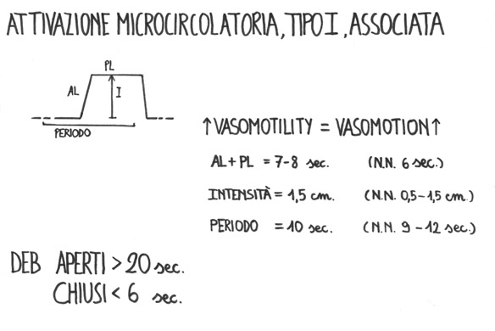

Fig. 2

The figure shows the increasing of oscillation waves: AL + PL 7-8 sec. Maximal intensity as well as a period of 10 sec. Arrowes indicate the activation of both vasomotility and vasomotion. Consequently, fractal dimension appears clearly reduced.

To summarize: smooth muscle cells activation by well-known polarization-depolarization processes, which bring about periodic vasoconstrictions, is caused by nervous, hormonal, local biochemical stimuli and also by myogenic stimuli, characteristic of myocells. These stimuli provoke in smooth muscle cells of small arteries and arterioles, according to Hammersen, the onset of depolarazition and consequenti jonic fluxes and, then, intracellular storage of Ca^{++,} partially due to realase from cytoplasmic and membraneous storages, which bring about the phosphorilation of myosine, that in turn interact with actine, to start contraction mechanism in presence of phosphorilated nucleotides with high caloric content, produced in mitochondria.

The “vasomotion” varies in relation to temperature fluctuation, O₂ concentration, pH variations, jonic concentration of vascular wall. In fact, it has been demomstrated that Ca⁺⁺ and K⁺ fluxes, due to channels voltage-dependent and, respectively, voltage and calcium dependent, at the base of the periodicity of these transports, brings about the rhytmicity of arteriolar contactions, ruled also by transmural pressure (Gonzalez-Fernandez J.M., Ermentrout B. On the origin and dynamics of the vasomotion of small arteries. Mathematical Biosciences. 119, 127-167,1994).
Some evidences demonstrate that cyclic variation of small arteries opening and, then, those of both capillaries and post-capillaries venules, AVA, functionally speaking, i.e. “vasomotion”, plays a primary role in the physiology and pathology of microcyrcle (Funk W., Intaglietta M. Spontabeous arteriolar vasomotion. Prog. Appl. Microcirc. 3,66-82, 1983; Intaglietta M. Vasomotion as normal microvascular activity and a reaction to impaired homeostatsis. Prog. Appl. Microcirc. 15, 1-9, 1988. ¸Lefer D.J., Lynch C.D., Lapinski K.C., Hutchins P.M. Enhanced vasomotion of cerebral arterioles in spontaneously hypertensive rats. Microvasc. Res. 39, 129-139,1990.; Rodgers G.P., Schechter A.N., Nogouchi et al. Periodic microcirculatory flow in patients with sickle-cell disease. N.Engl.J.Med.311,1534-1538,1984.).
The nature of “vasomotion” is complex. Therefore, in order to obtain a total, armonic outlook of the process it is unavoidable necessary to consider altogheter transmembrane jonic transport, trnsmural pressure and vasal wall relaxation.
In short, microcyrcle, site of “vasomotion”, is a biological deterministic-chaotic system (See Bibliography in the site), which shows a set of non-linear relations between a lot of variables with c lot of subsequent behaviours.
At this point spontaneously on must put the question: is the “vasomotion” really an activity of the microcirculatory bed or not?
In fact, microcirculatory fluctuation begins in the para-microcyrcle, according to F. Pratesi, i.e., in vessels with diameter varying from 90 to 20 μμ. The answer could seem negative. On the other hand, “vasomotion” influences without doubt the microcirculatory bed. As a matter of fact, the vasomotility causes the vasomotion, as demonstrates clinically Biophysical Semeiotics, i agreement to what states S.B. Curri by sophysticated semeiotics (Curri S.B. Pannicolopatia Mammaria da Stasi. Ed. Inverni della Beffa , Milano, 1992), and consequently provokes intermittent flux in nutritional capillaries, showing flux periods alternate with periods without flux, which are non-chaotic according to M. Intaglietta.
Really, the periodicity of capillary perfusion, we know vasomotion, brought about by vasomotility, physiologically shows deyerministuc chaotic behaviour, as previously demonstrated by us on the base of biophysical semeiotic data (See Bibliography in the site).
The most important consequences of arteriolar dynamics are tissue perfusion – during the opening and the first phase of contraction – and the re-absorption of interstitial fluids, immediately before the first phase of arteriolar contraction, when endocapillary pressure is loweghst, preventing so oedema formation (See diagrams of tissue-microvascular units, in Hypertensive Constitution).
It is necessary to consider that, frm hemodinamical vie-point, hydraulic resistance of a blood-vessel, with diameter fluctuating during time, is allways lower than that of the same blood-vessel with identical mean diameter, but static (Funk, ibidem). Conaequently, the “vasomotion” appears to be a factor of blood-pressure regulation (Fig. 3). Therefore, we have to consider the “vasomotion” as a motor activity taking a part to important physiologic events of microcyrcle, which bring about essential pathological conditions, by its variations: increase, decrease, disappearing (Allegra C., Piovella C. Storia e concetto evolutivo della microcircolazione, 1-3, 1-5,1993).

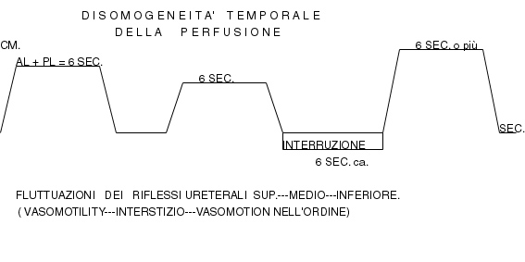

Fig.3

The figure shows physiological dynamics of small arteries- arterioles (upper ureteral reflex), interstitium (mean ureteral refle), and capillaries-post-capillaries venules (lower ureteral reflex); notheworthy is the periodical interruption of blood-flow, i.e. temporal dysomogeneity.

In our mind, among microcirculatory structures, a primary role in the microvessel blood-flow is played by Endoarterial Blocking Devices (EBD), which are largely prent in human body, practically they are everywhere, as allows us to state Biophysical Semeiotics. In fact, EBD are localized in arterioles with at least two layers of of muscular cells of finger-pulps, spinal meningis, bronchi, oesophagus, kidneis, thyroid, pancreas, gums,tonsils, nasal mucosa, myocardium, lever, spleen (hylus), vasa vasorum of numerous arteris and venous of large and mean diameter, lung, pleura, arms and legs arteries, vagina, penis.
As regards the microcirculation, the importance of all these structures has been outlined by us from the clinical point of viw, under physiological and pathological conditions (See Bibliography in the site) (Fig. 1 and 2). Both physiology and anatomy of EBD, we evaluated “clinically” for the first time, plays a primary role in diagnosis and prevention of all disorders, so that we foresee – when Clinical Microangiology will be a medicine discipline known to all physicians – the origin of its branch, represented by EBD biophysical-semeiotic study, we suggest to term Biophysical-Semeiotic Microangiologyof Endoarterial Blocking Devices.

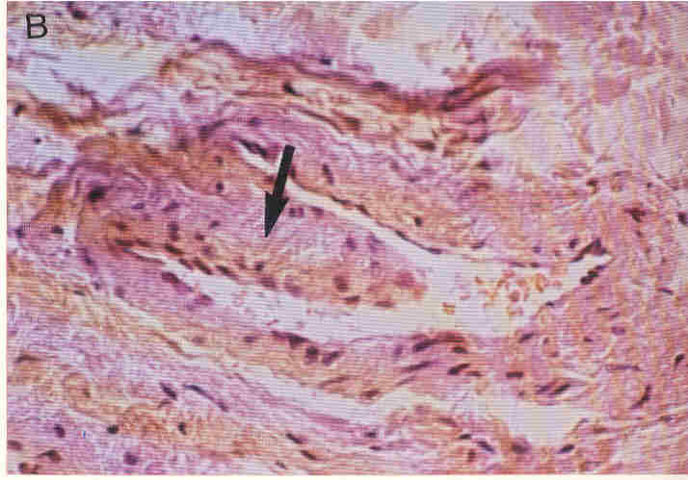

Fig.4

The figure shows a refined imagineof EBD with a large base of the type “proboscide”
(From: S.B. Curri: Microangiopatie, Inverni della Beffa)

From the above-mentioned remarks, in following we are going to illustrate, with the aid of examples provided by clinical and experimental evidence, the real reasons of our statement about clinical study of EBD, which over the last decades did give us precious information, useful in diagnosis and primary prevention of almost all human diseases, both acute and chronic, whose clinical symptomatology shows itself after years or decades from the onset of hemoderivative alterations, which are at the base of numerous biophysical-semeiotic constitutions (See: Biophysical Constitutions in the site).
At rest, ureteral mean reflex, caused by digital pressure of “mean” intensity, applied directly, e.g., on pulp-finger or on whatever trigger-points, in healthy, shows a latency time (lt) of 3 sec., duration (D) of 20 sec., intensity (I) of 1,5 cm., disappearing time, precedent the successive cyrcle, of 6 sec. (Fig.2) and, ultimately, the preconditioning is physiological (after 5 sec. of interruption, doctor performs a second time the same evaluation of reflex parameters: the values appears ameliorated, in healthy, and perfectly equal to those gathered with parenchyma preconditioning).
Interestimgly, we will refer often the late parameter, due to its importance in day-to-day practice.
Mean ureteral relfex is related to EBD myocells contraction and with subsequent arteriolar opening, as clinical and experienmtal evidence suggests: if the subject to examine opens and closes his hands rhytmically and quickly (= microcirculatory activation, type I, associated) (Fig.2), mean ureteral reflex, immediately evaluated, shows I ≥ 1,5 cm. (basal value 1,5 cm.), D 25 sec. (basal value 20 sec.), disappearance time of only 3 sec. (basal value 6 sec.), associated with “vasomotion” increasing of pulp microcirculatory bed.
In acute inflammation, in young-adult healthy, the behaviour of mean ureteral reflex is the same, described above, if the stimulation is performed, directly or indirectly by means of related trigger-points upon inflammatory areas.
At this point we refer a nothewhorthy fact: in healthy, when mean ureteral reflex of ≥ 1,5 cm. ebds (= arteriolar closure), auscultatory percussion shows a remaining ureter cutaneous projection space although of minimal dimension (≤ 0,5 cm.), indicating arteriolar closure, essential in causing temporal dysomogeneity, according to Schmidt Schoembein.
We will seen next that, on the contrary, under pathological conditions, even in initial pfase, arteriolar closure, rivealed by mean ureteral reflex disappearing, whose intensity is ≤ 1 cm., is followed by the pesence of middle third ureter projection area well clearly detected, related to the residual arteriolar opening. Finally, the reflex disappearing lt. is > 6 sec. (NN = 6 sec.), indicating a more intense temporal dysomogeneity of microcirculatory blood-flow at extrem physiological ranges (Fig 3).

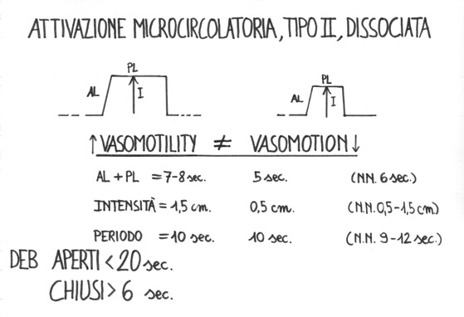
Fig. 4

Let’s try to illustrate, in a better way, this essential concept. EBD contraction, i.e. the contraction of its muscular cells, at the base of mean ureteral reflex (= arteriolar opening), brings about blood flow increase in the capillaries, microcirculatory stasis and, then, if lasting, possible hypertensive damage of related capillay net, and subsequently dilation at first, and, therafter, basal membrane thikening. In case of microcirculatory activation type I, associated, EBD contrbute significantly to increasing materia-energy-information supply to parenchymas, according to the physiological behaviour.
On the contrary, microcirculatory activation type II, dyssociated, in which vasomotion is reduced, is always associated to EBD dysfunction (= D 16 sec. , I ≤ 1 cm., residual ureteral reflex ≥ 0,5 ≤ 1 cm. time of reflex disappearance < 6 sec.), indicating pathological local micorcirculation: microcirculatory maldistribution of blood flow, according to S.B. Curri.
Likely, typical vasomotion behaviour of dyssociated activation, type II, pathological (Fig. 4), represents a defence mechanism against increased endocapillary pressure. In other words, one may suggest the hypothesis that the lowered vasomotion, secondary to blood increased supply (increased vasomotility) to capillary net or microcirculatory maldistribution, could be caused by a less elastic, more tonic state, with subsequent functional damage of endothelial as well as myocellular mitochondria of EBD and of local microvascular wall, icluding local periangium, under these circumstances edematous. As a matter of fact, the above-described micorcirculatory situation ends into interstitial obstruction, first, and susequently into basal membrane thickening of capillaries themselves.
From the above remarks, it does exist a strict relation between “vasomotion” and EBD behaviour, under physiological and pathological conditions, and the abnormalities of EBD is counterbalanced, for months or years, by the increase only of vasomotility, which aims to preserve a physiologic vasomotion (dyssociation); this fact explains the importance of such structures as regards the regulation of microcirculatory blood-flow, we corroborated clinically for the first time.
In case of chronic disease, i.e. diabetes mellitus (pancreas), dyslipidaemia (abdominal adipose tissue), myxedema (thyroid), hischaemic heart disease (heart), arteriosclerotic involutive cerebropathy (brain), a.s.o., the stimulation of related trigger-points (between brakets) by mean-intense digital pressure, beside other stage-dependent alterations of both vasomotility and vasomotion, allows to observe mean ureteral reflex (EBD) of duration of ≤ 16 sec. (NN=20 sec.), intensity ≤ 1 cm.(NN≥ 1,5), residual ureteral reflex ≥ 0,5 ≤ 1 cm., reflex disappearing time > 6 sec. and preconditioning pathological.
The parameters pathological values of the reflex characteristic of EBD, by themselves give evidence of a disease, potential or actual, of thr evaluated biological system, whose seriousness their degrees parallel.
An example: cutaneous, persistent, and mean-intense pinching of VI thoracic dermatomere (the skin immediately below costal arch at right and/or left, in the epigastrium) in healthy, brings about mean ureteral reeflex with normal parameters values: I ≥ 1,5 cm., D = 20 sec., I ≥ 1,5 cm., D = 20 sec., minimal or absent residual reflex, and duration of reflex disappearing = 6 sec.
On the contrary, starting from IGT, in case of glucidic dysmetabolism, reflex parameters result pathologically modified in a direct relation to disease seriousness.
Interestingly, as regards diagnosis and “quantification” of the disorder, e.g. diabetes mellitus, as in our case, the preconditioning (second performance of the maneouvre after 5 sec. from the former) does not cause any amelioration in initial stage, or provokes clear worsening in overt disease, i.e., parameters values persist unchanged or, respectively, appear altered after disease onset.
Vasomotion fluctuations (lower ureteral reflex = nutritional capillaries and venules), in realation to local EBD function, are physiologically more intense after the appearance of mean ureteral reflex, due to increased blood supply to capillary net.
On the contrary, in the course of chronic diseases, when can be present at basal line the above-mentioned microcirculatory maldistribution, and susequently capillary dilation, there is not vasomotion increasing after EBD attivation, since they are involved by degenerative phenomena in this stage.
Physiological EBD behaviour, activated by mean-intense stimulation, both direct and my means of related trigger-points (i.e. the trigger-points of the biological system to be examined), account for the reason that tissue blood-flow is increased, if such stimulation from “light” becomes rapidly mean-intense: AVA, functionally speaking, are disactivated, and obviously EBD are activated, in order to convey a more quantity of blood to micrcyrcle.
The “test of two pressure” is based on these interesting microcirculatory events, which explain the absence of necrosis of foots plants, when an individual is in orthostatic position for long time.
At this point, appears clear the value of EBD preconditioning, mentioned above, which consists in the evaluation of these structures, repeated subsequently three time with 5 se. interval,: in healthy, parameters values ameliorate, while, in case of dysfunction of the same structures, are going on worsening, although in initial stage the values can persist identical to those at basal line.
To summarize, among numeorus parameters of EBD, we are to consider particularly the data, gathered by preconditioning, which proved to be essentially useful in detectng an initial abnormality, by means of this efficacious dynamic test.
From the above remarks appears clearly that the refined regulation of microcirculation is fascinating and fine; already at rest, but particularly under stimulation condition, all microcirculatoy structure necessarily must be under uppermost conditions in order to perform their complex and harmonious work, unavoidable in normal tissue blood-supply.
As a matter of fact, we have to cosider all microvascular components in a total manner, from the functional view-point, i.e., aiming to provide promptly the physiological blood to local parenchyma, under both basal and, particularly, stress conditions, as allows to state plainly Biophysical Semeiotics, outlining the scientific truth of the term tissue-microvascular unit.
In conclusion, based on clinical and experimental evidence, referred above, we forsee that, hopefully in next future, a new branch of Clinical Microangiology, and suggest to term it Biophysical-Semeiotic Microangiology of Endoarterial Blocking Devices.
From the above remarks it appears clear that A. Krogh was right, when stated that the microangiology, one day, will reveal a precious tool in both diagnosis and research, not only useful in angiology, but also in every field of Medicine.
Our clinical researches corroborate the correctness of this bright statement of one of the most skilful physicians of microangiology of all time.

