DIABETIC DIAGRAM OF TISSUE-MICROVASCULAR UNIT.

After the detailled description of physiological diagram tissue-microvascular unit (tmv.u) of nail-fold, finger-pulp, a.s.o., in the following articles I am going to describe the most common diagrams of tmv.u, “typical” of the most frequent and common human diseases, doctor faces in day-to-day practice, in order to underline the usefulness of the original physical semeiotics from the diagnostics, therapeutic monitoring and research viewpoint.

Due to its unquestionable importance, it is illustrated at first the diabetic diagram, which shows “characteristic” modifications since diabetic syndrome initial stage and it progressively becomes so significant and full of information, to allow directly a physician to make the correct diagnosis of diabetes in advanced stage, i.e., after disorder occurrence.

IGT DIAGRAM.

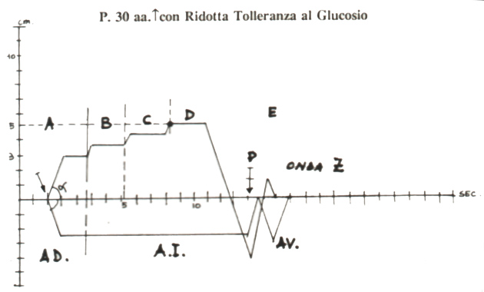

Fig.1

In tissue-microvascular unit diagram of a patient with “initial” IGT, latency time (lt) is still normal (NN = 6 sec.), while in evolutive diabetic phases (Fig. 1), lt is lowered to 5 sec. (= hyperglicemic episodes, even short and/or isolated, preferebly in post-prandial stage), A Phase is “characterized” by wide dilation area (DA) (= dilation of nutritional capillaries), gastric aspecific reflex shows an intensity ≥ 2,5 cm.(NN 1-2 cm), that is reached in 1 sec., as the angle α > 45° clearly indicates.
Interestingly, the angle α is > 45°. Microvessels dilation, due to hyperinsulinemic hypoglycemia, which occurs sporadically, starting from 1 h. after meals, i.e., in the absorptive state, disappears after apnea test lasting 5 sec. (= reduced insulin secretion) as well as after 10 mgr. Nifedipine, sublingually administered.
This modification of microvessels diameter is sufficient to provide tissue both O₂ and substrates.
In fact, subsequent three phases show physiological behaviour: A phase whit the upper line, normally “horizontal”; critical point (PC) of 5 cm. in D phase; duration of every phase of a 6 sec.; lt of tGC appearing and disappearing and the presence of Z wave show that tissue-microvessel unit is practically unchanged from the structural view-point (= functional diabetic microangiopathy, according to Ditzel).
At this point, obviously, doctor has to evaluate all biophysical-semeiotic signs, reliable in early recognizing IGT: pancreatic preconditioning, “vasomotion” assessement, both pancreatic and periheral, in the post-absorptive state as well as in absorptive state.
During such a state of initial glycemic dysmetabolism – CP 5 cm. in D phase and Z wave present in the diagram – a correct diet, ethymologically speaking, brings about complete disappearance of tissue-microvascular unit diagram alterations.
Contemporaneously, we observe the return to the normal stage, as far as their complete disappearance, of the numerous biophysical-semeiotic signs, characteristic of “initial” phases of diabetes mellitus.
In fact, insulin receptor sensitivity becomes normal if body weight is similar to “ideal” weight; histangic acidosis and/or lipidic dysmetabolism, always present when evaluated by means of the Biophysical Semeiotics (= adipose central tissue preconditioning), independently from lipidemic blood concentrations, disappear; the later is often present, although slight, due to the negative influence of both acidosis and lipid elevated blood levels (particularly tryglycerides) on insulin receptor sensitivity.

Diabetic diagram.

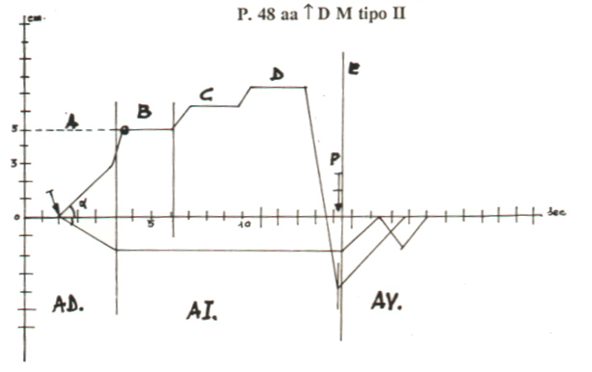

Fig.2

The figure shows clearly the latency time < 6 sec., related to raised glycemia values, A Phase is characterized by “ascending” line, PC (°) location is in B Phase, which lasts < 6 sec. (essential parameter in assessing glycosilated proteins), dilation area (AR) as well as ischaemia area (IA) really large, intense impairement of “vasootion” area (VA).
Interestingly, the gastric aspecific reflex appears slowly after 5 sec.lt, so that we observe the typical “ascending” line of A Phase, which is a characteristic sign of overt diabetes mellitus. Under the abscissa cholecystic-choledocus reflex behaviour is referred.

The characteristic sign of “diabetic” diagram, which allows by itself to make at the bed-side correct diagnosis, is the slow occurrence of gastric aspecific reflex, that lasts for the entire A phase (= microvessel wall stiffened by storage of PAS-positive material as well as local connectival synthesis) (Fig.2).
Therefore, its diagnostic value is realy remarkable: typical appears to be the slow transition from A Phase to B Phase, without the physiological horizontal line. Such as behaviour is observed exclusively in case of type 1 and type 2 DM,.

Analogously, it should be noted that the behaviour of lymphatic diagram first phase (that I will describe in a future paper), as Bilancini-Lucchi’s sign shows (See Glossary in the site), is the same, indicating clearly internal as well as external coherence of biophysical-semeiotic theory: after lt < 10 sec. (NN = 10 sec.), in relation to DM seriousness, initiating from the application of “light” digital pressure on internal suface of middle third of an arm, the lymphatic diagram, i.e., gastric aspecific reflex, occurs, which is realized slowly, in a long time, as we have observed in tmv.u diagramm as far as A Phase is concerned.
Therefore, DA of an intensity ≥ 2 cm., also due to amyloid deposit in interstititum (See article on the site) , is closed in its upper side, particularly at the end, by an “ascending” line, which appears to be more steep, due to the absence of Phase A physiological, horizontal tract, in relation to the seriousness of diabetic syndrome. Consequently, α angle is < 45°.
In addition, Critical Point CP appears shifted to left, localized mostly in initial part of B, and it is always less intense than subsequent reinforcements of gastric aspecific reflex: verticalization with shifting to left.
Obviously, the presence of ATS increases the pathological “verticalization with shifting to left” of tissue-microvascular unit diagram.
It is easy to understand that vasomotion area (VA) appears noteworthly compromised, even in patient with properly controlled NIDDM, even only by diet (Fig. 2): tGC is “fast” and disappears “slowly” (O₂RT > 2 sec.), after digital pressur interruption: Z wave absent.
From the diagnostic point of view, interesting is tissue-microvacular unit diagram od IDDM (Fig. 3).

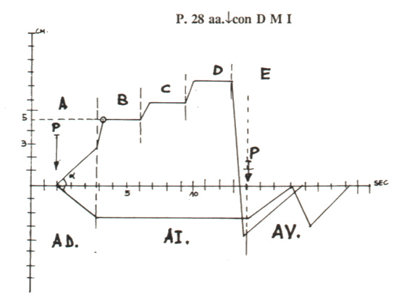

Fig.3
Figure shows t.mvu. diagram in type I diabetes mellitus. The behaviour of A phase is really characteristic with upper line “ascending” and raising particularly sharply in the final segment. Intersestingly the duration of B Phase (NN = 6 sec.) appears reduced in relation to increasing of glycated haemoglobin.

Once again lt is shorter than normal (< 6 sec.) and gastric aspecific reflex initially is slow and, then, rapid, lasting for the entire duration of A Phase, closed by an upper “ascending” line in a typical manner; characteristically, moreover, there is the fast final increasing exclusively in diabete mellitus as well as in more severe case of IGT; α-Angle is < 45°. DA is larger, so that CP of 5 cm. is localised in the beginn of B Phase and afterwards the line keeps going higher: verticalization whit shifting to left.

The duration of B Phase (NN = 6 sec.) appears smaller than normal, in relation to diabetes decompensation, i.e. as much greater is glycosilated haemoglobin
Due to the failure of post-ischemic reactive hyperemia, tGC occurs in less than 2 sec., and its disappearing is realized slowly (O₂RT > 2 sec.); Z wave is absent (Patient of Fig. 3 was 28 years old!).
In other words, the illustrated diagram allows doctor to make the correct diagnosis of DM, showing an intense impairement of tissue-microvascular unit, for example, of finger-pulp or nail-fold, caused by stiffned, dilated vessels (large DA), where, therefore, both microcirculation and gas exchanges are intensively compromised: diagram verticalization and shifting to left.
Interestingly, at this point, in patient with IDDM there is not the storage of amyloid in Langheran’s islets interstitium, so that pancreatic-“in toto” ureteral reflex is normal (< 1 cm.) unlike NIDDM, where interstitium is very largen since initial stages.
In addition, the accurate assessement of pancreas – central organ – and peripheral organs (lever, muscle, central and peripheral adipose tissue) vasomotion allows doctor to recognize the DM, due the more or less intense discrepancy between duration values of AL + PL, in both absorptive-state and post-absorptive state.
Before the conclusion of “diabetic” diagram illustration it is necessary to underscore the importance of latency time: lt (NN = 6 sec.) is approximately correlated with blood glycemic level in inverse manner, while B Phase duration (when < 6 sec.; NN = 6 sec.) appears inversely related to glycosilated haemoglobin, which can be evaluated for the first time at the bed-side in a really reliable way.
The reader can overlook the patho-physiological mecanisms, surely fascinating, underlying such very interesting relations, really useful from the “clinical” view-point, due to the fact that I have preferred a “pragmatic” description of these events.
However, it is sufficient to know that the short lt as well as A Phase behaviour are related to capillaries dilation and stiffeness, as well as to early amyloid deposit in interstitium, due to histangic suffering, caused by hyperglycemia, and the short B Phase is related with thickening of capillary basal “membrane”, brought about also by glycation phenomenon.

