TISSUE MICROVASCULAR UNIT DIAGRAMS OF THE MOST COMMON HUMAN DISEASES.

Conclusive considerations.

Introduction. 1
Some of the most frequent tissue-microvascular unit diagrams. 1
A) Arteriosclerotic diagram. 1
B) Rheumatic diagram. 2
C) Iron deficiency diagram. 2
D) Flu diagram. 3
E) Microcirculatory stasis diagram. 4
Tissue-microvascular unit in clinical research. 6
Conclusive considerations on tissue-microcirculatory unit diagram. 6
Bibliography. 8

Introduction.

In this article, some interesting tissue-microvascular diagrams, doctor usually observes in everyday practice, are fully described. Not all graphics will be showed, since for learned reader, who have studied former papers of this original semeiotics, is really sufficient to consider the tissue-microvascular unit of healthy. (1)

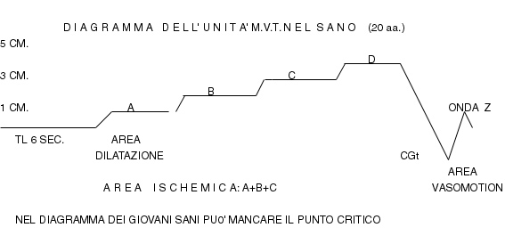

Fig. 1

Tissue-microvascular unit diagram in healthy.
Latency time (TL) is 6 sec. and critical point (PC = 5 cm.) is absent. Z wave is clear.

Some of the most frequent tissue-microvascular unit diagrams.

A) Arteriosclerotic diagram.

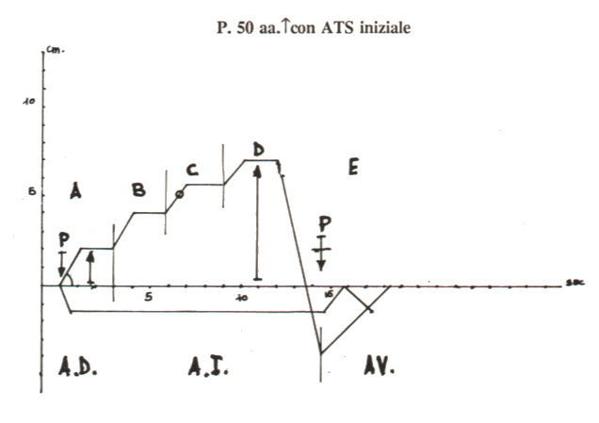

Fig.1.
Patient, 50 year old, with initial ATS.
Both verticalization and shifting to left of PC(°) indicate aspecific histangic disorder, showed also by diagram highest intensity (> 5 cm.) as well as by clear alteration of vasomotion area (AV), where Z wave is absent. In addition, somach slowly comes back to basal size at the end of examination, soon thereafer digital pressure swift interruption (O₂ Recovery Time 4 sec.).

Considering the figure 1, i.e., the diagram of a patient 50 year old with initial ATS, it is surprising latency time (lt) shorteness, Phase A intensity, and consequently AD width in relation to patient’s age (50 years). The α angle is 45° so that diagrams shows the so-called phenomenon of “verticalization and shifting to left of critical point (PC = 5 cm.) already localized in the initial part of C Phase.
In addition, tonic Gastric Contraction (tGC) appears rapidly but disappears slowly; Z wave is absent and O₂ Recovery Time is prolonged (NN = 2 sec.).
Altough the patient seems healthy, i.e., symptomless, the diagram reveals a definite disorder of tissue-microvascular unit, circulatory in nature: microvessels are dilated and stiffen, both flow- and flux-motion are reduced, suggesting unavoidably a correct diet, ethymologically speaking, as well as hemoreological and vaso-active drugs, associated possibly with hypolipidemic agents.
At this point, we would like to put reader’s attention on “early” impairment of microcircle in arteriosclerosis, as shown in the diagram, corroborating our previous statements (1, 2, 3), and our “arteriosclerotic microcirculatory theory”, illustrated in the site, HONCode 233736, www.semeioticabiofisica.it/semeioticabiofisica.
Diagrams are varyng, of course, from patient to patient, in relation to severity, stage, and nature of underlying diseases. Therefore, there are a large number of shades: in overt ATS both A and B Phases are large, lt is short and, particularly, tGC disappears slowly (= O₂RT).

B) Rheumatic diagram.

Now-a-days Acute Rheumatic Arthritis (ARA) is actually more frequenth than generally admitted; lacking laboratory data, which can be in normal ranges as allows me to state my 45-year-long clinical experience, bed-side recognizing ARA is very difficult, at least in initial phase, when the proper treatment could permitt to obtain the best results.
Like in all others connective disorders – LE, AR, CREST, a.s.o. – also in case of ARA diagram is characterized by an intense C Phase, that occurs rapidly. Latency time (lt) is short (< 6 sec.), while A and B Phases are normal. Further alterations are both the verticalization and shifting to left of PC of 5 cm., beside altered E Phase, in which Z wave is absent.
The rheumatic diagram is so characteristic that allows doctor to make the correct diagnosis of the disease “nature” (4); other numerous biophysical-semeiotic signs subsequently permitt to make the proper diagnosis or, at least, to recognize the patients, who must undergo rationally to further examinations, including those of laboratory.
Notoriously, very often it is present iron deficiency syndrome, characterized by intense B phase, which is brought about rapidly (5).
In conclusion, a diagnosis really difficult, is easy and promptly made at the bed-side by means of a clinical tool, really reliable, i.e., tissue-microvascular-unit diagram, which helped us in recognizing and describing the Acute Benigne “Variant” Polymialgia Rheumatica (4, 6).

C) Iron deficiency diagram.

Of paramount importance is the tissue-microvascular unit diagram in case of iron-insufficiency syndrome as well as of anaemia of whatever nature. In fact, under these conditions, B Phase is particularly width and it appears rapidly. In addition, all others known alterations are present, indicating an aspecific histangic disorder: “verticalization and shifting to left” of the diagram, in which tGC occurs quickly, but disappears in a really slow way.
In young patient a small Z wave is generally present, because their microvessels, structurally normal, are physiologically elastic.

D) Flu diagram.

Flu diagram proved to be, in a long „clinical“ well-established experience, very useful and reliable at the bed-side in making the correct diagnosis of flu; such as diagnosis is often really difficult, for instance during the days before its onset, as well as when clinical symtomatology disappeared since a few days (1, 2, 8, 9).
In fact, more often patient present with general malaise, erroneously considered, and the proper diagnosis is possible with the aid of specific diagram, even a week after disease onset, when clinical phenomenology is not always present or characteristic.

In case of flu and viral diseases, Phase D is characteristically high (≥ 3 cm.), and its realising is rapid, already present in initial, symptomless phase, when “uncomplete” RESHS, acute antibody synthesis, Domenichini’s sign with 7 sec. duration, and Daneri’s sign of 3 cm., are all absent.
On the contrary, in case of bacterial infections, B Phase is high, and sometimes also C Phase. These signs are easier evaluated by utilising stress tests, e.g., Restano’s Manoeuvre (See Glossary, in the site), generally soon therafter doctor recognizes characteristic alterations of diagram, i.e., intense C Phase.
“Verticalization and shifting to left” of the diagram are present, of course, as well as E Phase alteration (Vasomotion Area = AV), whereas Z wave persists generally only in young.
The diagnosis of flu, very often difficult to make, especially in absence of the known clinical symptomatology, which can occur after a few hours, or in case of atypical phenomenology (vertigo, exspecially in patienys who underwent recently to cerebral surgery due to intraparenchymal hemorrage or post-traumatic sub-dural hematoma: two personal cases), abdominal syndrome with vomiting and dyspepsia, thoracic e/o precordial pain, which cause usually patient’s admission to hospital.
Consequently, the presence of typical biophysical-semeiotic signs, particularly the characteristic tissue-microvascular unit diagram, allows doctor to make the correct diagnosis in the interest of patient, physician and NHS (= less prescription of drugs, e.g., antibiotics, as well as laboratory investigations).
The characteristic flu diagram, without contemporaneous presence of intense, high, B Phase, indicating bacteria in the tissues, does not advice to doctor antibiotic prescription, surely not useful at this moment, perhaps dangerous, which, on the contrary, are absolutely necessary when B Phase is high (sometimes also C Phase), in presence of “complete” RESHS as well as Domenichini’s sign, lowered from 7 sec. to 4,5 sec. , in a subsequent time (9, 10) (Table 1)

U.MVT DIAGRAM: DIFFERENTIALE DIAGNOSES

IGT, DM: INTENSE A PHASE, SLOW FULFILMENT

Fe-DEFICIENCY SYNDROME : INTENSE B PHASE (ABSENT RESHS)

BATTERIC INFECTION : INTENSE B PHASE (PRESENT RESHS)

AAR AND CONNETTIVITES: INTENSE C PHASE

FLU VIROSIS : VERY INTENSE D PHASE
Tab.1

E) Microcirculatory stasis diagram.

The microcirculatory stasis diagram, described in following, is really interesting. In microcirculatory stasis, for instance, in case of venous insufficiency of legs, A Phase is particularly large, due to venular, capillary, and arteriolar dilation: PC is shifted to left accompanied by the diagram verticalization. At the end of D Phase, moreover, tGC fulfilment is rapid, because of severe histangic acidosis. Finally, O₂ Recovery Time (O₂ RT), assessed as time, in seconds, necessary for tGC disappearing, immediately after the swift interruption of digital pressure, occurs really in a slow way, due to the venous stasis (TRO₂: NN = 2 sec.) (Fig.2).

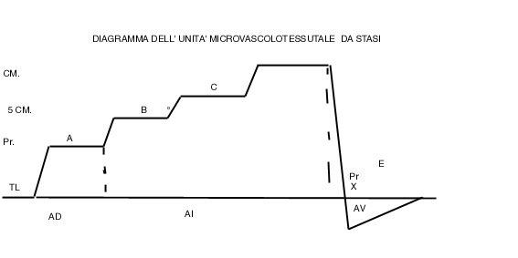

Fig.2
Tissue-Microvascular-Unit Stasis Diagram.
Explanation in the text.

All parameters values of referred diagrams, characteristic of different pathological condition, I underlined from time to time, are directly or indirectly correlated with the numerous biophysical-semeiotic signs, typical of diverse diseases, indicating, once again, internal and external coherence of the theory. As referred previously elsewhere (“Introduction to Biophysical Semeiotics”, in press), the coherence of a theory, does not represent the “truth”, but it is its conditio sine qua non.
In the histangiopathic hypotonic congenital flebopathy (11, 12), starting from the initial state (A type), is present microcirculatory stasis, revealed by large A phase of tissue microcirculatory unit diagram.
Moreover, doctor observes really interesting data, referred in the literature. Of course, lt of both skin-caecal and –aspecific gastric reflex appears intensively less to normal value (NN = 8 sec.) in relation to the severity of stasis. Such as datum is in practice interesting, for instance, in case lt does not augments after Valsalva’s manoeuvre: it indicates that comunicating veins persist open.
From the above-referred remarks one understands clearly the paramount importance of the accurate bed-side investigation of these diverse diagrams, because of their diagnostic value.
In reality, the referred examples allow doctor to realize that the new diagnostic way, brought about by routinary use of tissue-microvascular unit diagrams of digital pulp in the course of the normal physical examination, will proved its paramount usefullness.
In addition, following statement is well-grounded: regarding human body, digital pulp is like soul for the eye.
At this point, it is necessary remember an useful consideration on the outcomes of the accurate analysis of tissue microvascular unit diagram.

Tissue-microvascular unit in clinical research.

The “physiological” cutaneous and sub-cutaneous microcirculation of the leg is clearly varying from are to area, as the location of phlebopatic ulcers on internal surface of III inferior of leg demonstrates, in consequence of diverse structure, correlated directly with related function. Doctor, therefore, must consider such local circulatory patterns in both research and day-to-day-practice.
In healthy, in fact, there is a clear-cut difference between tissue-microcirculatory unit diagram of internal surface of III inferior of leg and that of III internal, both median and upper: verticalization and shifting to left, although of small intensity, are present exclusively in the first diagram.
Such as difference is more clear, obviously, in the venous insufficiency of lower limb, particularly in diabetic patient. Hypossia, oedema, hemorrage (Bateman’s sign), infiltration are underscored by a more intense C area. Moreover, A Phase shows the typical “diabetic” behaviour, characterized by the ascending tract of the linea closing A area, which physiologically is horizontal.
In a few words, when hemoderivative activity is more intense and, at least in some positions, is present “arteriolar blood venous-transformation” and, therefore, latency time of caecal as well as splenic reflex is lowered (< 8 sec.), doctor observes in tissue-microvascular unit diagram the “verticalization with shifting to left “ of PC, and a large C Phase, indicating the real relation between diagram different components and microcirculatory, biochemical, metabolic and molecular-biological events of local histangium.
The diagrams of internal and external cutaneous and sub-cutaneous area of the III inferior part of leg are different in a clear-cut way, more apparent during muscle movements, showing the microcirculatory difference of local microcirculation.
In conclusion, internal malleolar area, even in healthy, shows altered blood-flow at rest as well as during various stress tests because of compromised microcirculatory functional reserve.

Conclusive considerations on tissue-microcirculatory unit diagram.

At the bed-side, in a easy but reliable manner, Biophysical Semeiotics allows doctor to evaluate both the “morphology” and the function of tissue-microvascular unit, e.g., of nailfold and digital pulp, by means of the original observation of qualitative and quantitative modifications of various parameters of gastric aspecific reflex, as well as those of subsequent reinforcements, and, finally, of tonic Gastric Contraction, during digital pressure, applied on these tissues.
Gathered at the bed-side, these results allow doctor to draw the microvascular diagrams, which proved to be really valuable in giving physiogical as well as pathological information.
Doctor is able to obtain tissue-microvascular unit diagram tranferring, even mentally, the values of diverse parameters of gastric aspecific reflex and its subsequent modifications upon cartesian axes system, according to the described original method.
These results, of course, are more complete if doctor can assess also all other interesting biophysical semeiotic data, as caecal, choledocus-cholecyst (referred below the abscissa reflex in Figg.1, 2, 3), splenic, upper ureteral reflexes, antibody syndrome, RESHS, the vasomotion, a.s.o.
In fact, mean microvessel diameter, modified by digital pressure, is paralleled by the intensity of gastric aspecific reflex of A Phase (and by cholecyst-choledocus reflex as well as upper ureteral reflex), according to the synergetic model, now known to reader,
The information, given by E Phase, which appears soon therefater the reflex disappearing after pressure rapid interruption, corroborates such as paramater; in healthy, reflexes appear a second time showing the same intensity lasting a few seconds, and, than, transiently become more intense, causing the Z wave, which indicates the transitory and physiological dilation of capillaries and post-capillaries veins, brought about by the “wave” of blood-flow during the reperfusion.
The velocity of both reflex and its various enhancements fulfilment is correlated with the conditions of blood-flow as well as the elasticity of microvesels. In fact, experimental evidence demonstrates that Z wave is absent also in healthy if digital pressure is “slowly” interrupted, so that blood-flow velocity is reduced, like under a pathological condition, when O₂RT results > 3 sec. (NN = 2-3 sec.).
The pattern of the diverse phases of “anaerobic” glicolysis gives information on physiological blood-flow at rest among tissue-microvascular unit and on efficacy of local histangium mitochondrial function. For instance, in a young involved by IGT and hypoglicemia due to slow and prolonged insulin secretion (starre Insulin-Sekretion, according to german authors), microvessel compensatory dilation (= A Pahse gastric aspecific reflex, choledocic-cholecyst reflex, and upper ureteral reflex) augments in order to provide related parenchyma, in initial phase, O₂ and various compounds in a physiological way.
In reality, such biological events are more complex, because of the activation of local vasomotility and vasomotion, firstly of type I, associated, and subsequently of type II, dyssociated, while interstitium is initially reduced: “in toto” ureteral reflex ≤ 0,5 cm. (See the site www.semeioticabiofisica.it/microangiologia). In fact, the subsequent biophysical-semeiotic phases occur in a regular way: highest intensity of the gastric aspecific reflex 5 cm., with PC physiologically present in D Phase.
On the contrary, in ATS, even initial, we observe augmented microvessel dilation (intense AD), followed by clear-cut pathological phases (highest intensity of gastric aspecific reflex > 5 cm., PC shifted to left with verticalization of the diagram, large interstitium, as “in toto” ureteral reflex > 0,5), i.e., tissue acidosis, which happen quickly, to demonstrate that vasodilation is accompanied by slowing down and stasis of blood in microcirculatory bed, followed by alteration of O₂, CO₂, and various substartes exchange in local histangium.
Once again, we must remember that the nature of referred parameters, related to tissue-microvascular unit, is twofold: hemodynamic-hemorheological and metabolic-biochemical. In addition, they provide information on biological functions of related tissues in a really precise manner.
If all these data are transferred upon a system of cartesian axes, even in the mind, one can draw the original diagram, which represents a clinical tool of paramount importance, very useful in diagnostics, research, and therapeutic monitoring. In fact, there are typical diagrams of the numerous and common human diseases, which facilitate bed-side recognising them, in an easy and rapid way, since initial and symptomless stages.
The illustrated diagrams, therefore, represent an original and useful clinical tool, doctors will ameliorate surely in next future. In fact, biophysical-semeiotic diagram – we forsee it – will be a component of patient’s physical examination, when it will be completely understood in all it particulars.
We are really delighted with diagram’s descovery, since to our “metaphysical” intuition has followed a logic deduction, illustrated, then, to readers in a hopefully clear way, useful in both practice and research.
Oncological diagram of tissue-microvesssel unit is illustrated and analysed in detail in this site in “Biophysical-Semeiotic Constitutions”.

Bibliography.

1) Stagnaro-Neri M., Stagnaro S., Auscultatory Percussion Evaluation of Arterio-venous Anastomoses Dysfunction in early Arteriosclerosis. Acta Med. Medit. 5, 141, 1989
2) Stagnaro-Neri M., Stagnaro S. Indagine clinica percusso-ascoltatoria delle unità microvascolotessutali della plica ungueale. Acta Med. Medit. 4, 91 , 1988.
3) Stagnaro-Neri M., Stagnaro S., Modificazioni della viscosità ematica totale e della riserva funzionale microcircolatoria in individui a rischio di arteriosclerosi valutate con la percussione ascoltata durante lavoro muscolare isometrico. Acta Med. Medit. 6, 131-136, 1990
4) Stagnaro S., Auscultatory Percussion of Rheumatic Diseases. X European Congress of Rheumatology. Moscow. 26 June-July, Proceedings, pg 175, 1983
5) Stagnaro S., Auscultatory Percussion Therapeutic Monitoring and Cerebral Dominance in Rheumatology. 2nd World Congress of Inflammation, Antirheumatics, analgesics, immunomodulators. Abstracts, A. Book 1, pg. 116, March 19-22, Montecarlo, 1986
6) . Stagnaro S., Polimialgia Reumatica Acuta Benigna Variante. Clin. Ter. 118, 193 (Pub-Med indexed for Medline)1986
7) Stagnaro-Neri M., Stagnaro S., Il diagramma linfatico dell’arto superiore nella diagnosi clinica percusso-ascoltatoria del diabete mellito. III Congr. Intern. Di Flebolinfologia. Ferrara-San Marino, 18-21 Settembre. Atti 21-11, 1991.
8) Stagnaro-Neri M., Stagnaro S., Il diagramma venoso nelle arteriopatie obliteranti periferiche. Atti Congr. Naz. Soc. It. Flebologia Clinica e Sperimentale. Firenze 10-12 Dicembre 1990. A cura di G. Nuzzaci, pg. 169, Monduzzi Ed. Bologna,1990
9) Stagnaro S., Polimialgia Reumatica Acuta Benigna Variante. Clin. Ter. 118, 193, 1986 (Pub-Med indexed for Medline)
10) Stagnaro-Neri M., Stagnaro S., Semeiotica Biofisica del torace, della circolazione ematica e dell’anticorpopoiesi acuta e cronica. Acta Med. Medit. 13, 25, 1997
11) Stagnaro-Neri M., Stagnaro S., Radicali liberi e alterazioni del microcircolo nelle flebopatie ipotoniche costituzionali. Min. Angiol. 18, Suppl. 2 al N. 4, 105, 1993.
12) Stagnaro-Neri M., Stagnaro S., Flebopatie Ipotoniche Istangiopatiche. Min Angiol. 19, 57, 1994

