BIOPHYSICAL-SEMEIOTIC DIAGRAMS.
MICROCIRCULATORY ACTIVATION.

INTRODUCTION.

Biophysical-semeiotic diagrams, discussed in this introduction to the original, fascinating and useful clinical tool of investigation, provide really a lot of information, reliable in bed-side diagnosing, prevention, both primary and secondary, as well as in the therapeutic monitoring. Doctor can apply them, of course, to all biological system, but in particular to finger-pulp microcirculatory bed (See later on).

Based on a 45-year long experience with the new physical semeiotics, in my mind, the finger-pulp histangium is for human body what the eye is for soul.

Analogously with the events of ECG as well as EEG waves, in such wonderful geometrical designs is written the actual and future state of an individual, even apparently healthy, in whose histungium, however, occur pathological biological-molecular events, genetically ruled, which arise at clinical level and therefore become observable by physician at the bed-side by means of microcirculatory abnormalities, assessed by Biophysical Semeiotics.
In other words, a large variety of pathological processes, initiated years or decades before their clinical phenomenology, e.g., diabetes mellitus, as referred often in bmj.com (Bed-side primary prevention is the major step in the war against diabetes mellitus.10 June 2001. The best therapy of diabetes mellitus, type 2, and its complication is the primary prevention, 26 October 2001, and subsequently in the same site: Primary Prevention of NIDDM by Clinical Methods, 17 March 2002), for the first time are recognized clinically, when the patient apparently is healthy and performs regularly hes daily activity.
Starting from the end of ’80 years, interpreting correctly and utilizing properly the ureteral reflexes, we succeded in transorming in a “geometrical” way the deterministic-chaotic activity of microcircle of all biological systems, under both phsiological and pathological situations (1, 2, 3), “suggesting”, thus, a new and unusual way to “clinical” investigation of tissue-microvascular unit structure and function, and consequently of related parenchyma.
Really, in that time we thought that a biological system, e.g., the microcircle, so well developped in a refined manner, could react to damage, different in origin, in a “monotonous” way, which would account for the reason that doctor can not recognize early and “quantitatively” neither the abnormalities onset nor their underlying causes.
As a matter of fact, every structure, finely developed, as the various components of microvessels, has only steady responses, even under different circumstances.
Fortunately, our forecasts were all wrong and the bed-side study of microcirculatory system, possible by the new physical semeiotics (obviously, in years ’80, we were speaking of Auscultatory Percussion Reflex-Diagnostic), proved to be precious also when applied to clinical diagnosis in all Medicine disciplines and not exscusively restricted to vascular diseases: Krogh was right (See site www.semeioticabiofisica.it/microangiologia).

Biophysical Semeiotics allowed, infact, to carrying out Krogh’s prophetic intuition.

In reality, clinical microangiology is essential not only to angiological diagnostics, but also to early bed-side recognizing the most common human diseases, involving all biological systems, apart from their origin.
Among numerous and different clinical-microangiological tools, a primary role is played by biophisical-semeiotic diagrams, “microvascular” as well as “macrovascular”, which can be subdivided in five groups:

1) tissue-microvascular unit diagram;

2) lymphatic diagram;

3) venous diagram;

4) arterial diagram;

5) various biological systems diagram: cardiogram, renogram, pancreogramm, hepatogram, surrenogram, a.s.o.

In following we are going to examine definition and significance of the diagrams in general, in order to comprehend completely the clinical importance of such tools in day-to-day practice, when both laboratory and sophysticated semeiotics data are lacking.

Definition and significances of the diagrams.

We can define biophysical-semeiotic diagrams as geometrical designs of the parametric values of gastric aspecific reflex and its subsequent enhancements, brought about by digital pressure upon tissue-microvascular unit of finger-pulp, femoral vein at groin, superficial lymphatic vessels, e.g., at the level of internal surface of arm, and finally of an artery, e.g., brachial artery.
Doctor carrys out a diagram by translocating parameters values on Cartesian axes system. On the ordinate, in cm., is transferred the intensity and on abscissa, in sec., the latency time of gastric aspecific reflex as well as its re-inforcements and their duration (Fig. 1).

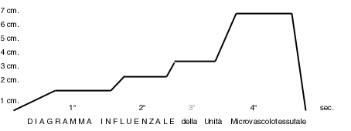

Fig.1
Flu diagram of the finger-pulp tissue-microvascular unit.

Figure shows gastric aspecific reflex behaviour during digital “mean-intense” pressure applied on a finger-pulp of an individual lying down in supine position, involved by flu: lt of 1° reflex is short (4-5 sec. versus 6 sec.in physiological condition); 4° reflex appears very intense, indicating characteristically a flu episode, starting from initial and symptomless stage. Figure does not show the tonic Gastric Contraction after the end of phase 4, followed by a final, small gastric aspecific reflex (Z wave), caused by interruption of the pressure on finger-pulp, i.e the return of the stomach to its initial size in 2-3 sec. (Oxygen Recovery Time: ORT).

Surely, the reader can observe in flu diagram that such as tools open new ways, unknown untill now, and, thus, really original and clearly interesting as well as useful in clinical assessement of biological systems, whose results prove to be very helpful in day-to-day practice.
With regards to this argument we underline an important aspect of biophysical semeiotic diagrams application in day-to-day practice, following flu diagram example: flu diagnosis is often very difficult to be made from the clinical and laboratory view-point, in particular if clinical phenomenology is misleading, as it happens frequently: vertigo, lipothymia, nausea, vomiting, with or without diarrea, precordialgia, a.s.o.
In addition, in single patient pre-existing pathological conditions, e.g., recent subarachnoidal or intra-parenchymal cerebral hemorrhage surgical intervention, confuse diagnostic procedure at the bed-side (personal cases).
Now, to diagnose correctly flu is sufficient the diagram of finger-pulp tissue-microvascular unit (Fig.1); certainly, other numerous biophysical semeiotic signs, sensitive and specific, allow doctor to diagnose definitively this viral disorder: among them, it is unavoidable to remember the typical “incomplete” CAEM.
As clinical evidence demonstrates, every diagram component or diagram phase is strictly correlated with both function and structure of well-defined parts of different macro- and micro-vascular systems, we are descussing here, in which occur some modifications during local or systemic morbid processes.
It follows that doctor is able to study the most common pathological conditions, irrespective of their etiology, by means of accurate analysis of such reliable diagnostic tools, even drawing the diagrams exclusively in its mind, at the bed-side.
At this point, we must admit that although a lot of descoveries are already performed in Clinical Microangiology, the most remains to be fullfilled, enlightened, and probed as regards the correct interpretation of the relations between structure and function of single micro- and macro-vascular components and numerous parameters of both gastric aspecific reflex and subsequent re-inforcings and their significance.
In other words, we are now in the same Eindhoven’s situation, when he faced for the first time the electrical derivations of heart activity, he descovered, and, of course, we hope analogously that in next future we would succesfully enlighten all aspects of geometrical designs of gastric aspecific reflex behaviour under above-described circumstances, in both physiology and pathology, by the efficacious help of younger forthcoming students of Clinical Microangiology.
As the science history indicates, what is difficult nowadays is going to become routine in the future, when the steady experience will enrich, broaden and raise enthusiam in minds, open to the new ideas.
We are definitively convinced that following argument will appear difficult to understand to doctor who untill now does not use new thinking regimens, but surely less difficult and laborious to those of you who have accompanied me this far, visitng my site, and now are delighted for the new knowledges, obtained reading previous papers as well as the weekly articles posted in the pages “Semeiotica Biofisica” by www.Katamed.it.
Really, a 45 year-long well established experience at the bed-side, allows us to state that noteworthy, original, and remarkable are the knowledges proved to doctor by macro- and micro- vascular diagrams, which bring about clear-cut changing in the study of both human physiology and pathology (See Biophysical-Semeiotic Constitutions in the site).

In diagnosing “pre-morbid, pre-metabolic state”, biophysical-semeiotics diagrams play a pivotal role: a lot of year or decades before their onset, it is possible and easy to recognize the “real” risk of serious endocrine-metabolic, degenerative, neoplastic diseases – diabetes mellitus, various dyslipidemias, gout, osteoarthrosis, osteoporosis, malignancies, a.s.o. – providing, thus the necessary tools for primary prevention of such disorders in rationally selected individuals(4).
A further example of diagrams usefulness is “diagnostic” in origin, as I former referred it, i.e., the feasability of recognizing flu virosis (Fig. 1) many hours before the occurrence of well-known clinical signs (really not always present in the classic form), as well as of numerous others of Biophysical Semeiotics, when doctor looks for them at patient’s rest (basal values), i.e. without sensitization manoeuvres or dynamic tests.
Moreover, when pathological process apparently finishes, in finger-pulp tissue-microvascular unit the typical sign of intense fourth phase perists for about an week, allowing doctor to recognize the former disorder nature, even considered erroneously, in both emergency room, in hospital as well as in day-to-day practice (large variety of personal cases).
As a matter of fact, all doctors have faced a “patient”, apparently not involved by whatever disease, who after some hours began to sneeze, vomit, present cephalalgia, vertigo and diarrea, finally diagnosed as flu. The knowledge of flu diagram and/or the performance of sensitization manoeuvres of biophysical-semeiotic signs allow to avoid such disappointing episodes, although they are not cause of patient’s damage.
Biophysical Semeiotics, even by the diagrams, allows doctor to make diagnoses otherwise impossible at the bed-side (A new physical semeiotcs in detecting disorders otherwise undiagnosed. bmj.com , Rapid Response, 30 March 2001).

To summarize this particular “diagnostic” aspects of utilizing tissue-microvascular unit diagrams, a long well established clinical experience allows us to state that their routine use during physical examination will provide certainly to doctors a very large paramount information, so that they will be able to direct the successive diagnostic process and to study deeply all diseased biological systems, even in individuals symptomless and therefore apparently healthy.
Beside the diagnostic aspect, surely of primary importance for general practitioners, it is absolutely necessary to remember clinical research, facilitated by the different diagrams, unavoidable in bed-side detecting hemorheological, vasomotor, biochemical-metabolic and chemical modifications under different situations, physiological as well as during numerous dynamic tests: “clinical” evaluation, static and dynamic.
Finally, we do not forget or eroneously assess the paramount contribution given by the use of various diagrams to therapeutic monitoring, performed at the bed-side in an objective way.
As demonstrates the detailed description of single biophysical-semeiotic diagrams, their original use in clinical diagnostics has certainly broaden physical semeiotics field as well as that biophysical one, for both patient’s and physician’s interest, rewarding for unavoidable difficulties faced in initial studying and learning the new method of investigation, even succesfully ended.

Tissue-microvascular unit diagram and micrcirculatory activation.

Theorical discussion and practical application of both macro- and micro- vascular diagrams go on as deep knowledge of microcirculatory events, we termed microcirculatory activation (See the site: www.semeioticabiofisica.it/microangiologia), to which students all over the world must pay attention, due to its central role in Clinical Microangiology.

In fact, to understand “diagnostic” value of microcirculatory activation it is sufficient reading what is written in the above-cited site as regards the particular microcirculatory behaviour in begnin tumours, different from that we observe in malignancies: in the former, in case of cysts, is present the so-called phenomenon of microcirculatory dysactivation, while in adenomas, polyps, a.s.o., doctor observes associated microcirculatory activation, type I. Ultimately, malignancies show a characteristic microcirculation of type II, dissociated, helping therefore bed-side diagnosis as well as differential diagnosis.

In order to illustrate once again, briefly but not roughly, the difficult concept of microcirculatory activation, first of all we wish remember that numerous conditions, physiological and pathological, bring about “rapidly” modifications of deterministic-chaotic fluctuations of the small arteries, arterioles, nutritional capillaries, post-capillaries venules, and AVA, functionally speaking, in particular EBD, ubiquitous structures, essential in causing flow-motion in the microcircle of biological systems.
It is easy to understand that such microcirculatory modifications aim to adapt in a better way the biological system to new conditions.
Obviously, the activation of “peripheral heart” aims to realize and maintain a sufficient flow-motion in nutritional capillaries in relation to actual functional situations of local parenchyma, whose local microcircle has to supply material-energy-information in a perfect way.
An example to illustrate clearly the abstract importance of the concept: in healthy, after assessing at basal line the deterministic-chaotic behaviour of adventitial microvascular system of a carotid artery (“light” digital pressure on carotid vessel wall, followed by the evaluation of ureteral reflexes behaviour: adventitial microvessels “vasomotion”), doctor invites the subject to do whatever mental work. Immediately carotid adventitial microcircle appears activated, i.e., microvessel fluctuations are most intense or “highest spikes”, in both vasomotility and vasomotion.
Cerebral microcirculatory activation, under above-mentioned situation, aims to mantain the necessary blood-flow supply to activated cerebral parenchyma, and thus causing also an increasing of carotid performance. It follows that, contemporaneously, microcirculatory activation occurs at the level of adventitial carotid microvessels, evaluated by means of Biophysical Semeiotics.
However, such condition is realized exclusively by the associated variant of microcirculatory activation, or type I, characterized by augmentation of both vasomotility and vasomotion, as readers, who have accompanied me this far, knows perfectly.
In fact, the fluctuations of upper and lower ureteral reflexes increase: in the first stage, really, only opening phase is greater, i.e., AL + PL lasts more than normal, and, then, both intensity and duration of oscillations increase (Fig. 2).
It follows that we observe a progressive increase of blood supply to local parenchyma, i.e., material-energy-information supply increases, allowing physiologically to mantain the greater activity of biological system.
As far as the real cause of “adventitial” microcirculatory activation is concerned, we underscore the statement that it is certainly related to the incresing blood-supply to the external third of carotid wall, but particularly to the necessary work of removing local catabolites, whose production is sugmented under the above-illlustrated condition.
By contrast, in the dissociated, type II form of microcirculatory activation, in which occurs the microcirculatory phenomenon of the so-called “blood-flow centralization”, due to the greater opening of AVA, and subsequent removal of capillary blood, we observe an insufficient blood-flow to parenchyma, that flows mostly in AVA, shunting therefore it away from parenchymal cells. (For further information, See above –mentioned site).

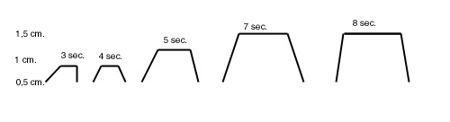

Fig. 2

Figure shows, in subsequent geometrical forms, from left to right, initial “morphological” modifications of microvessels fluctuation wave during microcirculatory activation, which aim to increase both intensity and duration of waves themself. Microvessel fluctuations, in the known manner, are assessed as oscillations of upper (vasomotility ) and lower (vasomotion) ureteral reflex.

From the above remarks, it is easy to understand that microcirculatory dynamic behaviour, by means of microvessel fluctuations morphology, conditions both form and type of their geometries, illustrated in various diagrams.
Under a large variety of stimuli, physiological as well as pathological, described in following, the morphology of “vasomotion” waves fluctuations “quickly” appears modified, according to R. Thom’s “catastrophes theory”, from biological view-point.

In these functional modifications, rapid, well programmed and precise in healthy, one can “read” the information “written” in the matter, unavoidable to react in a scheduled manner and by a lot of diverse ways, indicating clearly the particular reactivity of living matter.

In addition, it appears noteworthy the fact that the microcirculatory way of providing information about the being as well as functioning of related parenchyma, allows doctor to assess biological and molecular-biological events, untill now impossible to perform at the bed-side.
The causes of microcirculatory and consequently parenchymal activation are really numerous, diverse, physiological and pathological. Obviously, activation type varies from case to case, allowing, thus, to recognise both a normal and abnormal activated biological system in a “quantitative” manner.
In following, a “secondary” microcirculatory activation, i.e. a singular form of microcirculatory activation, very interesting as well as common in day-to-day practice, is discussed. It derives from whatever disorder, even initial and symptomless, of the “vasa publica”, up-stream, according to Ratschow’s (5).

Microcirculatory activation in biophysical-semeiotic diagnosis of macroangiopathies, even silent.

In above-mentioned site (www.semeioticabiofisica.it/microangiologia) is described in detail the interesting phenomenon of microcirculatory activation, in both physiological and pahological conditions, and the two more important types are illustrated: type I, associated, and type II, dissociated, that differ greatly in their vasomotility and vasomotion behaviour, which are the same in the former, but really different in the later.
In healthy at rest, there is not microcirculatory activation, while a upstream arterial obstruction, even jatrogenetic and of low degree, bings about very quickly downstream type I, associated (Fig.3), microcirculatory activation od related microcircle. In other words, in type I, associated, “vasomotion” activation both “para-microcircleand “microcircle”, according to Pratesi, appear to be similarly augmented, as Fig. 3 clearly indicates.

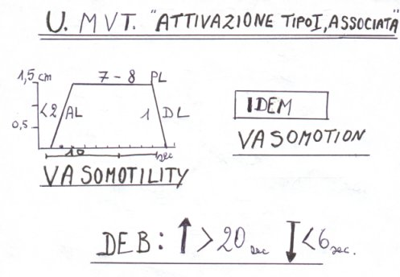

Fig.3.

The explanationis in the text.

As Fig. 3 indicates, microcirculatory fluctuations are clearly more intense and prolonged than under rest condition, at arteriolar level (vasomotility)as well as in capillary and post-capillary region (vasomotion): all oscillations are identical to highest spikes (intensity = 1,5 cm.) showing AL + PL duration of 7-8 sec. In other words, both upper ureteral reflexes and lower ones fluctuate in a highest manner, with a fixed period of 10 sec., showing a longer opening phase duration.
The under curve area “shows” microvessel sagittal surface during their highst and prolonged opening phase so that, under such condition, microcirculatory blood-flow is greatest.
It is of interest to observe EBD behaviour, which partecipates predominantly in the blood-flow supply to tissues by opening during greatest performances. In fact, based on our clinical, 45-year-long experience, we state that the role played by EBD in causing flow-motion in microcirculatory bed is surely pivotal, because the opening of these ubiquitous structures induces a clear-cut augmentation of the blood-flow downstream in nutritional capillaries.
In healthy, both EBD and all other present AVA, functionally speaking, act in a perfect agreement with arterioles, according to an harmonious and sophysticated vasomotor action, which aims to provide parenchyma with requested blood in capillary and post-capillary microvessels, in order to fulfil the actual request of matter-energy-information by local tissue.
It is clear that healthy biological system during its greatest functional activity need of an increased amount of matter-energy-information, which has to be provided by means of a particula microcirculatory phenomenon, i.e., microcirculatory activation, type I, associated (Fig. 3), indicating physiological activation of Microcirculatory Functional Reserve (MFR), realized by singular and distinct functional modifications of all microcirculatory structures, described in detail in the above-mentioned site.
In type I, associated micorcirculatory activation, vasomotility shows the greatest oscillations, as well as vasomotion, whereas both endoarterial blocking devices and other AVA, functionally speaking, are extremely “closed” (EBD are “open”, of course, or more precisely speaking, “contracted”) for a duration longer than normally at rest: in biophysical semeiotic termes, “mean” ureteral reflex during middle-intense” stimultion (= EBD) is > 1,5 cm. (NN = 1,5 cm.), indicating the augmentation of microcirculatory blood-flow in related arterioles, i.e. an increased supply of blood, coming from arterioles and small arterioles, according to Hammersen, and moving towards nutritional capillaries (Fig.3).
In fact, contemporaneously the parameters of both caecal and gastric aspecific reflex, expression of histangic acidosis, during stimulation of adrenergic receptors of the activated biological system, doctor investigates, ameliorate by a clear-cut way, showing that histangic pH is rised: latency time (lt) from 8 sec. increases, e.g., to ≥ 12 sec. as regards fingerpulp-gastric aspecific reflex.
At this point it appears useful to say that the behaviour of biophysical-semeiotic preconditioning results jet physiological, altough slightly, due to the fact that microcirculatory system is already activated, so that a further ameliorating is possible but limited.

The role played by EBD in microcirculatory activation and, then, in realizing Microcirculatory Functional Reserve, is of primary importance. Therefore, we have forseen the origin in next future of a new medical discipline, derived from Clinical Microangiology, whose task will be the study of Endoarterial Blocking Devices under both physiological and pathological conditions.

As demonstrate our investigations on “pre-metabolic” or “pre-morbid stage” – grew zone – up to now such result are noteworthy, facilitating “bed-side” definition of the real risk of a lot of diseases – metabolic, endocrine, oncological, a.s.o. – by evaluating both function and structure od EBD in various tissues, as I have already referred.
In fact, a system at real risk of diseases, starting from the individual’s birth, shows EBD functional abnormality, of different degree, quantifiable at the bed-side both directly, by “vasomotion” assessement, and indirectly by means of preconditioning.
As one correctly understand, the normal, positive preconditioning is expression of a basal “physiological” condition of microcirculatory system as well as of related parenchyma, doctor investigates.
Clinical and experimental evidence has suggested us to broaden and go deepen into the investigation on microcirculatory activation, even in relation to clinical diagnosis of macroangiopathies.
At first, a fundamental experimental evidence must be referred. Digital “non”-occluding pressure on femoral artery physiologically provokes increase of peripheral vasomotor activity downstream, in homolateral region: the subject to be examined, lying down in supine position and psycho-physically relaxed, pinches the thumb against the forefinger (or another finger, of course) “slightly”, while doctor evaluates ureteral reflexes, which notoriously provide useful and reliable information about basal vasomotility and vasomotion. At this moment, digital pressure on homolateral common femoral artery, at the groin level, brings about “rapidly” augmentation of ureteral fluctuations, both upper and lower, i.e. the associated, type I, microcirculatory activation, to which immediately follow normal oscillations when digital pressure on the artery is abruptely interrupted.
In addition, increasing more an more the pressure on finger-pulp, mean ureteral reflex appears, characteristic of EBD “actively” functioning, as referred above
At rest, all fluctuations show the typical deterministic-chaotic behaviour, geometrically expressed as “saddle type” in Fourier’s biophysical-semeiotic transformation (Fg. 4).

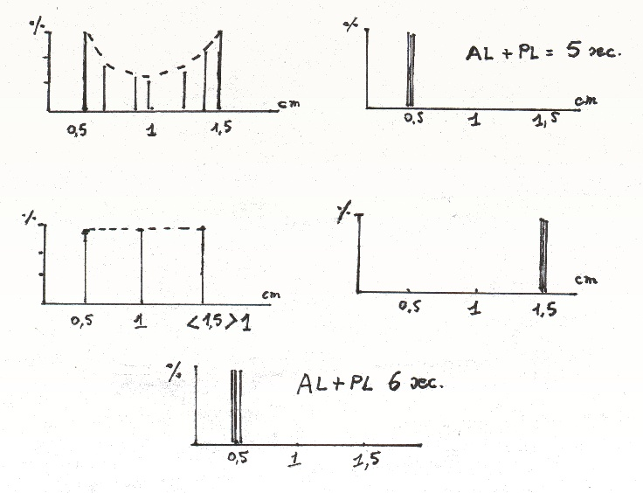

Fig.4

“At rest” physiological type of Fourier’ biophysical-semeiotic transformation of “vasomotion” is indicated above at left: the fluctuations, grouped in relation to their intensity in Cartesian axes system, on the ordinate the percentage and on the abscissa microvessel fluctuations intensity, are geometrically represented as “saddle type”, i.e.,all fluctuation types are present.

However, soon thereafter, i.e immediately after the beginning of digital pressure on the artery, vasomotility appears increased: firstly raises only fluctuations duration, whitout any change of their intensity; in a second time, when digital pressure on arterial vessel increases, the intensity and particularly the duration result also augmented (Fig.2), indicating clearly the harmonious fulfilment of microcirculatory refined mechanisms, which aim to meet related tissues blood demand.
Contemporaneously both EBD and other AVA “open” in highest way: it appears the type “at far column” in Fourier’s biophysical-semeiotic transformation (Fig.4, middle line design, at right), which replaces the former, showing a fractal dimension clear-cut lowed: from 3,81 to about 1,2.
In other words, blood-flow reduction in “vasa publica” (5) provokes downstream the activation of “vasa privata”, i,e., the microcirculatory system, which plays in a perfect manner its pumps role, corroborating the value of the definition of peripheral heart.

At this point, we underscore an observation that contradicts what untill now is accepted by everybody as scientific truth: “vasoconstriction” of about 50% of an artery “physiologically” does not cause downstream any deterioration of bood supply, in a only apparent contradictory way, due to efficacious microcirculatory reaction-activation, aiming to compensation for macrocirculatory reduced activity.

Analogously, on the other hand, as far as a determined dilation intensity is reached, artery “vasodilation” does not ameliorate at all parenchymal blood supply downstream, because the related microcirculatory system appears to be slightly disactivated, so that tissue oxygenation persists among normal basal values: caecal, gastric aspecific and upper ureteral reflex latency time (lt) is unchanged , indicating the same tissue pH.

The microcirculatory activation is subdivided in two primcipal groups:

A) type I, associated, “physiological”, in which both the vasomotility and vasomotion result increased and consequently blood-flow in nutritional capillaries and post-capillary-venules is augmented, due also to right AVA reaction;

B) type II, dissociated, “pathological”, in which the vasomotility shows increasing of both intensity and oscillation duration, while the vasomotion shows a highly differentiated behaviour, in relation to the presence of microcirculatory “compensation” or “decompensation” (failure), as we will say later on.
In reality, the transition from type I to type II goes through numerous intermediate stages, which from the compensation reach the total irreversible decompensation of microcirculation, showin a large variety of different and significant forms. For further information, See the above-cited site

From the type II, dissociated, microcirculatory activation to the microcircultary failure.

In case of initial decreasing of blood-flow in the great arterial vessels, both muscular and elastic (See my site Microangiologia), as it occurs in the peripheral arteriosclerotic obliterative arteriopathy as well as in coronary artery disease, even silent, first of all arterioles and small arteries, according to Hammersen, increase suddenly the duration of arteriolar fluctuation wave, so that PL is prolonged to the detriment of AL, and therefore AL + PL is unchanged (6 sec.), aiming to maintain blood-flow to nutritional capillaries and post-capillaries venules at a sufficient level (Fig.3).
After this first microcirculatory event, but always in a second time, it follows also the augmentation of oscillation intensity, and finally, as third adaptation mechanism, the further increasing of PL duration, which shows maximal value as well as greatest velocity of microvascular oscillation.
In other words, in our “synergetic” and “fractal” model of microcirculatory activation, microvessel open more quickly, more intensively and for a longer time, bringing about a greater blood-flow, while in initial stage the increase of necessay blood supply is carried out by the prolonged PL at the detriment of AL (AL + PL 6 sec.), in presence of a higher velocity of “systo-diastolic” microvascular performance with unchanged oscillation intensity.
In a second moment, when flow-motion, already increased by the above referred way, appears to be insufficient, facing parenchymal demands, in case of impairement of macrovascular blood supply, microvascular opening degree increases, i.e., microvessel diameter, and ultimately AL + PL duration (≥ 8 sec.) reaches maximum values to maintain a sufficient supply of material-energy-information to the related parenchyma.
Therefore, we observe a refined vasomotor fulfilment, perfectly programmed and skilfully carried out, that needs physiological free energy level within the local smooth muscle cells, terminal component of a complex chain reaction.

To summarize, the “peripheral heart” answers to increased request of related parenchyma and/or react to the lowered blood supply, cause by cardiac, vascular, blood disorders, initially by a rapid dilation of its “pump-structures”, i.e., small arteries and arterioles, as well as by a prolonged opening duration, but without any modification of vessel diameters.
If all these microvascular reactions are not able to meet the reduce macrovascular blood-supply, it increases also the intensity of microvessels “dilation” in the region of sphygmicity and the duration of oscillation becomes greatest. Under condition of “physiological” tissue hyperactivity, in the initial phases is increased also the duration maximal dilation or smooth muscle cells relaxation (about 9 sec.), that preceds the strongest contraction HS).
At this point, it appears interesting to consider the chaotic-deterministic behaviour of “basal”, at rest, of microcirculatory structures, in which it is easy to observe the identical adaptation reactions, described formerly. In other words, normal non-linear behaviour of microvessel fluctuations proves to be an event that aims to a possible adaptation in face at modified tissue demands.
From the above-referred remarks one understands that microcirculatory activation, type I, associated, physiological event secondary to the increased demand of blood supply from the related tissue in a stage of activity greater than normal, indicates an emergency or stress situation, as regards the biological system in a precise moment.

It is necessary to think that “symptomless obstruction of a large arterial vessel (50%), for example, represents an emergency situation as far as biological system downstream is concerned, even at rest, which worsens obviously during physical activity, also slight.
Fortunately, in practice such as condition influences favourably both the diagnosis and the prevention. For instance, in a patient “at rest”, involved by “silent coronary artery disease”, who does not present any clinical phenomenology, the “light” digital pressure, applied on cutaneous projection area of right or left ventricle, allows doctor to recognize the microcirculatory activation, type I, associated, by the well known way (ureteral reflexes evaluation), indicating the symptomless coronary pathological condition.
By contrast, in healthy at rest, coronary “vasomotion” shows the typical deterministic-chaotic behaviour, geometrically represented by the type “at saddle” of biophysical semeiotic Fourier’s transformation (Fig.4, above at left).
In future papers, we will come back, of course, at these interesting “diagnostic” aspects of microcirculatory activation, that corroborate Krogh’s statement ofte referred.
In conclusion, we consider usefull to illustrate both function and structure of cutaneous microcircle (thigh, leg) as well as that of finger-pulps in lower limb arteriosclerotic macroangiopathy, e.g.
Really, also in anemic conditions, of whatever origin, doctor observes the same microcerculatory pattern, descrbed as follows.
In a symptomless patient, at rest, involved, however, by obstructions of large arterial vessel of a lower limb, as well as in an anemic subject, cutaneous, sub-cutaneous, muscular microcircle appears activated, according to type I, in initial stage, and, due to persistence and/or worsening of arterial obstruction, according to type II, in the various and different forms (as far as “claudicatio intermittens” occurs), and ultimately one observes the microcirculatory failure, which clinically is characterized by ulcerous-necrotic lesions.
From the above-referred examples, it appears that microcircuatory evaluation plays a pivotal role as regards “also” the diagnosis of macroangiopatyhies (and parenchymopathies) starting from initial and asymptomatic stages, when, however, one can easily observe in a “quantitative” way the microcirculatory activation.

Arterial avventitial microcirculatory activation in physiology and pathology.

The study of both arterial avventitial microcirculation and various forms of its activation represents a biophysical research field in active evolution, which shows interesting and positive influences on the diagnosis of common human diseases, including arteriosclerosis.
In fact, by means of Biophysical Semeiotics, doctor can evaluate also the function and the structure of large arteries avventitial microcircle, within the reach of palpation, as common carotid artery, brachial artery and common femoral artery.
Avventitial microcirculation functional condition is correlated with that of vessel wall itself, in the sense that the functional rest of arteries is accompanied by related avventitial microvascular rest, due to the fact that the later provides blood exclusively to the outward third of vessel wall, but, interestingly from the vessel wall economy viw-point, it removes the catabolites of almost all vascular structure. Catabolites storage in whatever tissue represents an important factor of metabolic damage, causing lesion to local parenchyma, as the following experimental evidence clearly shows: during the partial obstruction of an artery, caused by digital pressure, lateny time of gastric aspecific reflex and/or caecal reflex is compared with that observed during eflluent vein partial occlusion. One observes that the later appears to be further lowered.
Therefore, when blood flow increases, supplying related tissues with a grater amount of material-energy-information, as during parenchymal hyperactivity, contemporaneously is present avventitial microcirculatory activation, that aims to maintain the optimal level of vessel wall conditions, unavoidable to increase the flow-motion.
On the contrary, if there is a lesion of the related arterial vessel, local avvential microcircle appears “disactivated”: during “light-moderate” digital pressure on the artery, the fluctuation of both upper and lower ureteral reflexes show minimal intensity (0,5 cm.), all the same, with AL + PL phase of solely 5 sec. (NN = 6 sec.), whereas Endoarterial Blocking Devices (EBD) show the greatest “closure” (NN = 6 sec.) as well as the lowerest “opening” (NN = 20 sec.): middle ureteral reflex, caused by “mean-intense” digital pressure on an artery, shows a duration <20 sec. and its disappearing persists more than the normal 6 sec.
Once more, avventitial microcirculatory “vasomotion” is clinically evaluated by means of ureteral reflexes, caused by “light-moderate” digital pressure, applied upon an artery, analogously to what occurs as regards all other biological systems, as already described: ureteral oscillation give information, as reader knows, on local vasomotility (upper ureteral reflex) and on related vasomotion (lower ureteral reflex).
In healthy at rest, the proper stimulation, e.g., of femoral artery avventitial microcirculation, allows doctor to observe in a “quantitative” way deterministic-chaotic fluctuations of physiological “vasomotion”, including those of AVA, and particularly of EBD, really important structures, which play a primary role in the realization of Microrcirculatory Functional Reserve and, then, in microcirculatory blood-flow control (Fig.5).

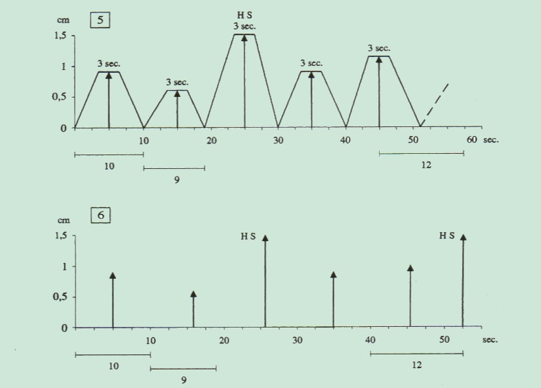

Fig.5
Physiological microcirculatory oscillations, at rest, are characterised by a period varying from 9 to 12 sec., by an intensity varying from 0,5 to 1,5 cm., as well as the phase AL+ PL of 6 sec.,with a fractal dimension of 3,81, easily calculated by the tacogram: the ratio greatest / lowerest fluctuation intensity is 3/1 ( fF, fractal factor = 3).

In reality, during associated, type I, microcirculatory activation, as illustrated in above-cited site, EBD are “open” (= mean ureteral reflex, brought about by “middle” digital pressure on the artery, lasts for > 20 sec. (NN = 20 sec.), i.e., for a time longer than that observed at baseline, and, moreover, reflex disappearing (= EBD decontraction, expressed by reflex cessation from biophysical-point of view) is < 6 sec. (NN = 6 sec.).
These functional “vasomotion“ modifications aim to increase the blood-flow in nutritional capillaries of arterial wall external, outward third and, consequently, to remove efficaciously H⁺ as well as various catabolites.
In healthy, who is invite, e.g., to bend and extend repeatedly homolateral foot or, more easily and refined, to “think” of perform such movements, avventitial arterial microcircle of common femoral artery moves rapidly from basal microcirculatory condition, characterized by microvessels deterministic-chaotic oscillations, revealed by upper and lower ureteral reflex fluctuations (Fig.5), where fD is 3,81, to the typical type I, associated, activation, in which all fluctuations show the same, greatest, intensity (highest spikes) and fractal dimension lowers from 3,81 to 1,5 (Fig.6).

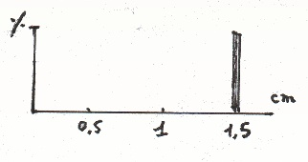

Fig. 6

The figure illustrates the “at far column” type of Fourier’s transformation of oscillations observed in the type I, associated, microcirculatory activation, in which capillary as well as arteriolar fluctuations intensity are all identical and highest, showing value of about 1,5, as conventional measure.

Under this situation, Fourier’s biophysical semeiotic transformation, that demonstrates in a geometrical way the percentage of fluctuations grouped according to their intensity, associated microcirculatory activation is represented by “at far column” type (Fig.6).
Of course, avvential microcircle of every artery shows the same behaviour, including that of common carotid artery. In healthy at rest, “light” digital pressure, applied on this artery, allows to ascertain tha analogous behaviour of avventitial microvessel, evaluated by the accurate analysis of ureteral reflexes, geometrically designed in “at saddle” type of Fourier’s biophysical semeiotic transformation (Fig.7).

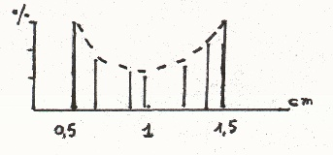

Fig.7

“At sadle” type, physiological, of Fourier’s biophysical semeiotic transformation, indicaes the different distribution of upper and lower ureteral reflexes (= vasomotility and respectively vasomotion), which show all variety of intensity values, indicating the high adaptation of the biological system: normal fractal dimension: 3,81.

However, if the healthy subject “is thinking” to make a simple mathematical calculus or to speak to a large audience, immidiately it appears microcirculatory activation, associated, I type, and the related Fourier’s transformation shows type II ,“at far column” (Fig.6), indicating rapid and efficacious adatation of different tissues to modified condition, i.e., the increased functional performance.
It is now clear to the reader that the evaluation of microcirculatory activation, both peripheral and avventitial, plays a primary role in bed-side recognizing, promptly and “quantitative”, a macroangiopathy, even symptomless at the moment, as arteriosclerotic obliterative peripheral arteriopathy, according to Froment’s stage 0 and 1.
Obviously, doctor observes microcirculatory activation also in case of anemia, e.g. secondary to iron deficincy, dyscrasia, blood-hyperviscosity; such microcirculatory modification aims to maintain a sufficient blood-supply to nutritional capillaries.
Finally, in case of chronic arteriopathy, arteriosclerotic as well as of other origin, it is present the dissociated type of activation, which brings about tissue acidosis, recognized at the bed-side by caecal, gastric aspecific and upper ureteral reflexes.

At this points we must remember the type III, incomplete, microcirculatory activation (zero Stage or Pre-Metabolic Stage), in which it is present the initial abnormality of AVA dynamics (AVA, functionally speaking), while is carryed out the activation of both vasomotility and vasomotion, the later , however, subsequently shows a reduced fuction: : AL + PL from 7 sec. lowers to 6 sec. and ultimately to 5 sec. exclusively in the vasomotion.
Such interesting avventitial microcirculatory situation indicates the “initial” asymptomatic stage of arteriopathy, e.g., arteriosclerotic in origin.

Before the conclusion of this argument, essential for Clinical Microangiology, that must be investigated during every common physical examination, it is necessary to underscore the role played by such refined microcirculatory phenomenon, i.e., microcirculatory activation, as regards the therapeutic monitoring: under a really efficacious treatment, micorcirculatory must recover at rest, i.e., return to the physiological type, showing the characteristic deterministic-chaotic behaviour with fractal dimension 3,81, as the reader knows it (Figs.6 and 7)
In my opinion, the ecographyc study, doppler velocimetry, angiography, a.s.o., are surely reliable and useful in case of arterial pathology, but they have to be preceded as well as completed by the accurate “clinical” evaluation of distal microcirculatory events, where happen the vital, essential phenomena, which can not be evaluated by above-mentioned sophysticated semeiotics.
In following papers are described in detail most common “biophysical-semeiotics” diagrams, starting with that related to finger-pulp tissue-microvascular unit, under both physiological and pathological conditions: diagram of finger-pulp tissue microcirulatory unit.

