From Diabetic and Dyslipidemic Biophysical-Semeiotic Constitutions
to Type 2 Diabetes Mellitus.

Introduction. 1
Dyslipidemic and Diabetic Constitutions. 1
Adipose Tissue and Pancreas Preconditioning in bed-side recognizing dyslipidemic and diabetic Constitutions. 2
Evaluation of the Endoarterial Blocking Devices (EBD) of Adipose Tissue and Pancreas, in both healthy and diseased subject. 4
Lipid and Insulin Resistance. 5
Genetics of complex Diseases 6
Regulation of Energy Balance. 6
The Role of Leptin in Adiposity and Energy Balance. 7
Lipids, muscle Insulin Resistance, and type 2 Diabetes. 8
Diabetic and dyslipidemic Constitutions, tissue Lipid Accumulation, Hyperinsulinemia - Insulin Resistance, metabolic Syndrome, classic and “variant”, and type 2 Diabetes mellitus: the biophysical-semeiotic view-point. 8
Conclusion: “Elliot P Joslin was right”. 11
References. 12

Introduction.

A part from its inflammatory, infectious, degenerative, metabolic, neoplastic nature, diseases occur and evolve in relation to the individual constitution, since environmental factors, surely important and determinant, interact with genetic factors, always present, as clinical evidence demonstrates it.
As extreme example, let us consider the “traumatic” pathology: if the diseased subject does not die, of course, fracture evolves and ends certainly in relation to patient’s constitution. In fact, there are notoriously identical cases, as regards the trauma severity, among them some people rapidly and completely recover, while in others morbidity and even mortality occur, due to complications, clearly correlated with efficaciousness of tissue repair, bone synthesis, tissue heal, a.s.o., all events genetically directed.
The primary role played by the constitution(s) is clear also in infectious diseases, incuding the common children diseases, viral in origin, which evolve especially, but not exclusivelly, in relation to individual’s psycho-physical situation, besides sensitivity to treatment, of course, although nowadays only specific vaccines are successfull.
The constitutional factors play their primary role in degenerative, metabolic diseases, in chronic inflammations, and malignancies, as I demonstrated previously (See the site, HONCode, N° 233736, www.semeioticabiofisica.it , Biophysical-Semeiotic Constitutions).

Dyslipidemic and Diabetic Constitutions.

Clinical evidence demonstrates that the dyspipidemic constitution necessarily exists: among individuals comparable as regards age, sex, social state, lifestyle, diet, a.s.o., some are dyslipidemic, while others are not.
In addition, among children of dyslipidemic parents only some present high cholesterol blood concentration (total Ch. and/or LDL), as well as tryglyceridies blood level, of course, under the same conditions, e.g., when diet, etymologically speaking, i.e. day program, is the same.
Finally, among individuals with identical lipidemic concentration values, the seriousness of well-known disorders are clearly different.
Therefore, the “real” risk of dyslipidemia, based on genetic alterations, surely exists, as allows me to state the referred clinical evidence, besides actual genetic investigations.
Biophysical Semeiotics permits doctor to recognize, in a few minutes, at the bed-side and in “quantitative” manner, both the presence of dyslipidemic constitution and diabetic constitution, by a large number of methods, which obviously need a very different knowledge of this original semeiotics.
As follows, in the interest of reader not jet experienced in this diagnostic method, I shall illustrate two ways, easy to perform, certainly reliable in recognizing dyslipidemic situations, even in intial stages, until now undiagnosed clinically. Contemporaneously, analogue method of ascertaining diabetic alteration are described.
In fact, in my 45-year-long clinical experience, I observed that the prediabetes, when insulin resistance is already in place since a long time, and the ß-cell actually hypersecretes insulin as well as the amyloidogenic substrate amylin resulting in islet amyloid formation, according to P. Hayden (27, 28), despite normal glucose blood levels, from years or decades there was already lipid dysregulation or, more precisely speaking, biophysical-semeiotic dyslipidemic constitution, even without increased lipid blood level, but with deposit of lipid within skeletal muscle as well as hepatic cells (See later on).

Adipose Tissue and Pancreas Preconditioning in bed-side recognizing dyslipidemic and diabetic Constitutions.

1) Preconditioning of abdominal adipose tissue.

Notoriously there is a great structural-functional difference between “central” adipose tissue, i.e. abdominal and visceral adipose tissue, and that “peripheral”, e.g. thigh. In fact, insulin-resistance involves almost always central adipose tissue, as we clinically demonstrated (21, 25).
Biophysical-semeiotic preconditioning is the method based on the comparison of the parameters values of some reflexes, assessed in “quantitative” manner, firstly, at rest (basal line) and then in a second evaluation, performed after exact 5 sec. of intervall from the first: preconditioning.
From the clinical-microangiological point of view, by means of this clinical tool, doctor evaluates precisely both structure and function of local tissue-microvascular system, i.e. local, adipose tissue Microcirculatory Functional Reserve (MFR)
(www.semeioticabiofisica.it /microangiologia).
From technical view-point, at least, it is unavoidable the knowledge of stomach auscultatory percussion (Fig.1) (HONCode 233736, www.semeioticabiofisica.it , Technical Page, N° 1).

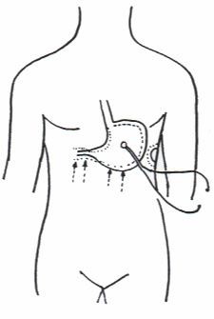

Fig. 1

Figure shows both the precise location of the bell-piece of a stethoscope and parallell and centripetal lines, on which digital percussion, directly and gently, must be applied in order to outlining properly the great curvature of stomach, or, in practice, of a small tract.

In an individual, psycho-physically relaxed and in supine position, cutaneous “lasting” pinching of the abdomen (lateral abdominal part at right and at left, or near to umbilicus) provokes physiologically gastric aspecific reflex (Fig. 1): in the stomach, both fundus and body are dilated, while antral-pyloric region contracts, after latency time (lt) 8 sec. In healthy, moreover, immediately after preconditioning, lt rises typically to ≥ 10 sec.
On the contrary, in subjects with dyslipidemic constitution, as well as obviously in dyslipidemic patients, lt at basal line results ≤ 8 sec. and after preconditioning appears to be either the same or reduced, in inverse relation to the seriousness of underlying disorder.
Without discussing the interesting patho-physiological mechanisms, the values of gastric aspecific reflex parameters are based on, it is enough, at this moment, to know that their behaviour is related to local Functional Microcirculatory Reserve (FMR), which in turn is strictly related to both anatomy and function of important microcirculatory structures, essential in direct blood-flow to nutritional capillaries.
Among these microcirculatory, really interesting, structures we consider, later on, only ubiquitarious Endoarteriolar Blocking Devices (EBD). According to our researches (See Bibliography in www.semeioticabiofisica.it/microcircolazione), in fact, altered “genetic” information acts on both parechymal function-structure and local microvessels, that nowadays can be assessed clinically, thanks to Biophysical Semeiotics, whereby originated Clinical Micorangiology.

Microcirculatory abnormalities, genetically caused, parallell the parenchimal alterations, identical in origin, according to Tiscendorf’s Agiobiopatie concept.

As regards the biophysical-semeiotic diabetic constitution, doctor can recognize it in the easiest way, by pancreatic preconditioning: in healthy, the lasting pinching at VI thoracic dermatomere (= epigastrium skin, soon below costal arch) brings about gastric aspecific reflex after a latency time of 12 sec.-13 sec., which rises to ≥ 14 sec. soon thereafter preconditioning.
On the contrary, in case of hyperinsulinemia-insulin resistance, pancreas-gastric aspecific reflex basal lt results 13 sec. – 14 sec.; after preconditioning raises to > 14 sec. in case of efficient β-cells functioning.
By contrast, in individuals with initially impaired β-cells function (= slow diabetic evolution) basal lt is in normal range, but after preconditioning it persists either the same or it lowers, in relation to the seriousness of diabetic constitution slowly evolving to diabetes.
For further information, See my site, HONCode 233736, www.semeioticabiofisica.it, Biophysical-Semeiotic Constitutions.

Evaluation of the Endoarterial Blocking Devices (EBD) of Adipose Tissue and Pancreas, in both healthy and diseased subject.

Before going on, reader must remember that EBD (Fig. 3) (2, 3), present in all tissues, are manifold microvascular structures, made up by smooth muscle cells, placed in different ways, and lined with endothelial cells. They are localized in two stations (first and second stations) along small arteries, according to Hammersen, whose media is formed by 2 or more layers of smooth muscle cells.
Their action mechanism (blood-flow direction toward the capillary bed) is obvious, in that their contraction brings about volume increasing, while the relaxation causes arteriolar lumen obstruction; these parameters are assessed as dilation and intensity of mean ureteral tract, and respectively of its disappearing: mean ureteral reflex (Fig.2).
EBD clinical biophysical semeiotic evaluation represents practically the assessement of “mean” ureteral reflex (dilation of ureteral mean third), caused by cutaneous-sub-cutaneous lasting pinching, of average intensity of adipose tissue, we want examine. (See above) (Fig. 2).

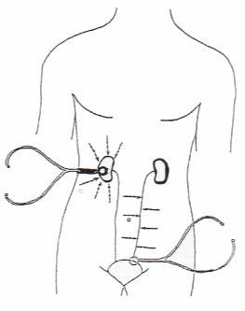

Fig. 2

In the figure, the correct locations of the bell-piece of stethoscope and the lines upon which auscultatory percussion, directly and gently, must be applied, in order to out-linig properly both kidneys and ureters, are clearly indicated.

After lt 3-4 sec., in healthy, appears the dilation (<1 cm. = interstitium) of mean ureteral third, or mean ureteral reflex, which lasts 20 sec. exactly and, then, disappears for precise 6 sec.
Interestengly, in healthy, preconditioning lenghtens clearly opening duration, which rises to about 22 sec., whereas reduces closure duration, that lowers to ≤ 5 sec., in relation to the efficacy of Microcirculatory Functional Reserve (MFR).

On the contrary, in case of dyslipidemic constitution as well as dyslipidemia, of course, basal reflex duration (= EBD contraction) results ≤ 19 sec. (NN = 20), and its disappearing persists for 6-7 sec. (NN = 6 sec. exactly).

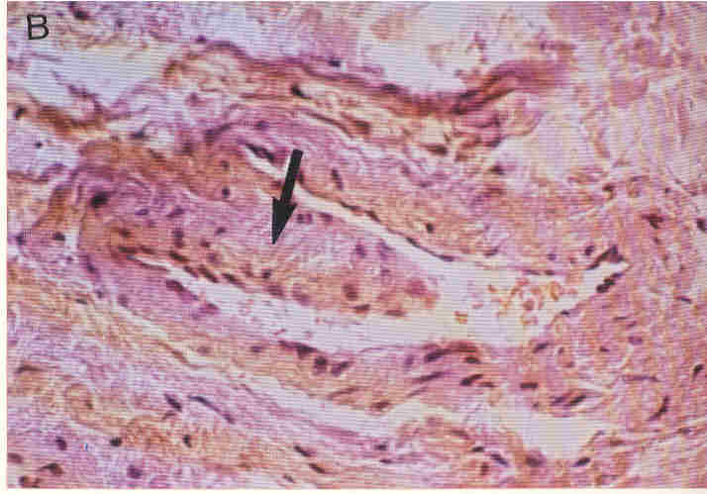

Fig. 3
Figure shows, in a very refined manner, a typical EBD(elephant trunk type) with large installation base.
(from “my Master” of Microangiology S.B. Curri’s Le Microangiopatie, Ed. Inverni della Beffa, for kind permission)

Moreover, soon after preconditioning, such as abnormal values either are unchanged, i.e. identical to those at basal line, or EBD opening (= EDB contraction or mean ureteral reflex duration) appears to be lessened in a statistically significant manner, and the EBD closure (= relaxation or reflex disappearing) is greater than before (7-8 sec.), once again in relation to the seriouness of underlying lipidic dysmetabolism, independently of actual lipidemia.

Analogously, doctor can evaluate pancreatic microcirculatory EBD by stimulation of the trigger-points of VI thoracic dermatomere utilizing “mean” intensity lasting pinching, assessing therefore the diabetic constitution .

In conclusion, the precise evaluation of microcirculation of “central” adipose tissue as well as insular pancreas allows, in really easy way, to assess local MFR and, then, to recognize the dyslipidemic constitution, and respectively diabetic constitution, initiating from the first decades of life, when lipid blood levels are jet in normal ranges.
A large variety of further biophysical-semeiotic evaluations, which require a firm knowledge of the new physical semeiotics, permits doctor to gather a lot of information about local metabolic situation (total Cholesterol, LDL, HDL, non-HDL, a.s.o.) and consequently about responsiveness to various hormons, including insulin (See Postabsorptive State, in above-cited site www.semeioticabiofisica.it/microangiologia).

Lipid and Insulin Resistance.
Even though genetic and physiological studies have not yet delineated the causes of obesity and/or diabetes, nevertheless the adipocyte is now recognized as a major culprit in a lot of the obesity-associated chronic diseases.
When adipocytes become full because of excess fat intake, reduced fat oxidation, or impaired adipogenesis, the overflow of fat increasingly accumulates in tissues not meant to accommodate excessive storage, such as skeletal muscle, liver, and pancreas (1). Recently, a new understanding emerged concerning the molecular mechanisms by which ectopic fat deposition seems to impact insulin resistance (1, 2). This information will certainly provide new pharmacological means to increase fat oxidation in insulin-dependent tissue and therefore decrease insulin resistance. Review of the recent intervention strategies to prevent or delay the development of type 2 diabetes in people at risk provided hope that changing lifestyle (dietary modifìcation and increased physical activity) can be effective in preventing diabetes.
The question is now how to successfully implement such strategies for the general public living into an environment so conducive to overconsumption of unhealthy food and sedentary lifestyles. Only new public health policies in concert with a change in the mind-set of food manufacturers could help to curb down the alarming increasing prevalence of diseases of affluence (1).

Genetics of complex Diseases

A few papers dealt with some of the results from genome-wide scans conducted to identify novel susceptibility genes for obesity and/or type 2 diabetes (2, 3, 4). However, despite new information, there is, thus far, almost no success story in the identification of new genes for complex diseases, with the exception of the identification of calpain 10 for diabetes in Mexican-Americans (5, 6).
The various presentations stressed the importance of potential false-positive or false-negative fìndings from genome scan studies and the need for replication of the results in the same and/or different populations. More importantly, authors emphasized the fact that, from the time of discovery and confìrmation of new genetic loci harboring susceptibility genes, there is an enormous amount of work to positionally clone the genes through strategies of linkage disequilibrium using numerous single nucleotide polymorphisms (7).
Many groups are presently working intensively on cloning such new genes using not only positional cloning, but in combination with gene expression strategies. The polygenic nature of complex diseases will render the hunt for new genes extremely diffìcult. Progress in this search will be much faster if more research funds were directed toward the analysis of QTLs (quantitative trait loci) in mice and rats (7).
In my opinion, however, all mit-DNA and n-DNA alterations converge to well defined biological modification in both parenchyma and related microvessell, which – the later – can be studied by the aid of Biophysical Semeiotics.

Regulation of Energy Balance.

A large literature reminded us that obesity is always the result of a positive energy balance, a condition in which food intake is exceeding energy expenditure. However, growing evidence indicates that some animal models of obesity and humans alike are predisposed to weight gain because of an impaired fat oxidation and energy expenditure.
It is indeed not surprising that species evolving in an environment rather restrictive for energy may have developed survival mechanisms in which energy expenditure and fat oxidation would be as thrifty as possible. We were all reminded of the importance of the work of late Dennis McGarry who discovered and championed the pivotal role of malonyl-CoA as a fuel-sensing mechanism that can tilt the fat balance towards lipogenesis or towards fat oxidation (8, 9, 10). The important roles of acetyl-CoA carboxylases and carnitine palmitoyl transferase I for tissues fat balance were reemphasized and proposed as potential targets for pharmacological therapy. In this group of presentations, results from classical physiological studies were provided emphasizing that 40% of insulin resistance may be due to impaired insulin transport in the insulin-sensitive cells and 60% to intracellular defects. Emphasis was also given to the importance of visceral fat. The basis to study a novel axis, that is, the visceral hepatic axis (VHA), was provided.
Compared to previous symposia, much less importance was given to circulating free fatty acids and the Randle cycle (11) in more recent studies (12, 13), according to which, much more focus was given to the fat and fat metabolites accumulating in the cells (12, 13). Surprisingly was the fìnding that food intake, but not energy metabolism, is usually precisely measured in rodents (1).
The reverse, however, is true in humans. It is now important that investigators involved in studies of body weight regulation begin to "dose the loop" by investigating both arms of the macronutrients' balances. Some novel imaging techniques may prove to become very important in tracing the fate of energy substrate from ingestion and absorption in the digestive system to oxidation and storage in tissues.

The Role of Leptin in Adiposity and Energy Balance.

A chronic minor imbalance between energy intake and energy expenditure may lead to obesity. Both lean and obese subjects eventually reach energy balance and their body weight regulation implies that the adipose tissue mass is "sensed", leading to appropriate responses of energy intake and energy expenditure. The cloning of the ob gene and the identification of its encoded protein, leptin, have provided a system signaling the amount of adipose energy stores to the brain. Leptin, a hormone secreted by fat cells, acts in rodents via hypothalamic receptors to inhibit feeding and increase thermogenesis. A feed-back regulatory loop with three distinct steps has been identified: (1) a sensor (leptin production by adipose cells) monitors the size of the adipose tissue mass; (2) hypothalamic centers receive and integrate the intensity of the leptin signal through leptin receptors (LRb); (3) effector systems, including the sympathetic nervous system, control the two main determinants of energy balance—energy intake and energy expenditure.
While this feedback regulatory loop is well established in rodents, there are many unsolved questions about its applicability to body weight regulation in humans (14). The rate of leptin production is related to adiposity, but a large portion of the interindividual variability in plasma leptin concentration is independent of body fatness. Gender is an important factor determining plasma leptin, with women having markedly higher leptin concentrations than men for any given degree of fat mass. The ob mRNA expression is also upregulated by glucocorticoids, whereas stimulation of the sympathetic nervous system results in its inhibition. Furthermore, leptin is not a satiety factor in humans because changes in food intake do not induce short-term increases in plasma leptin levels. After its binding to LRb in the hypothalamus, leptin stimulates a specific signaling cascade that results in the inhibition of several orexigenic neuropeptides, while stimulating several anorexigenic peptides. The orexigenic neuropeptides that are downregulated by leptin are NPY (neuropeptide Y), MCH (melanin-concentrating hormone), orexins, and AGRP (agouti-related peptide). The anorexigenic neuropeptides that are upregulated by leptin are a-MSH (a-melanocyte-stimulating hormone), which acts on MC4R (melanocortin-4 receptor); CART (cocaine and amphetamine-regulated transcript); and CRH (corticotropin-releasing-hormone) (14).
Obese humans have high plasma leptin concentrations related to the size of adipose tissue, but this elevated leptin signal does not induce the expected responses (i.e., a reduction in food intake and an increase in energy expenditure). This suggests that obese humans are resistant to the effects of endogenous leptin. This resistance is also shown by the lack of effect of exogenous leptin administration to induce weight loss in obese patients. The mechanisms that may account for leptin resistance in human obesity include a limitation of the blood-brain barrier transport system for leptin and an inhibition of the leptin signaling pathways in leptin-responsive hypothalamic neurons. During periods of energy deficit, the fall in leptin plasma levels exceeds the rate at which fat stores are decreased. Reduction of the leptin signal induces several neuro-endocrine responses that tend to limit weight loss, such as hunger, food-seeking behavior, and suppression of plasma thyroid hormone levels. Conversely it is unlikely that leptin has evolved to prevent obesity when plenty of palatable foods are available because the elevated plasma leptin levels resulting from the increased adipose tissue mass do not prevent the development of obesity (14).
In conclusion, in humans, the leptin signaling system appears to be mainly involved in maintenance of adequate energy stores for survival during periods of energy deficit. Its role in the etiology of human obesity is only demonstrated in the very rare situations of absence of the leptin signal (mutations of the leptin gene or of the leptin receptor gene), which produces an internal perception of starvation and results in a chronic stimulation of excessive food intake (14).

Lipids, muscle Insulin Resistance, and type 2 Diabetes.

There are a large number of evidence for, and putative mechanisms of, lipid-induced muscle insulin resistance (15). Acute free fatty acid elevation causes muscle insulin resistance in a few hours, with similar muscle lipid accumulation as accompanies more prolonged high fat diet-induced insulin resistance in rodents. Although causal relations are not as clearcut in chronic human insulin resistant states such as obesity and type 2 diabetes, it is now recognised that muscle lipids also accumulate in these states, as allows to state Biophysical Semeiotics (= upper and lower ureteral reflexxes fluctuate more slowly than noramlly).
The classic Randle glucose-fatty acid cycle is only one of a number of mechanisms by which fatty acids might influence muscle glucose metabolism and insulin action. A key factor, among others, is seen to be accumulation of muscle long chain acyl CoAs, which could alter insulin action via several mechanisms including chronic activation of protein kinase C isoforms or ceramide accumulation (15) These interactions are fundamental to understanding metabolic effects of new insulin "sensitizers", e. g. thiazolidinediones, which alter lipid metabolism and improve muscle insulin sensitivity in insulin resistant states. Recent work has also pointed to a possible role of lipids in beta cell deterioration ("lipotoxicity") associated with type 2 diabetes.
Numerous author demonstrated (16-20) that a) artificial elevation of the circulating FFA level can, over the course of a few hours, result in a very significant suppression of insulin-mediated glucose uptake (IMGU) into muscle in healthy people; b) this effect correlates in a temporal sense with the accumulation of TG in skeletal muscle cells; c) diet-induced lowering of tissue TG levels improves insulin sensitivity and essentially reverses the diabetes in animal models of type 2 diabetes; and d) the increase in IMGU noted above in cross-sectional studies in humans is almost certainly instrumental in bringing about the associated decline in muscle insulin sensitivity.
However, not all obese patients, involved initially by dyslipidemic constitution and successively by hyperinsulinemia-insulin resistance, finally present diabetes mellitus: among such as patients, only those with the diabetic constitution (17, 21) (See above cited site, Biophysical Semeiotic Constitutions) can be slowly suffering for glucose dysmetabolism.

Diabetic and dyslipidemic Constitutions, tissue Lipid Accumulation, Hyperinsulinemia - Insulin Resistance, metabolic Syndrome, classic and “variant”, and type 2 Diabetes mellitus: the biophysical-semeiotic view-point.

Analogously with the data collected at the bed-side with the aid of Biophysical Semeiotics in case of hepatosteatosis, in patients showing lipid dysmetabolism (dyslipidemic constitution) doctor can nowadays evaluate lipid deposit in skeletal muscle and in liver, since the new physical semeiotics allows to recognize such as event in a precise manner.
At this point, firstly, we must consider the biological difference of lipid deposit in tissue interstitium from that within cells (22).
Work from a number of laboratories has shown that both in rodents and humans the TG content of muscle, as measured by Folch extraction of tissue samples followed by chemical analysis, bears a negative relationship to whole-body insulin sensitivity (22).
A case in point is the study by Pan et al. (23) in Pima Indians in which each subject underwent a hyperinsulinemic-euglycemic clamp to determine whole-body insulin sensitivity and then provided a muscle biopsy for chemical measurement of total TG content. Although a rough negative relationship was found between these two parameters, there was considerable scatter among the data points. In this type of analysis, there is always uncertainty as to the anatomical location of the TG measured.
In other words, how much of it is present within the myocyte, and how much arises from adipose tissue interspersed between the muscle fibers? We felt that variations in this extramyocellular lipid (EMCL) component might well interfere with the measurement of intramyocellular lipid (IMCL). There are elegant studies of Schick et al. (24) suggesting that EMCL and IMCL can be distinguished noninvasively using the technique of ¹H magnetic resonance spectroscopy (¹H MRS). This procedure detects resonances from protons associated with the methylene groups of fatty acids present in tissue TG. Importantly, these signals differ by ~0.2 ppm depending upon whether they arise from TG within the muscle cell or from surrounding adipose tissue, allowing separate quantification of the two pools. Accordingly, other authors recruited a group of healthy volunteers with normal glucose tolerance (NGT), who underwent a hyperinsulinemic-euglycemic clamp for assessment of whole-body insulin sensitivity followed by ¹H MRS of the soleus muscle to measure the quantity of IMCL. They observed a remarkably tight negative relationship between the two parameters, indicating that only IMCL impaired insulin sensitivity, but not EMCL (22).
At this point, I like to underline an interesting fact: hyperinsulinemic-euglycemic clamp for assessment of insulin sensitivity is usefull and reliable only for whole-body insulin receptor evaluation, but not for local events.
On the contrary, as referred above, Biophysical Semeiotics allows doctor to assess, clinically in a different way, both “local” insulin receptor sensitivity (25) and intracellular lipid from extracellular lipid, separately in lever, skeletal muscle, and adipose tissue (See the site www.semeioticabiofisica.it/microangiologia, Grew Zone). Obviously, doctor must know how detect the fluctuations of upper (= vasomotility) and lower (= vasomotion) ureteral reflex (Fig. 4), caused by mean digital pressure, applied on skeletal muscle, adipose tissue, and liver projection area, respectively. Doctor, who has firm knowledge of absorptive and post-absoptive state clinical microangiology (See above-cited site), will certanly understand the following argument, in a complete and easy manner.

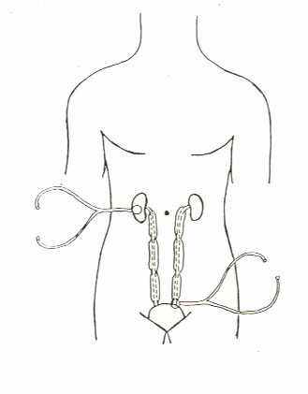
Fig. 4

As a matter of fact, in healthy, light-moderate stimulation (= digital pressure on liver cutaneous projection area of lever or biceps muscle or pinching lastingly abdominal adipose tissue, a.s.o.) brings about upper, middle, and lower ureteral reflexes, which fluctuate in a deterministic-chaotic manner (Fig.4).

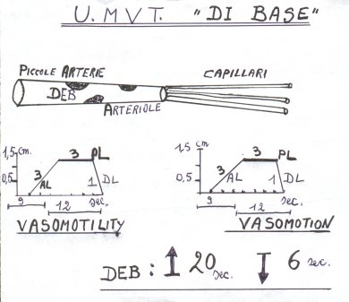
Fig. 5
In the figure, microcirculatory phenomena, observed at rest, in healthy, in whatever biological system are geometrically illustrated: deterministic-chaotic fluctuations, associated in both vasomotility and vasomotion; EBD are normally functioning showing a opening duration (↑) of 20 sec. and a closure duration (↓) of 6 sec.
Legenda: U.MVT. = tissue-microvascular unit; AL = ascending line, PL plateau line and DL descendent line of oscillation of upper and lower ureteral reflexes, which give information on the functioning of respectively vasomotility and vasomotion.

In healthy, AL duration is generally 2 sec., age-dependent; on the contrary, in case of lipid (TG) accumulation within the cells, AL becomes slower: > 2 sec. Interestingly, Biophysical Semeiotics allows doctor to assess and differentiate intracellular lipid accumulation from interstitial fatty acid deposit: exclusively in the later, “in toto ureteral reflex”, which appears firstly, i.e., soon thereafter stimulation is applied, is typically larger than normal (NN ≥ 0,5 sec. in the absorptive state).
In addition, in all case of lipid accumulation (ICL as well as ECL), AL, ascending line, appears characteristically slower (NN = 2-3 sec., age-dependent) (Fig.6).

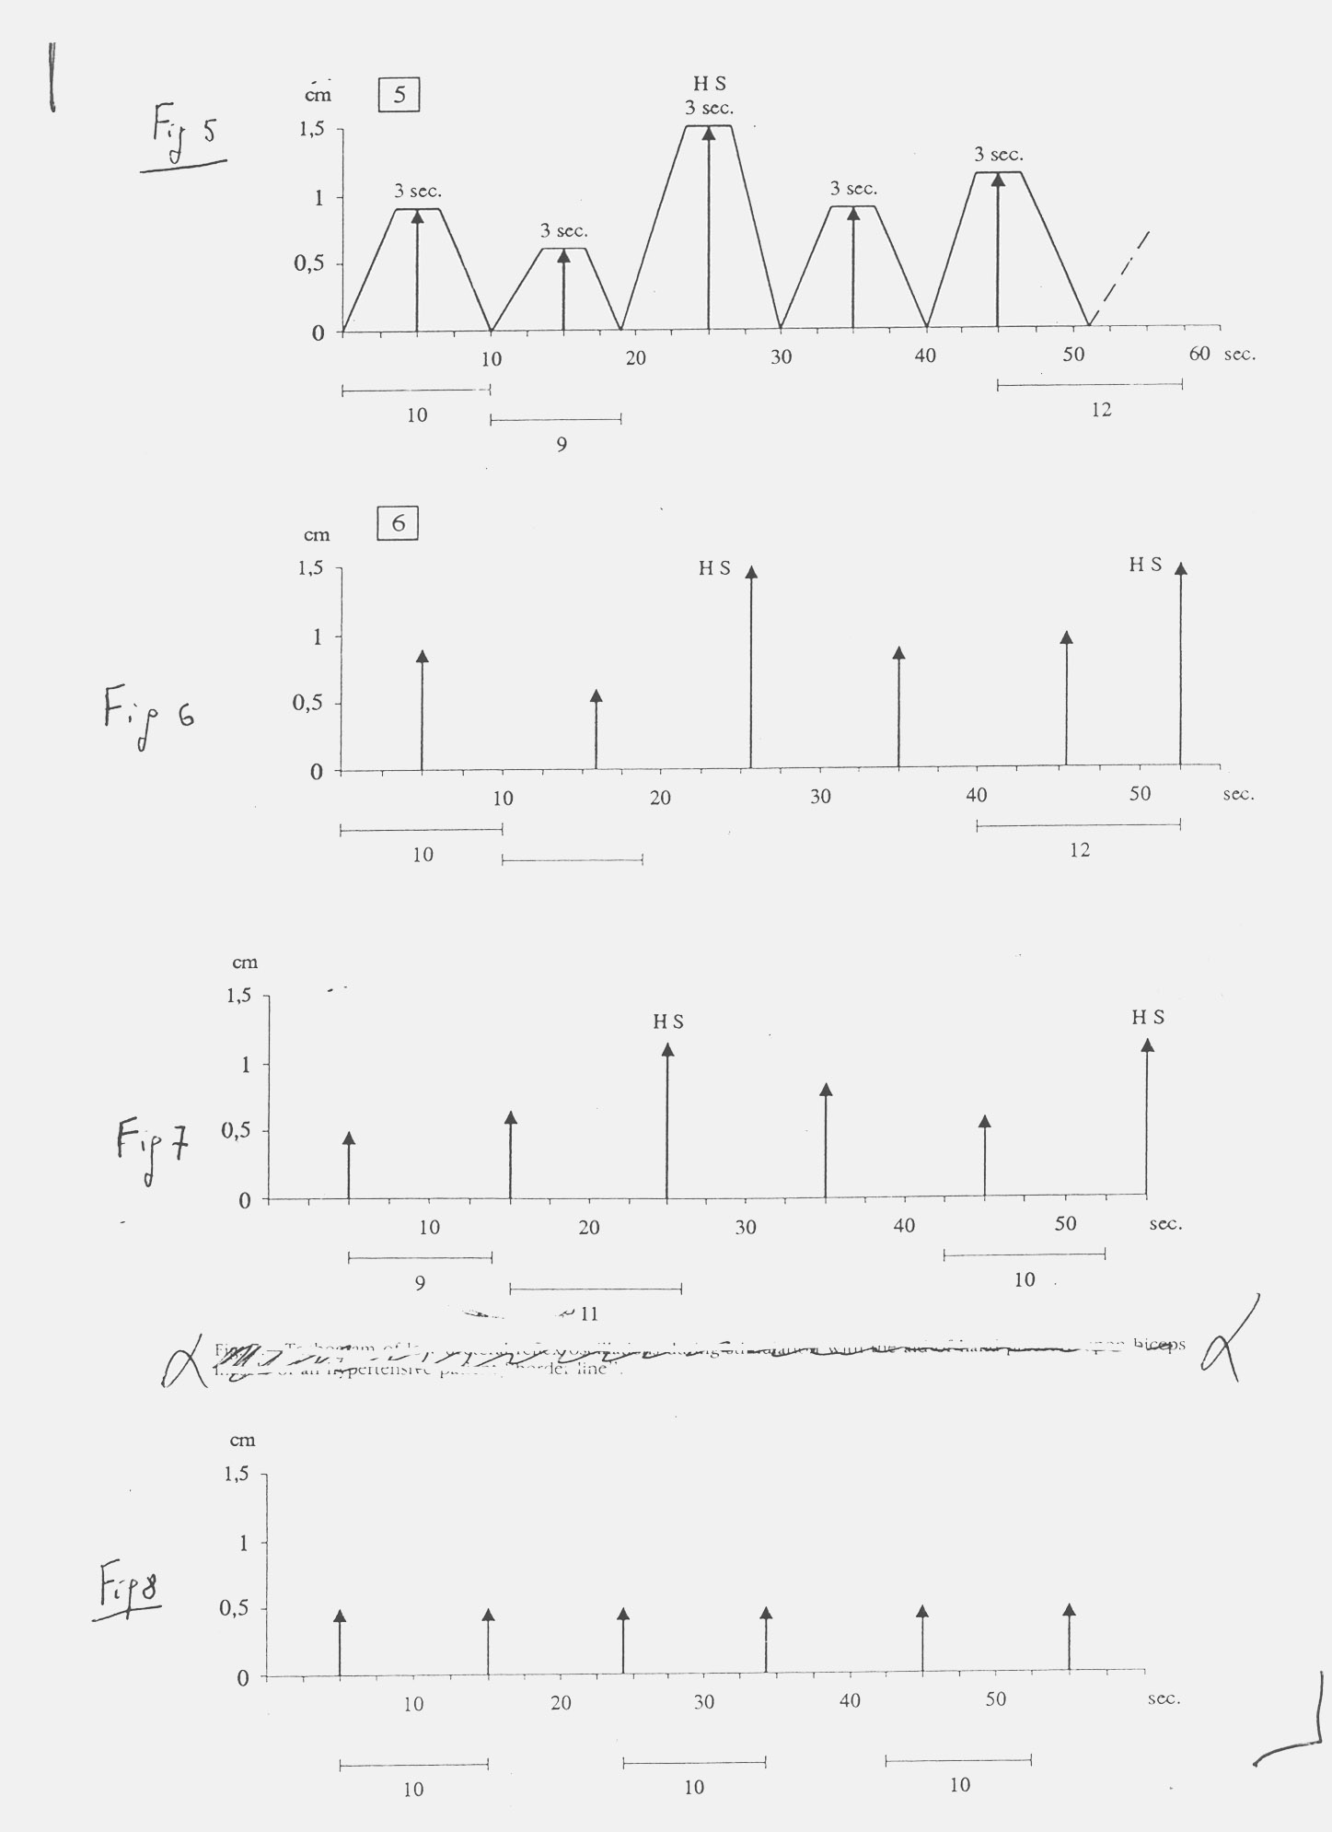
Fig.6
The upper diagram shows physiological vasomotility as well as vasomotion, which result typically deterministic-chaotic, as those of normal biological system. AL is rapid (2 sec.). When the biological system is involved by a chronic disease, e.g., diabetes mellitus, tachogram becomes slowly more “regular” and its deterministic chaos appear progressively reduced, as indicate clearly the two lower tachograms.

Conclusion: “Elliot P Joslin was right”.

In my 45 year-long clinical experience, as regards type 2 diabetes mellitus, at first, i.e., since birth-day, I have noted always the presence of diabetic constitution, associated with dyslipidemic constitution, independently of raised lipid blood level in subsequent time.
In a second stage, characterized by lipid accumulation within skeletal muscle cell, hepatocites, i.e. classical Reaven’s syndrome and “variant” Reaven’s syndrome, where there is not lipid accumulation in hepatocytes (24), and in pancreatic cells, local insulin resistance occurs. Under such pathological conditions, the pancreas produces more insulin and the amyloidogenic substrate amylin resulting in islet amyloid formation, according to P. Hayden (27, 28).
In fact, at this point, from biophysical-semeiotic view-point, Langheran’s islets interstitium appears clearly increased in size, due to islet amyloid deposit: pancreatic-“in toto” ureteral reflex is augmented in a clear-cut way, preceeding and accompanying type 2 diabetes mellitus (See my above-cited site www.semeioticabiofisica.it , Practical Application, Pancreatic Amyloid deposit). Finally, after years or decades, as a consequence of insulin secretion failure, NIDDM occurs, according to the following scheme:

diabetic constitution associated with dyslipidemic constitution ⇒ lipid accumulation within skeletal muscle cell, hepatocites (absent in “variant form of Reaven syndrome) , independently of raised lipid blood level ⇒ hyperproduction of both insulin as well as amyloidogenic substrate amylin, i.e., metabolic syndrome, classic or “variant” (26) ⇒ (after years or decades) type 2 diabetes mellitus.
Three quarters of a century ago, a quote from Elliott P Joslin's presentation to the American College of Physicians in 1927 seems appropriate.

"I believe the chief cause of premature development of arteriosclerosis in diabetes, save for advancing age, is due to an excess of fat, an excess of fat in the body, obesity, an excess of fat in the diet, and an excess of fat in the blood. With an excess of fat diabetes begins and from an excess of fat diabetics die, formerly of coma, recently of arteriosclerosis." (29).

Biophysical Semeiotics allows to state that “Elliot P Joslin was right”: without the association diabetic constitution and dyslipidemic constitution, there is no type 2 diabetes mellitus, but, in absence of the later, only the metabolic syndrome, classic or “variant”, never followed by NIDDM.

References.

1) RAVUSSIN E., KLIMES I., SEBOKOVA E., HOWARD B.V. Lipid and Insulin Resistance: What We’ve Learned at the Fourth International Smolenice Symposium. Ann.N.Y. Acad. Sci. 967: 576-580 (2002)
2) GARCIA, C.K., et al. 2001. Autosomal recessive hypercholesterolemia caused by mutations in a putative LDL receptor adaptor protein. Science 292: 1394-1398.
3) YAMAGATA, K-, et al. 1996. Mutations in the hepatocyte nuclear factor 1 alpha gene in
maturity-onset diabetes ofthe young (MODY3). Nature 384: 455-458.
4) RISCH, N. & K. MERIKANGAS. 1996. The future of genetic studies of complex human
diseases. Science 273: 1516-1527.
5) DUGGIRALA, R., et al. 1999. Linkage of type 2 diabetes mellitus and of age at onset to a
genetic location on chromosome l0q in Mexican Americans. Am. J. Hum. Genet. 64:
1127-1140.
6) HORIKAWA, Y, et al. 2000. Genetic variation in thè gene encoding calpain-10 is
associated with type 2 diabetes mellitus. Nat. Genet. 26: 163-175.
7) PAJUKANTA, R, et al. 1998. Linkage of familial combined hyperlipidaemia to
chromosome lq21-q23. Nat. Genet. 18: 369-373.
8) McGarry JD: What if Minkowski had been ageusic? An alternative angle on diabetes. Science 258:766 770, 1992[Medline]
9) DOBBINS RL, SZCZEPANIAK LS, BENTLEY B, ESSER V, MYHILL J, MCGARRY JD: Prolonged inhibition of muscle carnitine palmitoyltransferase-1 promotes intramyocellular lipid accumulation and insulin resistance in rats. Diabetes 50:123 130, 2001
10) MCGARRY JD: Lilly Lecture 1978: new perspectives in the regulation of ketogenesis. Diabetes 28:517-523, 1979[Medline]
11) RANDLE PJ, KERBEY AL, ESPINAL J: Mechanisms decreasing glucose oxidation in diabetes and starvation: role of lipid fuels and hormones. Diabetes Metab Rev 4:623 638, 1988.
12) BODEN G, CHEN X, ROSNER J, BARTON M: Effects of a 48-h fat infusion on insulin secretion and glucose utilization. Diabetes 44:1239 1242, 1995.
13) RODEN M, PRICE TB, PERSEGHIN G, PETERSEN KF, ROTHMAN DL, CLINE GW, SHULMAN GI: Mechanism of free fatty acid-induced insulin resistance in humans. J Clin Invest 97:2859 2865, 199614)
14) JEQUIER E. Leptin Signaling, Adiposity, and Energy Balance. Ann. N. Y. Acad. Sci. 967: 379-388 (2002)
15) KRAEGEN EW, COONEY GJ, YE JM, THOMPSON AL, FURLER SM.The role of lipids in the pathogenesis of muscle insulin resistance and beta cell failure in type II diabetes and obesity. Exp Clin Endocrinol Diabetes 2001;109(Suppl 2):S189-S201.
16) DRESNER A, LAURENT D, MARCUCCI M, GRIFFIN ME, DUFOUR S, CLINE GW, SLEZAK LA, Andersen DK, Hundal RS, Rothman DL, Petersen KF, Shulman GI: Effects of free fatty acids on glucose transport and IRS-1-associated phosphatidylinositol 3-kinase activity. J Clin Invest 103:253 259, 1999[Abstract/Full Text]
- CLINE GW, PETERSEN KF, KRSSAK M, SHEN J, HUNDAL RS, TRAJANOSKI Z, INZUCCHI S, DRESNER A, ROTHMAN DL, SHULAN GI: Impaired glucose transport as a cause of decreased insulin-stimulated muscle glycogen synthesis in type 2 diabetes. N Engl J Med 341:240 246, 1999
- KELLEY DE, MINTUN MA, WATKINS SC, SIMONEAU J-A, JADALI F, FREDRICKSON A, BEATTIE J, THERIAULT R: The effect of non-insulin-dependent diabetes mellitus and obesity in glucose transport and phosphorylation in skeletal muscle. J Clin Invest 97:2705 2713, 1996
- ROTHMAN DL, MAGNUSSON I, CLINE G, GERARD D, KAHN CR, SHULMAN RG, SHULMAN GI: Decreased muscle glucose transport/phosphorylation is an early defect in the pathogenesis of non-insulin-dependent diabetes mellitus. Proc Natl Acad Sci U S A 92:983 987, 1995
20)JACOB S, MACHANN J, RETT K, BRECHTEL K, VOLK A, RENN W, MAERKER E, MATTHAEI S, SCHICK F, CLAUSSEN C-D, HÄRING H-U: Association of increased intramyocellular lipid content with insulin resistance in lean nondiabetic offspring of type 2 diabetic subjects. Diabetes 48:1113 1119, 1999
21)STAGNARO S., Diet and Risk of Type 2 Diabetes. N Engl J Med. 2002 Jan 24;346(4):297-298. letter [PubMed –indexed for MEDLINE].
- MCGARRY J.D. Banting Lecture 2001: Dysregulation of Fatty Acid Metabolism in the Etiology of type 2 diabetes mellitu.
23)PAN DA, LILLIOJA S, KRIKETOS AD, MILNER MR, BAUR LA, BOGARDUS C, JENKINS AB, STORLEIN LH: Skeletal muscle triglyceride levels are inversely related to insulin action. Diabetes 46:983 988, 1997.
24) SCHICK F, EISMANN B, JUNG W-I, BONGERS H, BUNSE M, LUTZ O: Comparison of localized proton NMR signals of skeletal muscle and fat tissue in vivo: two lipid compartments in muscle tissue. Magn Reson Med 29:158 167, 1993
25) STAGNARO-NERI M., STAGNARO S., Semeiotica Biofisica: la manovra di Ferrero-Marigo nella diagnosi clinica della iperinsulinemia-insulino resistenza. Acta Med. Medit. 13, 125, 1997.
26)STAGNARO S.-NERI M., STAGNARO S., Sindrome di Reaven, classica e variante, in evoluzione diabetica. Il ruolo della Carnitina nella prevenzione del diabete mellito. Il Cuore. 6, 617 (Pub-Med indexed for Medline)
27)HAYDEN P. Hayden MR, Tyagi SC. Islet redox stress: the manifold toxicities of insulin resistance, metabolic syndrome and amylin derived islet amyloid in type 2 diabetes mellitus.
JOP. 2002 Jul;3(4):86-108.
28)HAYDEN MR. Islet amyloid, metabolic syndrome, and the natural progressive history of type 2 diabetes mellitus. JOP. 2002 Sep;3(5):126-38.
29) EP JOSLIN: Arteriosclerosis and Diabetes.Annals of Clinical Medicine 1927, 5 (13):1061-1079.

