BEYOND GLYCEMIA: BIOPHYSICAL-SEMEIOTIC EVALUATION OF GLYCEMIC METABOLISM.

By Sergio Stagnaro.

Introduction. 1
Methods. 1
Physiological diagram of the Tissue-Microvascular Unit. 3
The tissue-microvascular unit diagram in IGT 3
Tissue-Microvascular Unit diabetic Diagram (IDDM and NIDDM). 5
Discussion and Conclusion. 8
References. 9

Introduction.

In former articles, either published on medical reviws (1) or posted in my site HONCode 233736, www.semeioticabiofisica.it , URL.
www.semeioticabiofisica.it/semeioticabiofisica/Documenti/Eng/Diagnosi Semeiotico-Biofisica del Diabete Mellito_eng.doc , I have decribed the biophysical-semeiotic evaluation of diabetes mellitus, starting from the very initial stages, including both the “diabetic constitution”(See URL
www.semeioticabiofisica.it/semeioticabiofisica/Documenti/Eng/Costituzioni DM engl.doc), and the Grew Zone, illustrated in detail, from clinic-microangiological viw-point, in the site www.semeioticabiofisica.it /microangiologia, at URL:
www.semeioticabiofisica.it/microangiologia/Documenti/Eng/A Zona Grigia_eng.doc

In a large number of papers, I accurately described, moreover, the biophysical-semeiotic assessment of metabolic syndrome, or Reaven syndrome, both classic and “variant”, I descovered and illustrated formerly, characterized by the physiological sensitivity of the sole hepatic insulin-receptors (2,3).
In following, for the first time, thanks to Biophysical Semeiotics, “clinical” examination of glycemic metabolism is illustrated, including the present glycemic values, under both physiological and pathological conditions.

Methods.

Biophysical Semeiotics allows doctor to study all aspects of glucose metabolism: insulin secretion, tissue hormone function (= insulin receptor sensitivity), glucose up-take and, respectively, glucose hepatic disposal in absorptive and post-absorptive state, lipid metabolism, and present glycemia.
In fact, glycemic values (i.e., blood glucose levels) affect capillary permeability, modifying it even in initial diabetic stages, e.g., hyperinsulinemia-insulinresistance, and notoriously in overt diabetes, whose pathogenetic mechanisms are explained by the authors in really different ways (4, 5, 6, 7, 8, 9, 10, 11, 12) (V.
http://www.medicalcrossfire.com/debate_archive/2002/Aug02/BloodSugar.htm; http://www.merck-pharma.ch/deutsch/arzt/inhalt/produkte/gluco/met_study.htm).
In my opinion, in the venular-capillary permeability – an especially complex event (8) - a pivotal role is played by CAEMH-α-dependent histangic hypoxia (1), as the following clinical and experimental evidence suggests: in healthy, but CAEMH-α-positive, latency time (lt) of gastric aspecific reflex (Fig. 1), caused by “light” digital pressure, applied on inner brachial surface (= selective compression of superficial lymphatic vessels: lymphatic gastric aspecific Reflex) is 10 sec. (NN = 10 sec.); subsequent reflex reinforcement, or increasing, appears clearly after further 10 sec. (Fig.1). (See my aforementioned papers on diabetes and Grew Zone)
Really, as I have demonstrated “clinically” in earlier article (1) (See later on), capillary permeability is altered a long time before hyperglicemia occurs, according to other authors, who showed it with the aid of different methods (10, 11), due to allways present CAEMH-α, that affects both endothelial cells and the cells of peri-vascular matrix, taking part in glucosaminoglycanes synthesis (7, 8). CAEMH-α represents the conditio sine qua non of type 1 and 2 diabetes mellitus itself (1) (See above cited URL: my papers).

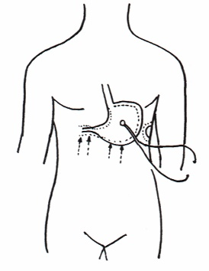

Fig. 1
Gastric aspecific reflex: in the stomach, both body and fundus are dilated, while the antral pyloric region cotracts.

By contrast, reflex lt (= lymphatic Diagram. See later on) lowers to 5 sec. ( NN = 10 sec.) in both decompensated diabetes, Bilancini-Lucchi’s Sign (4), and, in case of healthy, CAEMH-α-positive, but after > 10 sec. of insulin secretion interruption, for instance, by “intense” stimulation of pancreas trigger-points (= lasting and intense cutaneous pinching of VI thoracic dermatomere), or during stimulating melatonine secretion and/or SST-RH (13) (Tab.1).

BIOPHYSICAL-SEMEIOTIC METHODS OF GLYCEMIA EVALUATION

LYMPHATIC DIAGRAM (BILANCINI-LUCCHI’S SIGN)
basal and afterstress-tests

TISSUE-MICROVASCULAR UNIT DIAGRAM OF DIGITAL PULP
basal and afterstress-tests

INSULIN SECRETION AND PANCREATIC AND PERIPHERAL
MICROCIRCULATION ASSESSMENT

Tab.1

We are carrying on studies, whose present data are really promising, which aim to “quantify” the reduction of the lt of aforementioned reflex after “standard” (10 sec.) inhibition (impairement) of insulin secretion, a) in healthy, without CAEMH-α and with CAEMH-α, b) in subjects involved by “diabetic constitution”, c) in case of Grew Zone or pre-morbid Zone, d) in Reaven Syndrome, with and without the presence of slow diabetic evolution.
Obviously, such as evaluation must be applied after exclusion of whatever oedematous disorders of the arm.
In assessing the present glycemia with the aid of the original semeiotics, the “Tissue-Microvascular Unit Diagram” (T-MVU) of digital pulp plays a pivotal role, as is described in following. (For further information about practical application and all components significancies, See: www.semeioticabiofisica.it/semeioticabiofisica/applicazioni.htm) (Fig.2).

Physiological diagram of the Tissue-Microvascular Unit.

“Mean” (NOT intense) digital pressure, applied , e.g., on a digital pulp of healty individual, in supine position and psycho-physically relaxed, brings about gastric aspecific reflex after a latency time (lt) of 6 sec., lastings exact 6 sec., showing the same intensity, and is followed by three reinforcements with identical characteristics. Thereafter, tonic Gastric Contraction (tGC) appears slowly (> 2 sec.).
If doctor interrupts “quickly” digital pressur, immediately one observes a “small” gastric aspecific reflex, onda Z., indicating the physiological reperfusion as well as normal microvessel elasticity. The values of all these parameters, transported on cartesian asses, even in the mind, forme the diagram of tissue-microvascular unit (t.mvu), which gives a lot of information (Fig. 2).

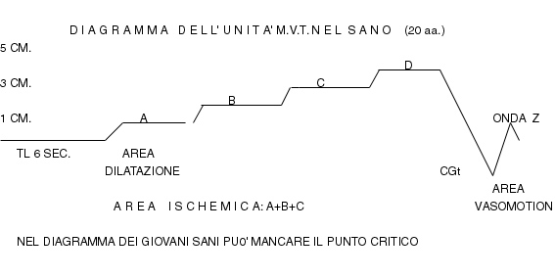
Fig. 2

Interesting the latency time of 6 sec., the orizontal line at the top of Dilation Area (AD), the absence of Acidosis Critical Point (CP) of 5 cm., and the definiteZ wave.
Explanation in the text.

As regards the evaluation of glucose blood level (glycemia) by means of Biophysical Semeiotics, all tests causing transitory lowering of insulin secretion modify pathologically the “physiological” diagram, which becomes that carachteristic of diabetic various phases (See later on), corroborating the reliability of employed method: lt lowers to 5 sec. (NN = 6 sec.), A Phase becomes large and closed at the top characteristically by “ascending” line, acidosis Critical Point (CP) of 5 cm appears in D Phase , tGC occurs rapidly, and Z wave disappears.

The tissue-microvascular unit diagram in IGT

In the patient with “initial” IGT, “basal” diagram of tissue-microvascular unit, but not that observed during stress tests, shows a normal latency time jet (NN = 6 sec.), while during both stress tests and various IGT phases in slow diabetic evolution, when insulin secretion is impaired (Fig.3), lt lowers to 5 sec.(= short-time, isolated episodes of hyperglycemia, particularly post-prandial).
A Phase is carachterized by large Dilation Area (DA) ≥ 1 cm. (= capillaries dilated NN ≤1 cm., in an age-dependent way): gastric aspecific reflex shows intensity ≥ 2,5 cm., realized in 1 sec., as α angle > 45° demonstrates.

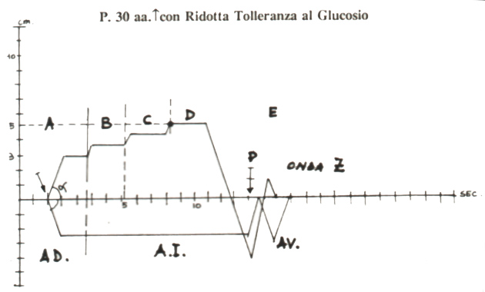

Fig.3

Explanation in the article.

Interestingly, α angle is > 45°, indicating A Phase rapid occurrence, showing upper line physiologically “horizontal”. Microvessel dilation, as consequence of hypoglycemic episodes, caused by hyperinsulinemia (values observed 3 hours after meal, i.e., in the postabsorptive stage) disappears, in fact, after apnea test of 5 sec. duration (= sympathetic hypertonus reduces insulin secretion). Such as microvessel modification aimed to the tissue normal supply of O₂ and substrates.
In fact, the subsequent three phases show a completely physiological behaviour: A Phase closed at the top by an horizontal line; critical point PC of 5 cm. in D Phase; duration of single Phases B, C, and D equal to 6 sec.; tGC appearing latency time is slow (2-3 sec.) and tGC disappearing lt is quick (2 sec.) as well as the presence of Z wave indicate that tissue-microvascular unit is slight suffering from the morphological view-point (= Ditzel’s functional diabetic microangiopathy) (6).
At this point, doctor must obviously examine carefully all biophysical-semeiotic signs reliable in rapid recognizing IGT: latency time duration of pancreatic-gastric aspecific reflex >12-13 sec. under hyperinsulinemic condition, pancreatic preconditioning, assessment of vasomotion – both pancreatic and peripheral – in post-absorptive state and absorptive state.
In this stage of glucose metabolism – in the diagram, CP of 5 cm. is located in D Phase and Z wave is present (= physiological capillary elasticity) – a correct, proper diet, etymologically speaking, discontinue, or let come back, the alterations of tissue-microvascular unit diagram, particularly in most favorable cases.
Contemporaneously, we observe the regression, untill the disappearing, of biophysical-semeiotic numerous signs of initial phases of diabetes mellitus.
In fact, insulin receptor sensitivity return to normal value (= pancreatic and peripheral vasomotion are the same), when real body weight parallels “ideal” body weight, and histangic acidosis and/or the alterations of lipid metabolism, independent of actual lipidemic values, assessed with the aid of Biopohysical Semeiotics (= preconditioning of abdominal adipose tissue), allways present, even of small intensity, due to negative lipid action (particularly triglicerides) on insulin receptor sensitivity (See in the site the aforementioned articles on diabetes mellitus).

Tissue-Microvascular Unit diabetic Diagram (IDDM and NIDDM).

Diabetic diagram, which allows by itself to diagnose diabetes at the bed-side, is carachyerized by lt of 5 sec. (NN = 6 sec.), slow carrying out of gastric aspecific reflex, wich persists for A Pase duration if diabetes is decompensated. i.e. 6 sec. (= stiffeness of microvessel wall due to PAS-positive substance storage and local connectivisation events) associated with pathological modifications of interstitial amorphous matrix (Fig.4).
In addition, diabetic diagram shows an intense A Phase, indicating capillary dilation. Typically and, therefore, interestingly, “ascending” line at the top of A Phase persists in relation to glycemic levels: in case of metabolic decompensation when glycemia is higher tha normal, highest duration is 6 sec. (Fig.4).
Consequently, diagnostic value of diabetic diagram is really noteworthy: typical is the slow, “ascending” line, at the top of A Phase, which continues in B Phase by degree, in a smooth manner, in absence of “horizontal” A line. This behaviour is carachteristic of both type 1 and type 2 DM, if glucose blood levels are pathological.

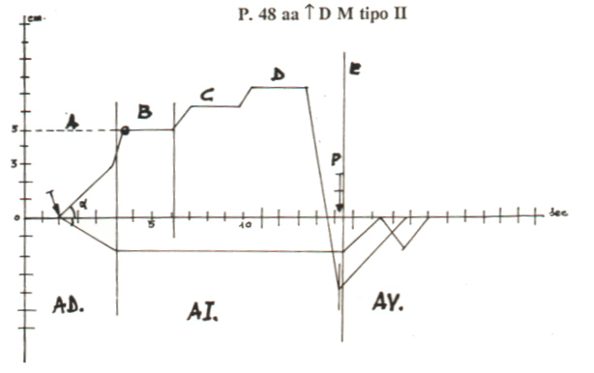

Fig.4

Figure shows a lt < 6 sec.,A Phase with the carachteric ascending line at the top related to raised glucose blood levels,PC (°) location in the B Phase, whose duration is < 6 sec. (important parameter value in bed-side assessing glycated proteins), intense Dilation Area (AD)as well as Ischaemia Area (AI), severe impairement of Vasomotion Area (AV). Noteworthy are particularly the typical behaviour of slow carrying out of gastric aspecific reflex, showing a lt of only 5 sec., and the “ascending” line at the top of A Phase, characteristic sign od overt diabetes mellitus: its duration is related to the glycemia arising. Under abscissa in referred the behaviour of cholecystic-choledocic reflex.

In case of type 1 and 2 DM. DA intensity is ≥ 2 cm. (NN = 1,5 cm.), due also to the store of interstitial amyloid (See my article in the site at URL
www.semeioticabiofisica.it/semeioticabiofisica/Documenti/Ita/Diagnosi DM. amiloide.doc), and it is closed at the top by “ascending” line, becoming more steep in the terminal tract, since physiologically horizontal line of A Phase is absent, in reltion to the diabetic syndrome severity.
Consequently, α angle appears to be < 45°. The Critical Point is located towards diagram left side, in initial part of B, and is allways exeeded by subsequent reinforcing of gastric aspecific reflex: diagram “verticalization with shifting to the left”, “aspecific” pathological sign.
Obviously, associated ATS increases the pathoogical “verticalization with shifting to the left of diabetic diagram of tissue-micorvascular unit.
Easy to understand, remarkable appears the impairment of Vasomotion Area (AV), even in case of a patient involved by NIDDM with glycemia properly controlled only by diet (Fig.2): tGC do “rapidly” occur and “slowly” disappears (O₂RT or O₂ Recovery Time) > 2sec., after quick interruption of digital pressure; Z wave is absent.
Analogous is the behaviour of first phase of lymphatic diagram, Bilancini-Lucchi’s sign, mentioned above, demonstrating internal and exteernal coherence of biophysical-semeiotic theory: after a lt < 10 sec. (NN = 10 sec.), in relation to DM severity, starting from the applying of “light” digital pressure on internal surface of arm middle third, gastric aspecific reflex appears, that forms lymphatic diagram, showing a slow, and prolonged realization, present since the initial phases of DM (6) (Fig. 5).

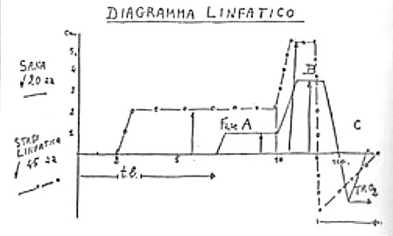

Fig.5

Explanation in the text.

From “clinical” diagnostic view-point, tissue-microvascular unit diagram plays a pivotal role in type 1 DM (NIDDM) (Fig. 3).

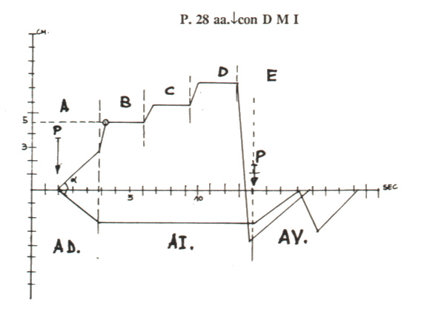

Fig.6
Figure shows the diagram of mvt.u in case of type 1 DM. The behaviour of A Phase is typical with “ascending line at th top, wich becomes steef in final tract.Interestingly, B Phase duration (NN = 6 sec.) appears reduced inindirect relation to the increase of glycated haemoglobin.

Once again, lt is smaller than normal (< 6 sec.) and ascending phase of gastric aspecific reflex close A Area at the topo: initially it realises slowly and, than, rapidly; quick final increasing is typical of diabetes mellitus as well as “severe” IGT. α-Angle is < 45°. Dilation A is large, so that CP of 5 cm. is located in the first part of B Phase and later is abundantly exeeded: “verticalization with shifting to the left”.
Duration of B Phase (NN = 6 sec.) is really interesting and gives a lot of information: it is shorter than normal value in inverse relation to diabetic metabolism impairmnet, i.e., as higher results glycated haemoglobin.
As a consequence of remarkable alteration of post-ischemic reactive hyperaemia, tGC realizes in less than 2 sec. (NN 2-3 sec.), and disappears “slowly” (TRO₂ > 2 sec.); finally, Z wave is absent ( the patient, whose diagram is referred in Fig. 6, was 28 year old!).
In other words, the illustrated diagram allows by it-self to diagnose diabetes mellitus, underlyning a severe disorder of tissue-microvascular unit, e.g., of digital pulp or ungueal nail-fold, caused by stiff and dilated microvessels (large DA), where, therefore, both microcirculation and gaseous exchange are enormeously compromised: diagram “verticalization with shifting to the left”.
At this point, it is useful to report an interesting datum regarding IDDM bed-side diagnosis, i.e., the absence of amyloid storage in the interstitium of Langheran’s isles. In consequense of this fact, pancreatic-“in toto” ureteral reflex show a normal intensity (< 1 cm.), in contrast to the above-mentioned observation in case od NIDDM (≥ 1 cm.). (For furter information, See the URL www.semeioticabiofisica.it/semeioticabiofisica/Documenti/Ita/Diagnosi DM. amiloide.doc),
In addition, the accurate evaluation of vasomotion, both in the pancreas and in peripheeral organs (lever, scheletric muscle, central and peripheral adipose tissue, useful in clinical assessing insulin receptor sensitivity), allows doctor to recognize DM by means of clear-cut “discordance” of relative values of AL + PL duration in the absorptive-state as well as in the post-absorptive state (For further information on this fascinating aspect of Clinical Microcirculation, See the URL www.semeioticabiofisica.it /semeioticabiofisica/Documenti/Ita/A IIR Lipids Sem. Bio it.doc).
Before concluding the illustration of “diabetic” diagram of t.mvu., it is necessary to underscore the correlation between latency time (NN = 6 sec.) and duration of A Pase “ascending” line with present glucose blood level – with some extent – while B Phase duration (in sec.) (NN = 6 sec.) reveals an inverse correlation with glycated haemoglobin values, for the first time clinically assessed in a really reliable manner.
We avoid now and here discussing pathophysiological mechanisms, surely interesting, afore-mentioned relations are based on, useful from “clinical” view-point, preferring a “pragmatic” illustration. We must , however, state that lt shortness and A Phase behaviour are correlated with capillary dilation and stiffeness, as well as early store of interstitial amyloyd, secondary to the histangic disorder, caused by hyperglycemia. Moreover, B Phase shortness (NN = 6 sec) is related to capillary basal memmbrane thickeness, related in turn to glycation phenomena.

Discussion and Conclusion.

Half of patients with type 2 diabetes mellitus (95% of all diabetes cases) are nowadays undiagnosed, although the assessement of glycemia in unfasted individuals is to-day routine investigation.
Therefore, in the war against diabetes we must go “beyond glicemia”.
The biophysical-semeiotic methods, described in this paper, are based on capillary altered permeability, present at base-line, or in initial phases during dynamic tests, detectable in DM starting from “diabetic constitution”.
Beside the well-known diabetic microangiopathy of overt cases, carachterized by structural alterations involving type II AVA, B group, according to Buccciante (7), and, as we demonstrated, by DEB genetically dependent modifications (See the papers in above-cited two sites), really exists capillary altered permeability, secondary to endothelial as well as perivascular matrix disorders, cused by CAEMH-α (1). Our clinical data are in perfect agreement with those of other authors, who demonstrated endo-capillary increasing even in the first stages of DM, before microangiological structural alteration, notoriously and obviously worsened by successive metabolic alterations (14).
In reality, the increasing of blood insulin level, present in those stages preceeding for years and decades diabetic manifestations onset, brings about venular-capillary pathological permeability (15). Both diabetes and IIR cause endothelial dysfunctions, including the augmentation of permeability (16), which plays a pivotal role in patho-physiology of cardiovascular diseases.
Formerly, in papers cited in this article, we have demonstrated that tissue acidosis plays a primary role in provoking microvascular damage; such as negative action is already present at birth, i.e., years or decades before the occurrence of whatever sign of retinopathy and nephropathy, in agreement with other authors (6, 17). Caused by CAEMH-α,histangic acidosis, through capillary pathological dilation (= high A Phase in t.mvu diagram) provokes increasing of capillary permeability, that in diabetic patient is correlated with the severity of glicemic values.
As a matter of fact, in overt disease, we observe reduction of blood supply and increasing of oxygen consumption. Consequently, under these metabolic conditions, the genetically-dependent histangic acidosis, which acts in negative manner on vascular permeability, is further augmented and thus capillary permeability appears worsened (17).
At this point, we must remember that obesity, associated very often with IIR, is correlated with low-grade inflammation, nowadays regarded as a progression factor of arteriosclerotic process (18);partly, such as association may be explained by the increasing of adipose tissue in subjects with metabolic syndrome. Adipose tisssue, an intern secretion organ, produces cytochines, like IL-6, among other substances, wich increse by itself capillary permeability.
Biophysical Semeiotics allows doctor to evaluate, not only the present “glycemia”, correlated with capillary altered permeability, but also efficaciously insulin secretion (stress tests and pancreatic preconditioning), insulin receptor sensitivity in various peripheral organs, lipid dysmetabolism in individuals involved by “diabetic” and “dyslipidemic” constitutions, conditio sine qua non of type 2 diabetes occurrence.

References.

- Stagnaro S., Stagnaro-Neri M. Valutazione percusso-ascoltatoria del Diabete Mellito. Aspetti teorici e pratici. Epat. 32, 131, 1986.
- Stagnaro S.-Neri M., Stagnaro S., Sindrome di Reaven, classica e variante, in evoluzione diabetica. Il ruolo della Carnitina nella prevenzione del diabete mellito. Il Cuore. 6, 617, 1996 (Pub-Med indexed for Medline).
- Stagnaro-Neri M., Stagnaro S., La “Costituzione Colelitiasica”: ICAEM-α, Sindrome di Reaven variante e Ipotonia-Ipocinesia delle vie biliari. Atti. XII Settim. It. Dietol. ed Epatol. 20, 239, 1993.
- Stagnaro-Neri M., Stagnaro S., Il Segno di Bilancini-Lucchi nella diagnosi clinica del diabete mellito. The Pract. Ed. It. 176, 30, 1993.
- The Diabetes Control and Complications Trial Research Group. The effect of intensive treatment of diabetes on the development and progression of long-term complications in insulin-dependent diabetes mellitus. N Engl J Med. 1993;329:977-986.
- Ditzel J. Functional Microangiopathy in Diabetes Mellitus. DIABETES, 17, 388, 1968.
- Curri S.B. Le Microangiopatie. Inverni della Beffa. Milano 1968.
- Pratesi F. Microcircolazione e Microangiologia. <fisiopatologia, Clinica, Terapia. Ed. Minerva Medica. Torino, 1990.
- Stagnaro S., Diet and Risk of Type 2 Diabetes. N Engl J Med. 2002 Jan 24;346(4):297-298. letter [PubMed –indexed for MEDLINE].
- Ditzel J, Standl E. The problem of tissue oxygenation in diabetes mellitus. I. Its relation to the early functional changes in the microcirculation of diabetic subjects. Acta Med Scand Suppl 1975;578:49-58.
- Feener EP, King GL. Endothelial dysfunction in diabetes mellitus: role in cardiovascular disease.Heart Fail Monit 2001;1(3):74-82.
- Zenda T, Murase Y, Yoshida I, Muramoto H, Okada T, Yagi K.
Does the use of insulin in a patient with liver dysfunction increase water retention in the body, i.e. cause insulin oedema? Eur J Gastroenterol Hepatol 2003 May;15(5):545-9.
- Stagnaro-Neri M., Stagnaro S., Semeiotica Biofisica: valutazione clinica del picco precoce della secrezione insulinica di base e dopo stimolazione tiroidea, surrenalica, con glucagone endogeno e dopo attivazione del sistema renina-angiotesina circolante e tessutale – Acta Med. Medit. 13, 99, 1997.
- Sandeman DD, Shore AC, Tooke JE. Relation of skin capillary pressure in patients with insulin-dependent diabetes mellitus to complications and metabolic control. JAMA. Volume 327:760-764 September 10, 1992 Number 11.
- Zenda T, Murase Y, Yoshida I, Muramoto H, Okada T, Yagi K.
Does the use of insulin in a patient with liver dysfunction increase water retention in the body, i.e. cause insulin oedema? Eur J Gastroenterol Hepatol 2003 May;15(5):545-9.
- Feener EP, King GL. Endothelial dysfunction in diabetes mellitus: role in cardiovascular disease. Heart Fail Monit 2001;1(3):74-82
- Ditzel J, Standl E. The problem of tissue oxygenation in diabetes mellitus. I. Its relation to the early functional changes in the microcirculation of diabetic subjects. Acta Med Scand Suppl 1975;578:49-58
- Mohamed-Ali V, Goodrick S, Rawesh A, et al. Subcutaneous adipose tissue releases interleukin-6, but not tumor necrosis factor, in vivo. J Clin Endocrinol Metab.1997;82:4196-4200.

