Arteriosclerotic Obliterans Peripheral Artheriopathy: Biophysical-Semeiotic Bed-Side Diagnosis, since initial, asymptomatic stages.

Summary.

In the paper, the author describes biophysical-semeiotic methods, which are useful, reliable, and effective in recognizing “clinically” arteriosclerotic obliterans peripheral arteriopathy (AOPA), even in its symptomless and/or initial stages. On the contrary, bed-side diagnosis of AOPA is notoriously very difficult by means of the old, traditional, acàdemic physical semeiotics, at least in early, asymptomatic phase, when the treatment provides the best results. In addition, biophysical-semeiotic methods, based upon a large number of signs, different in refinement and difficulty, allows doctor to apply obiective therapeutic monitoring.

Introduction.

AOPA is a common disorder, particularly among aging men in the developed countries, which evolves slowly, so that many years or decades pass overlooked, before patients complain about the well-known clinical symptomatology. Due to this reason, patients undergo to opportune and common medical treatment an diet, etimologically speaking, to late, i.e. a long time after the “real” onset of the frequent disorder. As a matter of fact, we do not are astonished at high prevalence of AOPA because the numerous risk factors of arteriosclerosis are really widespread among men and nowadays also amon women: tobacco smoking, obesity, arterial hypertension, diabetes mellitus, dyslipidaemia, a.s.o.
With regard to atherogenesis as well as its risk factors, we have to consider that they act on a congenital factor, conditio sine qua non of all these disorders, i. e. a mitochondrial cytopatology, characterized by functional impairment of the respiratory chain, which brings about a low cellular energy production. In according to the Microcirculatory Theory of Arteriosclerosis (See Arteriosclerotic Constitution in this site), the well-known risk factors work exclusively in presence of this congenital mitochondrial pathology, I termed Congenital Acidosic Enzyme-Metabolic Histangiopaty (1, 2, 3, 4, 5 and NEJM, correspondence, in press).
I agree completely with Alan T. and co-worker (7), who write that peripheral arterial disease is a highly prevalent atherosclerotic syndrome that affects approximately 8 to 12 million individuals in the United States and is associated with significant morbidity and mortality.
Because of its high prevalence, as a manifestation of systemic atherosclerosis, it is both common and associated with an increased risk of death and ischemic events, yet may be underdiagnosed in primary care practice.
In my opinion, however, the authors ignore generally that, nowadays, beside the traditional, académic, othodox physical semeiotics exists, fortunately, also the Biophysical Semeiotics, which allows doctors to recognize and detect promptly and easy peripheral arterial disease, even clinically silent (1, 2, 5, 6, BMJ.com. A new physical semeiotcs in detecting disorders otherwise undiagnosed. Stagnaro Sergio (30 March 2001).
Among a lot of biophysical semeiotic signs, in following I illustrate a simple but reliable clinical manouevre, useful in detecting in a “quantitative” manner arterial obliterans peripheral disease, since very initial, symptomless stage.
Conditio sine qua non of the efficacious therapy is clearly early clinical diagnosis, obtained with a method applicable on all patients, including those clinically silent, who attend examination room due to whatever disorder.

Methods.

As a premise, “all” patients involved by AOPA, even initial and silent, present arterioscleotic biophysical-semeiotic constitution (See in the site: Constitutions).
In healthy, in supine position, intense, occlusive digital pressure on common femoral artery, at the groin, brings about the “gastric aspecific reflex” (= in the stomach, both fundus and body are dilated, while antral-pyloric region contracts, evaluated by means of auscultatory percussion, as described in this site, Technical Page, N° 1, and in above-mentioned papers) after a latency time of 8 sec. (Fig.1).

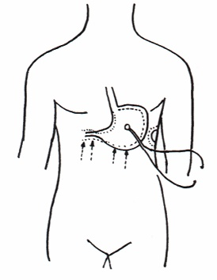

Fig. 1

Gastric aspecific reflex: in stomach, both fundus and body are dilated, while antral-pyloric region contracts. Doctor has to assess accurately some parameters value: latency time, starting from the application of “intense, occlusive” pressure upon the femoral arthery at the groin(NN = 8 sec.); duration of the reflex (NN = 6 sec.); duration of the reflex disappearance before a successive reflex. In our case, after the first reflex, doctor observes three further increasing before the tonic Gastric Contraction. At this moment, it is sufficient to assess exclusively lt.

On the contrary, in diseased subject, the latency time appears shorter in relation to the severity of underlying disorder, i.e. ATS: ≤ 7 sec.
A 45-years long experience allows me to state that Biophysical Semeiotics permittes to identify a large number of patients with previously unrecognized AOPD with the aid of only this sign.
At this point, it is necessary to underline that, in healthy, digital pressure, applied upon the skin, scheletric muscle, pulp of a toe, brings about a gastric aspecific reflex with lt 8 sec. (= tissue pH) identical to that previously ascertained, indicating the internal and external coherence of biophysical semeiotic theory.
Really, as above-mentioned, after this reflex doctor observe three further reflex increases, which take a part to the arterial diagram (Fig. 2), rich of information.

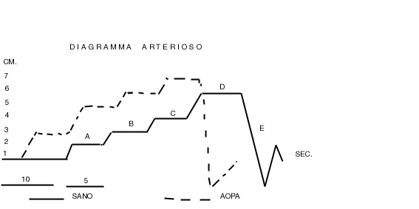

Fig. 2

The figure shows arterial diagram in healty (continuous line) and in case of AOPA, where lt is decreased (NN = 8 sec.) as well as the diagram “verticalization” with shifting to the left of Critical Point (CP = 5 cm. on the ordinate). Interestingly, Phase E is clearly compromised: soon after arterial occlusion rapid interruption, stomach return physiologically to its basal value, and then appears a small gastric aspecific reflex (E), which indicates normal elaticity of arterial wall.

Beside this biophysical-semeiotic method, there are a large variety of bed-side assessements of blood circulation in peripheral arterial vessels, more difficult to perform, but really refined, as the evaluation of the microcirculation in the pulps of toes: in healthy, in supine position and psycho-physically relaxed, digital pressur of “light-moderate” intensity, applied upon the pulp of a toe, brings about gastric aspecific after lt. 6 sec., and duration 6 sec., and three subsequent re-enhancements, followed by tonic Gastric Contraction (tGC). Soon after the rapid interruption of the stimulation, in only 2 sec. the stomach reaches the basal volume and subsequently appears a small gastric aspecific reflex (Z wave): tissue-microvascular unit diagram (Fig.3).

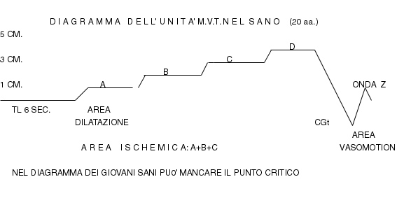

Fig. 1

Physiological diagramm of tissue-microvascular unit is characterized by lt 6 sec., duration 6 sec., intensity about1 cm., as are the parameters values of the three furter re-enhancements, so that Critical Point of 5 sec. could be absent, as in this case. Moreover, CGt is realized slowly in > 2 sec., while its disappearence is rapid (2 sec.), followed by Z wave, indicating elasticity of microvessels wall.

On the contrary, in case of AOPD, lt is decreased, Critical Point is present in phase B or C with diagram shift to the left, tGC is more rapid than normal (2 sec.) and, finally Z wave is absent (Fig. 2)

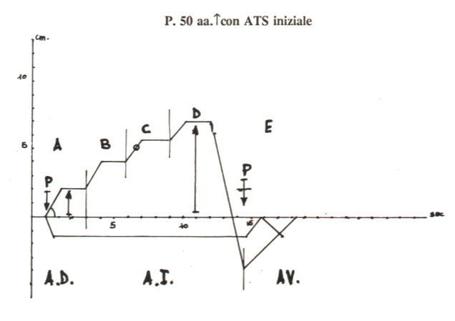

Fig. 3

The figure shows tissue-microvascular unit diagram of “initial” ATS, characterized by lower lt, higher Phase A, B, and C, CP(black point) present in Phase C (“verticalization and shifting to left”), rapid tGC and, finally, by the absence of Z wave, although the patient is 50 year old.

AOPA Diagnosis

Arterial-Gastric Aspecific Reflex.
Leg Tissue-Gastric Aspecific Reflex.
Arterial Diagram.
Microvascular-Tissue Unit Diagram.
Clinical Microangiology Data.

A large number of microangiological information can be collected in a refined manner by the accurate evaluation of both vasomotility and vasomotion, i.e. assessing the fluctuations of upper and, respectively, lower ureteral reflexes, brought about by “light” digital pressure, applied upon whatever limited part of the leg, e.g. the pulp of toes.
In a next future, in this site, a large space will be devoted to Clinical Microangiology, in both physiology and pathology.

1) Stagnaro S., Istangiopatia Congenita Acidosica Enzimo-Metabolica condizione necessaria non sufficiente della oncogenesi. XI Congr. Naz. Soc. It. di Microangiologia e Microcircolaz. Abstracts, pg 38, 28 Settembre-1 Ottobre, 1983. Bellagio

2) Stagnaro S., Istangiopatia Congenita Acidosica Enzimo-Metabolica. X Congr. Naz. Soc. It. di Microangiologia e Microcircolazione. Atti, 61. 6-7 Novembre, 1981. Siena

3) Stagnaro S., Istangiopatia Congenita Acidosica Enzimo-Metabolica. Una Patologia Mitocondriale Ignorata. Gazz Med. It. – Arch. Sci. Med. 144, 423, 1985.
4) Stagnaro-Neri M., Stagnaro S., Auscultatory Percussion Evaluation of Arterio-venous Anastomoses Dysfunction in early Arteriosclerosis. Acta Med. Medit. 5, 141 |  |  | 1989
5) Stagnaro S., Rivalutazione e nuovi sviluppi di un fondamentale metodo diagnostico: la percussione ascoltata Ligure di Scienze e Lettere. Vol. XXXIV, 1978.
6) Stagnaro-Neri M., Stagnaro S., Modificazioni della viscosità ematica totale e della riserva funzionale microcircolatoria in individui a rischio di arteriosclerosi valutate con la percussione ascoltata durante lavoro muscolare isometrico. Acta Med. Medit. 6, 131-136, 1990
6) Alan T. et coll. Peripheral Arterial Disease Detection, Awareness, and Treatment in Primary Care; JAMA. 2001;286:1317-1324

