Biophysical-Semeiotic Dyslipidemic Constitution.

By Sergio Stagnaro

(From the book, in advanced preparation: “Semeiotica Biofisica. Microangiologia Clinica” Stagnaro-Neri M. and Stagnaro S., with some modifications).

Introduction. 1
Methods. 2
1) Preconditioning of abdominal adipose tissue. 2
2) Evaluation of the EBD of “central” adipose tissue. 3
Bibliography. 4

Introduction.

A part from its inflammatory, infectious, degenerative, metabolic, neoplastic nature, a disease arises and evolves in relation to the individual constitution, since environmental factor, surely important, interacts with genetic factor always present, as clinical evidence shows it.
As extreme example, let us consider the “traumatic” pathology: if the diseased subject does not die, of course, fracture evolves and ends in relation to patient constitution. In fact, there are notoriously identical cases, as concerns the initial severity, among them some people rapidly and completely recover, while other undergo morbidity and even mortality, due to complications, clearly in relation to efficacious tissue repair, bone synthesis, tissue heal, all events genetically directed.
The primary role played by the constitution is manifest also in infectious diseases, incuding the common children diseases, viral in origin, which evolve especially, although not exclusivelly, in relation to psycho-physical situation of every individual and certainly to sensitivity to treatment, although nowadays only specific vaccines are successfull.
The constitutional factor shows its primary role in degenerativeas well as metabolic diseases, in chronic inflammations, in connectivitis, and malignancies, as we demonstrated previously (Oncological Terrain – accepted by Minerva Medica Edizioni, Turin; unfortunately until now we are awaiting for a sponsor, who publishes and spreades it. See www.semeioticabiofisica.it, www.staibene.it November 2001).
There is nowadays a general agreement with the fact that “genotype” influences both the onset and the course of most commom and frequent human diseases, very often associated with environmental factors, since it is plain that “without rice-field the rice does not grow” (Oncological Terrain, in the above-cited site).
To summarize, a part from its inflammatory, infectious, degenerative, metabolic, rheumatic, neoplastic nature, a disease arises and evolves in relation to the individual constitution, since environmental factor, surely determinative, must react with the genetic factor, which is always present.
Biophysical Semeiotics, enlarging enormeously the borderland, really limited, of traditional, orthodox, physical semeiotics, allowed us, over the last decades, to precisely define a lot of constitutions, as we illustrated in previous papers (See Bibliography in the site).
In characterising biophysical-semeiotic constitutions, we started from the hypothesis or conjecture – then revealed truh, scientifically speaking – that “altered” genome, nuclear as wel as mitochondrial, modifies both function-structure of various parenchymas and function-structure of related microvessels, thus, permitting us to enlarge and complete Tischendorf’s concept of Angiobiotopie.
Finally, by means of the original physical semeiotics, which proved to be essential and precious in giving rise to Clinical Microangiology, doctor now is able to recognize at the bed-side functiona-structural modifications of tissue-microvascular-units, characteristic of the diverse constitutions, starting from two first decades of individual life.

Methods.

Clinical evidence demonstrates that the dyspipidaemic constitution necessarily exists: among individuals comparable as far as age, sex, social state, lifestyle, diet, a.s.o., are concerned, some are dyslipidaemic, while other are not. In addition, among children of dyslipidaemic parents only some show high cholesterol concemtretation (total Ch. and/or LDL and/or non-HDL) as well as tryglyceridies, of course, when diet, etymologically speaking, i.e. day program, is the same. Finally, among individual with identical lipidaemic concentrations values, the seriousness of well-known disorders are clearly different.
Therefore, the “real” risk of dyslipidaemia, based on genetic alterations, truhly exists, as allows to state clinical evidence, beyond actual genetic investigations.
In a few minutes, Biophysical Semeiotics permits doctor to recognize, at the bed-side and in “quantitative” manner, both the presence of dyslipidaemic constitution and dysplipidaemia, by a large number of methods, which obviously need a very different knowledge of this origial semeiotics.
As follows, in the interst of reader not jet experienced in this diagnostic method, we will illustrate two ways, easy enough to perform, certainly reliable in recognizing dyslipidaemic situations, even in intial stages, until now undiagnosed clinically.

1) Preconditioning of abdominal adipose tissue.

Notoriously there is a great structural-functional difference between “central” adipose tissue, i.e. abdominal and visceral adipose tissue, and that “peripheral”, e.g. thigh. Insulin-resistance involves, as we clinically demonstrated, almost always central adipose tissue, we are here investigating, but not peripheral adipose tissue, e.g. tight.
Biophysical-semeiotic preconditioning is the method of examination based on comparison of the parameters values of some reflexes, assessed in “quantitative” manner at rest (basal line) and then in a second evaluation, performed after exact 5 sec. of intervall from the first. From the technical clinical-microangiological point of view, by means of this clinical tool, doctor evaluates precisely both structure and function of local microvascular system, i.e. local Microcirculatory Functional Reserve (MFR) (4, 5).
From technical view-point, at least it is necessary the knowledge of auscultatory percussion of stomach (Fig.1) (www.semeioticabiofisica.it, Technical Pages, N° 1).

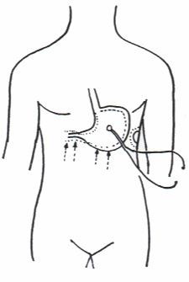

Fig. 1

Figure shows both the precise location of bell-piece of stethoscope and parallell and centripetal lines, on which digital percussion, directly and gently, must be applied in order to outlining properly the great curvature of stomach, or in practice only a small tract.

In an individual, psycho-physically relaxed and in supine position, cutaneous “lasting” pinching of the abdomen (lateral abdominal part at right and at left, or near to umbilicus) physiologically provokes gastric aspecific reflex (Fig. 1: in the stomach, both fundus and body are dilated, while antral-pyloric region contracts) after latency time (lt) 8 sec.
In healthy, immediately after preconditioning lt rises to ≥ 10 sec.
On the contrary, in subjects with dyslipidaemic constitution as well as obviously in dyslipidaemic patients, lt at basal line results ≤ 8 sec. and after preconditioning appears to be either the same or reduced, in inverse relation to the seriousness of underlying disorder.
Without discussing patho-physiological mechanisms, the values of gastric aspecific reflex parameters are based on, it is enough to know that these behaviours are related to local Functional Microcirculatory Reserve (FMR), which in turn is strictly related to both anatomy and function of important microcirculatory structures, essential in direct capillary blood-flow, which parallel parenchimal alteration, both structural and functional.
Among these really interesting structures we consider, later, only ubiquitarious Endoarteriolar Blocking Devices (EDB). According to our researches (See Bibliography in above-cited site and in www.semeioticabiofisica.it/microangiologia), in fact, altered “genetic” information acts on both parechymal function-structure and local microvessels, that nowadays can be assessed clinically, thanks to Biophysical Semeiotics, which originated Clinical Micorangiology.

2) Evaluation of the EBD of “central” adipose tissue.

Before going on, reader must remember that EBD, present in all tissues, are manifold microvascular structures, made up by smooth muscle cells, placed in different ways, and lined with endothelial cells. They are localized in two stations (first and second stations) along small arteries, according to Bucciante whose media is formed by 2 or more layers of smooth muscle cells (6, 7, 8).
Their action mechanism (blood-flow direction toward the capillary bed) is obvious, in that their contraction brings about volume reduction, while the relaxation causes arteriolar lumen obstraction, evaluated as dilation of mean ureteral tract (Fig.2 and 3).
EBD Clinical biophysical semeiotic evaluation represents practically the assessement of “mean” ureteral reflex (dilation of ureteral mean third), caused by cutaneous-sub-cutaneous lasting pinching, of average intensity of adipose tissue, we want examine. (See above) (Fig. 2).

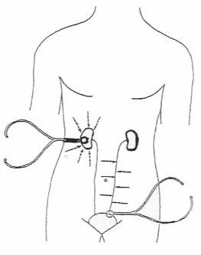

Fig. 2

In the figure the correct locations of the bell-piece of stethoscope and the lines upon which auscultatory percussion, directly and gently, must be applied, in order to out-linig properly both kidneys and ureters, are clearly indicated.

After lt 3-4 sec., appears the dilation (1 cm.) of mean ureteral third or mean ureteral reflex, which in healthy lasts for 20 sec. exactly and, then, disappears for exact 6 sec. (Fig. 3).
Interestengly, preconditioning lenghtens opening duration, which rises to about 22 sec., while reduces closure duration, that lowers to ≤ 5 sec., in relation to the degree or severity ot underlying metabolic disorder.

On the contrary, in case of dyslipidaemic constitution as well as dyslipidaemia, of course reflex duration (EBD opening) results ≤ 19 sec. (NN = 20), and its disappearing persists for 6-7 (NN = 6 sec. exactly).

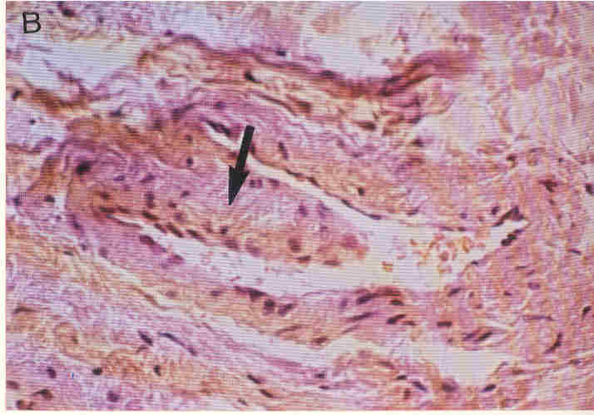

Fig. 3
Figure shows, in a very refined manner, a typical EDB with large installation base.
(from S.B. Curri’s Le Microangiopatie, Ed. Inverni della Beffa).

Moreover, soon after preconditioning these values either are unchanged, i.e. identical to those at basal line, or EBD opening appears to be lessened in a statistically significant manner, and the EBD closure is greater than before (7-8 sec.), in relation once again to the seriouness of underlying lipidic dysmetabolism.
In conclusion, the precise evaluation of microcirculation on “central” adipose tissue allows, in really easy way, to assess local MFR and, then, to recognize the dyslipidaemic constitution, starting from the first decades of life.
A large variety of further biophysical-semeiotic evaluations, which require a staedy knowledge of the new physical semeiotics, permits doctor to gather a lot of information about local metabolic situation and consequently about responsiveness to various hormons, including insulin (9,10).

Conclusion.

The precise evaluation of “central” adipose tissue microcirculation allows doctor to assess in an easy and rapid manner, clinically and on very large scale, the local function of MFR, and, therefore, starting from the first two individual’s life decades, to recognise the dyslipidemic constitution, since genetically-dependent alterations involve contemporaneously both the parenchyma and respective microcircle.
A lot of other biophysical-semeiotic evaluations, apllicable by doctor skilled in the new physical semeiotics, allow to collect at the bed-side a large number of signs on microcirculation, which give information on local metabolic situation as well as on sensitivity of many receptors, e.g., insulin-receptors (9, 10).
A long clinical experience permits us to state that the knowledge of dyslipidemic constitution is of paramount importance in day-to-day practice and research: rapid, early, easy, “quantitative” bed-side recognising individuals at real risk of dyslipidemia is unavoidable to primary prevention of a serious disease, that can bring about well-known severe macro- and micro-vacular complications, i.e., morbidity and mortality.
As regards the clincal research, the dyslipidemic constitution has allowed us to suggest an hypothesis, biophysical-semeiotic in nature, of type 2 diabetes mellitus, enlightening its natural history (See the above-cited site, Practical Applications, Diabetes Mellitus, article N° 3: “From biophysical-semeiotic diabetic and dyslipidemic constitutions to type 2 diabetes mellitus”).

Bibliography.

- Stagnaro S., Istangiopatia Congenita Acidosica Enzimo-Metabolica. Gazz Med. It. – Asch. Sci, Med. 144, 423,1985.
- Stagnaro S., Istangiopatia Congenita Acidosica Enzimo-Metabolica condizione necessaria non sufficiente della oncogenesi. XI Congr. Naz. Soc. It. di Microangiologia e Microcircolaz. Abstracts, pg 38, 28 Settembre-1 Ottobre, 1983 Bellagio.
- Stagnaro S., Istangiopatia Congenita Acidosica Enzimo-Metabolica. Una Patologia Mitocondriale Ignorata. Gazz Med. It. – Arch. Sci. Med. 144, 423, 1985. (Infotrieve).
- Stagnaro-Neri M., Stagnaro S., Deterministic Chaos, Preconditioning and Myocardial Oxygenation evaluated clinically with the aid of Biophysical Semeiotics in the Diagnosis of ischaemic Heart Disease even silent. Acta Med. Medit. 13, 109, 1997.
- Stagnaro-Neri M, Stagnaro S., Precondizionamento semeiotico-biofisico dei sistemi biologici. Il Medico delle Ferrovie. 3, 51 ,1999.
- Stagnaro-Neri M., Stagnaro S. Indagine clinica percusso-ascoltatoria delle unità microvascolotessutali della plica ungueale. Acta Med. Medit. 4, 91 , 1988.
- Stagnaro-Neri M., Stagnaro S., Auscultatory Percussion Evaluation of Arterio-venous Anastomoses Dysfunction in early Arteriosclerosis. Acta Med. Medit. 5, 141, 1989.
- Stagnaro-Neri M., Stagnaro S., Modificazioni della viscosità ematica totale e della riserva funzionale microcircolatoria in individui a rischio di arteriosclerosi valutate con la percussione ascoltata durante lavoro muscolare isometrico. Acta Med. Medit. 6, 131-136,1990.
- Stagnaro-Neri M., Stagnaro S., Semeiotica Biofisica: la manovra di Ferrero-Marigo nella diagnosi clinica della iperinsulinemia-insulino resistenza. Acta Med. Medit. 13, 125, 1997.

