NEOPLASTIC DIAGRAM OF TISSUE-MICROVASCULAR UNIT.

Preliminary reflections.

As we have already written in our book "Oncological Terrain" (See in the site: Oncological Terrain) about microcirculatory modifications, caused by stress hormones, particularly in the sites of "real risk" for cancer, during digital pressure stimulation, which brings about the secretion of related releasing-hormones (Fig.1), we have obviously supposed as possible the existence of a singular "microangiopathy" or more exactly speaking, the existence of the neoplastic histangiopathy, which, analogously with the diabetic one, could be "functional" in early stage (or mainly "functional", at beginning) and then structural (or mainly "structural", thereafter), due to the fact that structure and function, according to Leuckart, are terms of the same equation: changing the first, one modifies the later.
In following, we shall use the name of "microangiopathy", surely incomplete but more known among physicians, which really define, in our opinion, what we must mean as "histangiopathy".

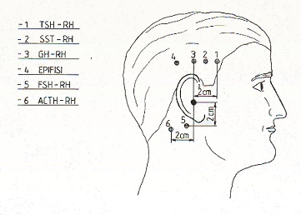

Fig. 1

Figure shows exactly the real sites of trigger-points necessary in order to stimulate, by the aid of digital pressure, different realising-factors of well known hormones, acting in oncological terrain.

In other words, we asked to ourselves whether the "initial" neoplastic microangiopathy exists or not, beside to the "overt or advanced" form, influenced by the particular neuro-hormonal terrain, that is on the base of the characteristic oncological terrain, Biophysical Semeiotics allowed us to describe (Fig. 2).

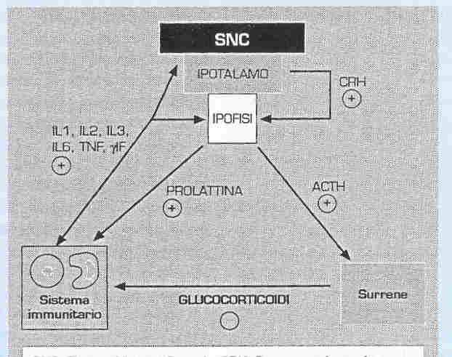

Fig.2

Figure indicates positive effect (signe + small ring) and negative one (empty ring) brought about by citochines and hormones upon immunological system, which shows a perfect functioning when opposite actions parallel each others. Explanation in the text.

It is necessary for reader to remember that the description of a "microangiopathy" from biophysical-semeiotic point of view, particularly in its advanced form, is very difficult due to frequent association with other disorders, which cause modifications of tissue-microvascular unit, that account for the reason that both mrphologial and biophysical-semeiotic pattern is indeed complex and atypical: for example, let us think on the microangiopathy of diabetic patient, suffering from arterial hypertension and/or rheumatic disease.

In addition, in case of "overt" neoplastic microangiopathy, it is really frequent the association with other disorders. It is enough to think about the contemporaneous presence of diabetes mellitus and/or deficiency syndromes and/or anemic syndromes and/or haematic hyperviscosity; reader clearly understands the difficulty of describing the "typical" overt neoplastic microangiopathy from biophysical-semeiotic view-point, if it exists, of course.
Moreover, in healthy, it is more difficult to recognize, if it exists, of course, initial "functional" neoplastic microangiopathy, that should represent an "epoch-making" event in primary prevention of cancer, since it sould take a part of oncological terrain, corroborated by such a microangiopathy.
On this subject, we have to ask to ourselves whether this singular microangiopathy, if really existing, is a "sistemic" one, i.e., present in every tissue, or "localised", i.e. cirumscribed, in a single tissue or, more precisely, restricted in a single well-delimited area of a tissue, which shows exactly to be at "real" risck for cancer.
In fact, recognizing this particular microangiopthy in an area of tissue would allow doctor to recognize exactly the site of oncological risk in a quantitative way: for example, in a mamma quadrant.
In presence of "oncological terrain", by means of type II, dissociated, microcirculatory activation, in the site of real risk both during and soon thereafter secretion stimulation of the hormones of stress-axis (Fig.1), possible characteristic, neoplastic, functional, and initial microcirculatory alterations could allow to selectively recognize, in "quantitative" and precise way, individual at "real risk" of well-defined tumour, who have to undergo preventive treatment, hopefully followed by best success.
Aiming to useful results in the practice, in both diagnosis and primary prevention, we utilized also a dynamic test, the "modified" Restano's manoeuvre (= sympathetic hypertonus), we will describe later on. (See Glossary).
To summarize, admitted the existence of initial "neoplastic microangiopathy", it is characterized by Oncological Terrain as well as type II, dissociated, microangiopathy, in the restricted are at "real oncological risk", whose clinical microangiological signs doctor can evaluate by means of Biophysical Semeiotics, at rest as well as during dynamic tests.

Neoplastic diagram of tissue-microvascular unit.

In healthy, under 30 year, positive for oncological terrain, apart from its seriousness or degree, tissue microvascular unit diagram shows, at rest, the phisiological behaviour, illustrated in Fig. 3: lt 6 sec., A, B, C, and D Phases, respectively of 1 cm. of intensity and duration of 6 sec.; consequently, very often CP, i.e., the critical point of 5 cm., is not present. In addition, vasomotion (AV) appears normal and Z wave is present (Fig.3).

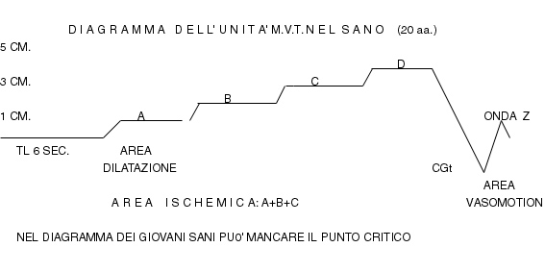

Fig.3

However, when evaluated during "modified" Restano's maneouvre (= subject, who must be investigated, does not take any breah for 7-10 sec., clentching for the test time only a fist, so that the other hand finger-pulps can be examined) soon thereafter apnea test, the diagram shows significant modifications, truly characteristic, and easy to be recognize clinically (Fig.4).

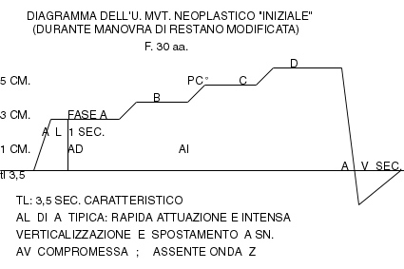

Fig. 4.

In patient involved by oncological terrain, not depending on its seriousness, confronting the basal, apparently physiological, tissue-microvascular unit diagram with that observed during "modified Reastano's manoeuvre (dynamic test = sympathetic hypertonus) shows ckearly modifications of certain parameters under sympathetic hypertonus, indicating that the responsiveness of the single components of microcircle in oncological terrain is statistically intense: "disease is an event ruled by sympathetic nerve", according to Prof. Malliani, corroborated by Biophysical Semeiotic.

A) The first relevant and typical sign, we observe, is the shortening of lt, which lowers from the physiological 6 sec. to exact 3,5 sec., value never observed in no other disorders, due to the "particular" tissue acidosic suffering, as shows in healthy prolonged apnea test, that brings about the same situation, described above.
Such as experimental evidence, interestingly show that, in healthy with oncological terrain, "intense" sympathetic hypertonus, carried out by means of apnea test lasting > 10 sec., changes, e.g., the diagram of digital pulp histangium in a "neoplastic" one.
Lt of 3,5 sec. exactly persists, of course, also in "overt" neoplastic diagramm, even at rest, at basal line, or in initial stages of disease, when it is evaluated by the aid of "modified" Restano's manoeuvre.
Capillary-venular dilation explains such as characteristic behaviour, as well as the increasing of interstitial space liquid component, which occurs during modified Restano's manoeuvre in individuals with hyperresponsiveness of microcircle, like that of oncological terrain.
Infact, under the same situation, type III, incomplete activation realizes, after which goes increased blood-flow in venules and, at rest, in capillaries causing endocapillary hypertension (lower ureteral reflex), since beside increased vasomotility, while vasomotion appears to be "normal", do not activate (or, worse, partially disactivate) AVA (arteriolare-venules anastomoses), functionally speaking, including EBD (endoarterial blocking devices).
In other words, the microcircle of an individual with oncological terrain, during sympathetic hypertonus, physician brings about, shows the typical situation of zero stage, formerly illustrated in this site, i.e., type II, dissociated, microcirculatory activation, in which interstitial space appears particularly large (= "in toto" ureteral reflex).
We must reflect upon this interesting phenomenon in order to comprehend cancer occurrence (1, 2, 3).
Actually, experimental evidence shows that lymphatic stasis, due to light pressure on the internal surface of middle third of the arm causes, in healthy, identical modification of tissue-microvascular unit, which is physiological at basal line, but, under the described cirumstance, it appears like the oncological one, observed when interstitial space is larger, indicating parenchimal suffering.

B) The second characteristic part of diagram is the typical intensity of A Phase: AL lasts 1 sec. and the hight is ≥ 3 cm. As it will be said later on, in diabetic's neoplastic diagram, when disease is advanced, "modified" Restano's manoeuvre changes the typical "diabetic" A Phase in the neoplastic one, described above.
Such as parameter parallells interstitial situation as well as actual capillary-venular condition (= dilation)

C) The third interesting part of diagram is the paramount alteration of vasomotion area, during which tGC realizes rapidly in < 2 sec. (NN 2-3 sec.) and its disappearing, after digital pressure withdrawl, arises to about 4 sec. (NN = 2 sec.); therefore, Z wave is absent, probably due to both microcirculatory stasis and interstitial oedema, present at this moment.
Infact, pathological interstitial condition is a hindrance to capillary-venular dilation, and, moreover, there is hypervisosity, both haematic and cellular, and blood-sludge in microvessels as well as endothelial thikening with subsequent histangic suffering.

To summarize, in oncological terrain, under sympathetic hypetonus condition, finger-pulp microcircle presents characteristic modifications, typical of highly responsive microvessels, likely those we observe in the transition – zero stage – from type I, associated, microcirculatory activation, when physiological temporal dysomogeneity ends, to the onset of type II, dissociated, microcirculatory activation, and the following pathological spatial dysomogeneity.
In other words, we observe the same microcirculatory situation, which, in experimental way, is brought about by superficial lymphatic stasis, that causes local pH lowering, histangic acidosis, and, ultimately, deficiency of catabolites and H⁺ removal.
Therefore, in the onset of microcirculatory alterations, upon which initial or functional (or more precisely speaking, mainly functional), as above-described experimental evidence suggests - superficial lymphatic obstruction - neoplastic diagram is based, we observe following subsequent events:

oncological terrain ⇒ microcirculatory hyperresponsiveness ⇒ (+ sympathetic hypertonus) ⇒ type II, dissociated, microcirculatory activation ⇒ "open" AVA ⇒ increased microcirculatory blood-flow in post-capillary venules and, than, in the capillaries ⇒ stasis and pressure raising with haematic and cellular hyperviscosity due also to blood-sludge ⇒ increased interstitial fluid producion ⇒ (from 10 sec. after apnea test beginning) typical modification of initial "neoplastic" diagram.

In patients, at the moment "clinically" recovered from a cancer, solid or liquid, tissue-microvascular unit diagram is normal, in relation to its or her age and to possible other disorders. Modified Restano's manoeuvre, however, brings about typical neoplastic diagram, getting rid of all signs of possible accompanying diseases.
On the contrary, in patients, young or adult, with overt neoplasia, i.e., in acute phase, the "basal" diagram is alike to that shown in Fig. 4, allowing doctor to recognize in this way the real nature of disease, even without "modified" Restano's manoeuvre.
We must remember that the diagram, observed in the finger-pulp - chosen exclusively for practical reasons - is exactly alike to that observed in whatever organ or tissue, including to cancer side, of course.

Bibliografia.

1) Stagnaro-Neri M., Stagnaro S., Microangiologia clinica della ipertrofia prostatica benigna. Ruolo patogenetico delle modificazioni del sistema microlovascolotessutale valutate con la Semeiotica Biofisica. Acta Cardiol. Medit. 14, 21, 1986.
2) Stagnaro-Neri M., Stagnaro S., Cancro della mammella: prevenzione primaria e diagnosi precoce con la percussione ascoltata. Gazz. Med. It. - Arch. Sc. Med. 152, 447, 1993.
3) Stagnaro S., Auscultatory percussion of the cerebral tumour: Diagnostic importance of the evoked potentials, Biol. Med., 7, 171-175, 1985.

