.

HIATAL HERNIA, HESOFAGEAL PERISTALSIS MODIFICAZIONS AND GASTRO-ESOFAGEAL REFLUX DISEASE (GERD):
CLINICAL DIAGNOSIS BY MEANS OF BIOPHYSICAL SEMEIOTICS.

Introduction.

The rate of cholelithiasis, diveticulosis, kidney as well as hepatic cysts – less frequent pancreatic and prostatic cysts – is really large in developed countries. Moreover, Biophysical Semeiotics shows that these disorders provoke, by means of esophageal reflex, contraction of the longitudinal, helicine fibers of esophagus and subsequently LES rising (1, 2, 3).
At this point, of special interest is the Saint’s syndrome (= cholelithiasis, colon diverticulosis and hiatal hernia), which involves exclusively subjects CAEMH-positives (See Home Page and Glossary) with Reaven’s syndrome, “variant”, we described previously (2, 3, 4, 7, 8).
In addition, the life stile of western populations actually plays a primary role in causing derangement of neuro-psycho-endocrine-immunological system as well as in modifying pathologically esopageal motility and particularly LES function.
The acute peak of insulin secretion test (8) (= cutaneous pinching lasting 15 sec. at the level of cross between the costal ribbon and emiclavear line, right and/or left), in healthy, does not bring about any modification of esophageal motility (See later on), while in case of Reaven’s syndrome, both classic or “variant”, charicterized by hyperinsulinaemia-insulinresistance, the speed of esophageal peristaltic wave appears to be slowed more or less intensively (as we will say later on) and LES results functionally modified: after latency time (lt) of 3 sec., in fact, the Low Esopageal Sphyncter is dilated for > 3 sec. (NN = 3 sec.) and than contracts only for 4 sec. (NN = 7 sec.).

This necessary introduction outlines usefulness and diagnostic value of Biophysical Semeiotics when it is applied in evaluating esophageal diseases.

As a matter of facts, the collected data revealed to be reliable in diagnosing at the bed-side the most common disorders of the esophagus, which until now were not recognized with the aid of old, traditional physic semeiotics, particularly when they were asymptomatic.

The role of transitory relaxations of low esophageal sphincter.

The gastric distension (gastric ectasy) and the vagal stimulation represent the mechanisms, LES transitory relaxations (TRL) are based on: both large food intake and gaseous drinks augment TRL number and intensity by means of in-puts, starting from visceral wall, which are carried along vagal nerve to central nervous system, and, than, transmitted by efferent nerve back to LES.
A large number of factors, different in nature, can negatively modify both frequency and intensity of TRL, as gastric dilation, of wathever origin, cholecystokinin, pharyngeal stimulation and hyperglycaemia.

On the basis of our clinical researches, however, a role of primary importance is played by hyperinsulinaemia-insulinresistance, present in “variant” Reaven’s syndrome, described by us previously (7, 8).

Consequently, AA. are interested in understanding these esophageal dynamics, particularly the TRL, to clarify pathogenetic mechanisms in order to control them therapeutically.
Until now, however, all investigation methods, although in part useful, are to roundabout and therefore they can not be used routinely on large scale and at the bed-side.
For this purpose it is necessary a clinical and reliable tool, to be used by everybody during the common, physical examination, because the most cases of TRL occur without clinical phenomenology.
In addition, small hiatal hernia, accompanied frequently by modifications of LES dynamics (60 % in individuals over 60 years, according to our data), is not recognized by X-rays investigation, unless manoeuvres are performed aimed to augment endo-abdominal pressure.
However, even in case of hiatal hernia of small size, this disorder can bring about gastro-esophageal reflux, not to take into consideration the esophageal-coronary arteries reflex, that causes precordialgia difficult to be recognize properly, particularly at the bed-side.

Biophysical-semeiotic diagnosis of the modifications of LES dynamics.

Biophysical-semeiotic signs, useful and reliable in early recognizing the hiatal hernia, are really numerous, sensitive and specific (Fig. 1).

1) Cutaneous-esophageal reflex with trigger-points at the level of hiatus hernia: its intensity is small or absent, in realation to the size of the hernia .

2) Esophageal-gastric aspecific reflex, type I: lt 3-4 sec. (NN = 6-8 sec.), duration > 4 sec. (NN ≤ 4 sec.), differential lt (duration of reflex disappearing, i.e. fractal dimension) ≤ 3 sec., (phisiological value: 3,8). This is a characteristic sign sensitive and specific in 100 % of cases as a long, well established experience allows to state.

3) Esophageal-gastric aspecific reflex, type II (= caused by ungeal pressure, precisely applied on esophageal projection area, present exclusively in the esophagitis. This reflex is pathological, i.e. it is absent in physiological conditions.

4) Esophageal-caecal reflex: lt ≤ 6 sec. (NN = 8 sec.), duration > 4 sec. (NN ≤ 4 sec.), differential lt ≤ 3 sec.(NN > 3 sec. < 4 sec.= fractal dimension).

5) Caecal-ureteral reflex: it appears after lt 9 sec. exactly (= digital pressure applied upon cutaneous projection area of the caecum). It is a characteristic sign of hiatal hernia, wich allows doctor to make the correct diagnosis in a short time. This pathological sign (absent in physiological condition) permits a “quantitative” analysis, that is, its intensity is correlated with the size of hernia.

In addition, in case of colon diverticulosis lt of caecal-ureteral reflex appears to be 3 sec.

6) Esofageal-ureteral reflexes, upper, middle and lower; when it is of “low” intensity, the stimulation of relative trigger-points, i.e. the skin projection area of the hiatal hernia, provokes at first in 6 sec. ureteral dilation “in toto” (intensity ≥ 1 cm.) (which gives information on esofageal interstitium) and soon thereafter the upper, middle and lower ureteral reflexes. Upper (vasomotility = arterioles and little arteries, according to Bucciante) and lower (vasomotion = nutritional capillaries and post-capillaries venules) reflexes fluctuate, showing a duration of AP + PL of only 5 sec. (NN = 6 sec.) and a fixed intensity of 0,5 – 1 cm. (Fig 1), characterized by type “near column” in the biophysical-semeiotic Fourier’s transformation: fractal dimension < 2 (Fig.2: the second transformation on high at right).

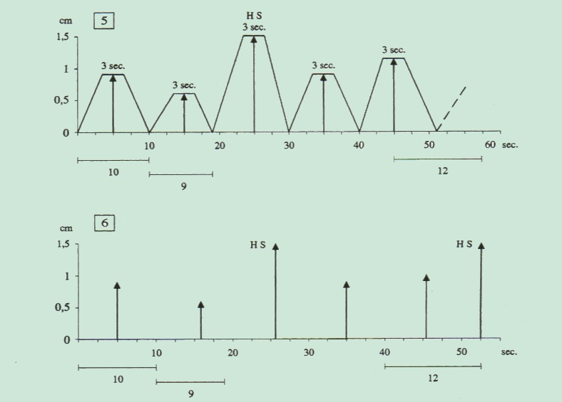

Fig. 1.
In healthy, the fluctuations of upper and lower ureteral reflexes show a chaotic-deterministic behaviour, with a large amount of information and fractal dimension of 3,8, identical to differential lt, i.e. the duration of caecal reflex disappearing, provoked by stimulation of the biological system, which has to be investigated.

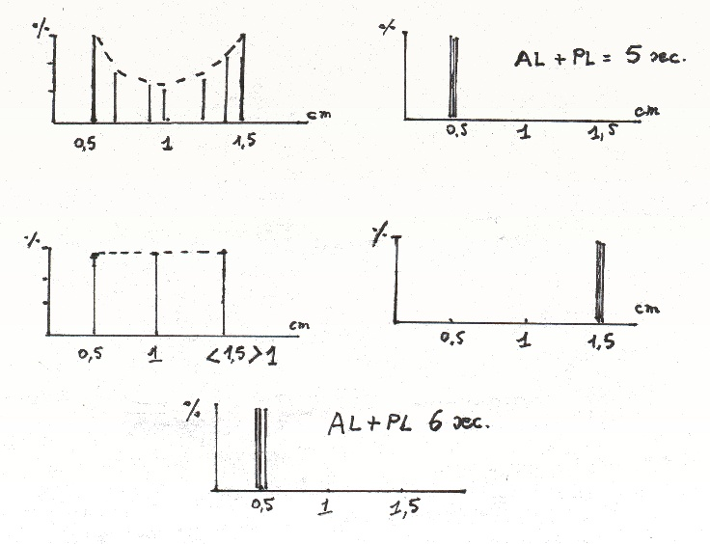

Fig. 2.
Biophysical-semeiotic Fourier’s transformation.
Ureteral fluctuations are transfered upon a system of cartesian axes: on the ordinate the percentage and on the abscissa the number of oscillations of same intensity.

As far as Endoarterial Blocking Devises (media-intimal structures present in the arterioles = EBD), evaluated as dilation of middle ureteral reflex when digital pressure on esophageal trigger-points is of “mean” intensity, is less than 20 sec. – physiological value – while duration of the closure (= reflex disappearing) reaches 7-8 sec. (NN = 6 sec. exactly).
The above-mentioned values of reflex parameter, characteristic of all cysts indipendently of their nature, indicate the alteration of local flow-motion as well as the lowered esophageal tissue oxygenation (acidosis) due to the impairment of Microcirculatory Functional Reserve (MFR).

7) Cardia-esophageal reflex: digital pressure applied on cutaneous projection area of the cardia (and/or of the stomach) brings about esophageal dilation in the absence of gastro-esophageal reflux, which hinders the movements of visceral wall.

8) Evaluation of the speed of esophageal peristaltic wave (esophageal peristaltic speed): hiatal hernia restrains peristaltic wave speed, which shows a longer time to reach the cardia (7 sec. versus 6 sec. in healthy). In practice, pinching the skin of sternal manubrium provokes a peristaltic wave, which physiologically arrives to the cardia after 5 sec. In addition, al esophageal diseases, including the cancer, slow clearly esophageal wave movements.

9) Evaluation of LES function: due to the fact that not allways hiatal hernia involves LES motility and induces Gastro-Esophageal- Reflux, this examination can appears normal or, on the contrary, results clearly pathological exclusively in case of GERD.
Interestingly, in healthy, digital as well as hand pressure, applied on the abdominal wall, cause LES contraction, which lasts 8 sec., whereas it persists 10 sec. in presence of colon diverticulosis, allowing doctor to made the correct bed-side diagnosis.
Finally, of special interest is the fact that simple auscultatory percussion permits to recognize directly the hiatal hernia, indipendently of its size degree(Fig.3) (1, 2, 3).

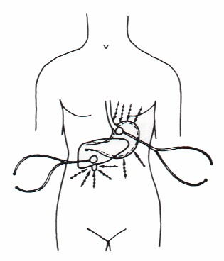

Fig. 1
The figure indicates the correct location of the bell piece of stethoscope in the performance of cardia, His’s angle and lower esophagus auscultatory percussion, which allows to evaluate the LES function. Digital percussion, directly and gently applied on abdominal and thoracic skin, starts from the outer side moving than in the direction of the bell piece of the stethoscope.

Our findings, collected in a long experience, underscore the importance of these biophysical-semeiotic signs in diagnosis as well as in differential diagnosis.

From the above remarks, appears evidently that the diagnosis of hiatal hernia is a clinical one, based on a large number of biophysical-semeiotic signs (partially referred), which allow both to recognize and to “quantify” the seriousness of disorder.
One has to remember that extrem head extension and turning it to right let hiatal hernia for some moment disappear, so that local flow-motion becomes normal, i.e., microcirculatory blood flow reveals to be physiological under this condition.
The clinical study of hiatal hernia improved the bed-side evaluation of motor activity of both esophagus and LES, based essentially on examination of peristaltic wave speed (biophysical-semeiotic evaluation of peristalsis), in physiology and pathology, as well as of antral-pyloric joint function.
As far as the first investigation is concerned, there is a statistically significant slowing: peristaltic wave, originated at the level of upper esophagus (spontaneously or brought about by pinching the skin over sternal manubrium) reaches the cardia, immediately after His’s angle, in ≥ 7 sec. (NN = 5 sec.), in absence of esophagitis. In addition, the wave intensity appears to be lower than the normal one.

The role played by biophysical-semeiotic evaluation of antral-pyloric joint is of primary importance also in diagnosing GERD, an underestimated disorder that involves 1 among 5 europeans:

a) in healty who takes a deep inspiration, LES at first dilates for 3 sec. in its upper area and, than, in lower muscular component. Soon therafter LES contracts for 8 sec. Due to its insufficiency, LES opening lasts longer than 3 sec. (NN = 3 sec.), while contraction persists for only 3 – 4 sec. (NN = 8 sec.);

b) cutaneous pinching at the right or left side of lower esophageal sphincter causes a dilation > 3 sec. and subsequently a small contraction that lasts about 4 sec. (NN = 8 sec.);

c) hand pressure on abdominal wall in an individual lying down in supine position and psicho-physically relaxed (e.g., augmentation of the pressure of bellpiece of the stethoscope) provokes is followed by the same results although inversely correlated as far as the appearance of movements of LES component are concerned. Under this circumstance, in case of colon diverticulosis LES dilates for ≥ 10 sec. (NN = 8 sec.);

d) Valsalva’s manoeuvre induces identical results, described in c);

e) acute insuline peak secretion test, above-illustrated, in healthy, does not bring about alterations of LES dinamics statistically significant, whereas, in case of LES dysfunction, LES dilation appears to be more intense and prolonged, i.e. > 3 sec. (NN = 3 sec.). On the contrary, the contraction of lower esofageal sphincter is smaller and shorter than that in normal people, i.e. 3 – 4 sec. (NN = 8 sec.), during cutaneous-esophageal reflex provoked by lower esophageal trigger-points.

In conclusion, data collected in a long, well established experience indicate that Biophysical Semeiotics is of greatest interest, usefulness and reliability in evaluating esophageal diseases, actually frequent and cause of serious complications, misdiagnosed by means of old, traditional, académic physical semeiotics.

References

- Stagnaro S., Rivalutazione e nuovi sviluppi di un fondamentale metodo diagnostico: la percussione ascoltata. Atti Accademia Ligure di Scienze e Lettere. Vol. XXXIV, 1978
- Stagnaro-Neri M., Stagnaro S., La sindrome dispeptica funzionale da discinesia delle vie biliari. Diagnosi percusso-ascoltatoria. Cin. Ter. 127, 363, 1988
- Stagnaro-Neri M., Stagnaro S., La “Costituzione Colelitiasica”: ICAEM-α, Sindrome di Reaven variante e Ipotonia-Ipocinesia delle vie biliari. Atti. XII Settim. It. Dietol. 20, 239, 1993
- Stagnaro-Neri M., Stagnaro S., Pancreatite Acuta Edematosa Interstiziale. Diagnosi percusso-ascoltatoria. Acta Med. Medit. 3, 14, 1987
- Stagnaro S., Stagnaro-Neri M., Diagnosi percusso-ascoltatoria dei calcoli biliari silenti. 6° Incontro Segusino di Medicina e Chirurgia. Susa 19 Maggio, 1990. Atti, pg. 79. Ed. Minerva Medica, 1990
- Stagnaro-Neri M., Stagnaro S., Appendicite. Min. Med. 87, 183, 1996
- Stagnaro-Neri M., Stagnaro S., Sindrome di Reaven, classica e variante, in evoluzione diabetica. Il ruolo della Carnitina nella prevenzione del diabete mellito. Il Cuore. 6, 617, 1993 (Medline)
- Stagnaro-Neri M., Stagnaro S., Semeiotica Biofisica: la manovra di Ferrero-Marigo nella diagnosi clinica della iperinsulinemia-insulino resistenza. Acta Med. Medit. 13, 125, 1997

