Biophysical Semeiotics in detection focal liver lesions even clinically silent.

Introduction

The patient with a focal liver lesion may present a difficult detection and management problem, in particular when upper abdominal symptoms are completely absent. In fact, the wider application of ultrasound and more recently computed tomography and NMR, has identified increasing numbers of patients with no symptoms related to their hepatic lesions.
The aim of this study was to describe several auscultatory percussion (AP) signs and syndromes valuable in finding out and diagnosing focal liver lesions, even clinically silent, as well as in monitoring the course of the diseases. Due to clinical phenomenology in the right upper abdominal quadrant, related to retrocecal and/or subhepatic atypical localization, appendicitis is considered in differential diagnosis and AP "tonic gastric contraction sign" is thus illustrated. Moreover, in the paper the usefulness of auscultatory percussion in both avoiding unnecessary overinvestigation and in selecting patients who might benefit from high quality specialist studies is emphasized.

Methods and Materials

The fundamental bases of AP are elsewhere fully described (4, 14, 16, 17, 18, 19, 20), as well as AP of the stomach and gall-bladder (15, 21, 22, 23). In order to facilitate the understanding of the topic, however, several AP signs and syndromes are once again briefly described, as follows:
1) AP of the stomach (14, 15, 16, 17, 18, 19, 20, 21, 22, 23) is performed by placing the conical bell of the stethoscope just below the left costal margin and applying the finger percussion, gently and directly on the skin, along radial lines from outer areas towards the bell piece of the stethoscope (bps) (Fig. 1).
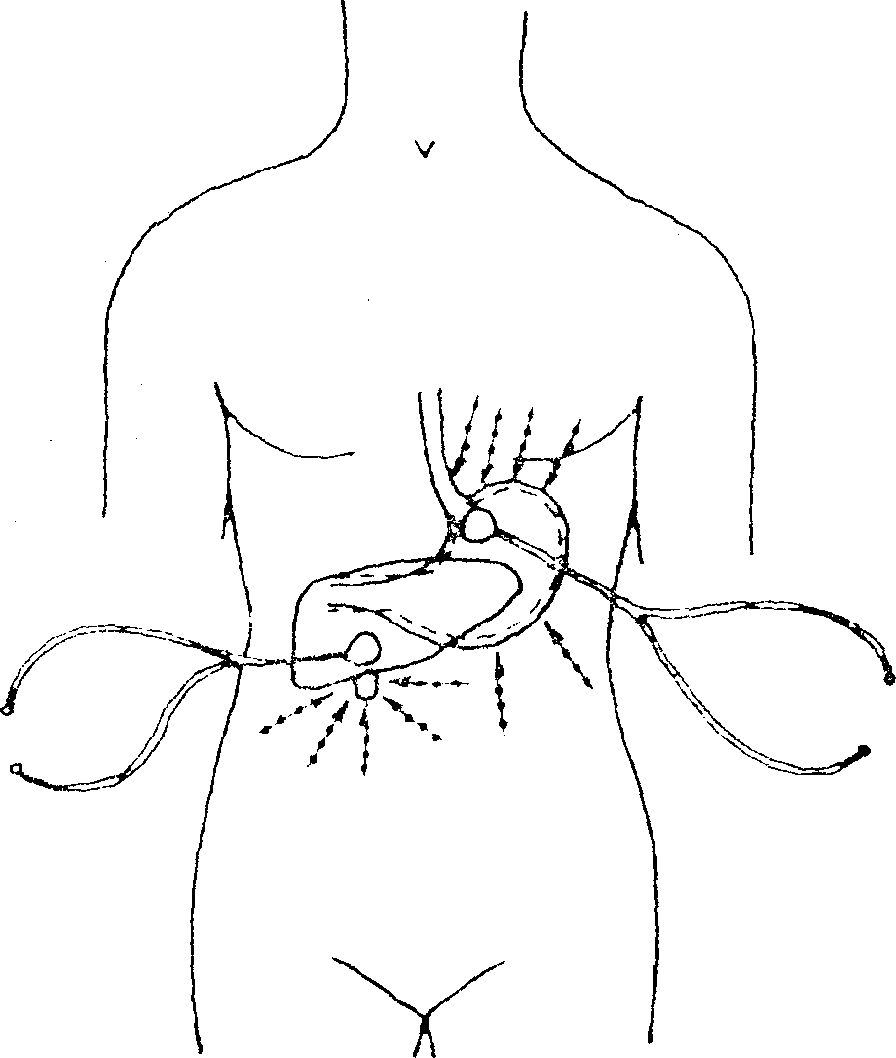
Fig. 1

Fig. shows the right position of the conical bell of a stethoscope and lines (arrows —>) along which finger percussion must be applied, directly and gently, carrying out auscultatory percussion of the stomach and gall-bladder as well as His's angle, necessary in detecting hiatus hernia. Moreover, fig. shows the aspecific gastric reflex, characterized by fundus and body dilation and antral-pyloric area contraction.

When digital percussion is applied on the skin projection area of the great gastric curvature, the sound is perceived clearer, louder, more resonant, modified "as originating from a site close to the investigator's ear" (14, 16, 18, 19, 20, 22).

2) AP of the gall-bladder (14, 15, 22); the bps must be placed just below the right costal margin as shown in Fig. 1; the digital percussion along parallel lines, from lower sites towards upper ones, provokes a modified, "solid", "dull" sound when it is applied on the lower margin of the liver. Subsequently, cholecyst margin is detected with the aid of AP, performed as Fig. 1 clearly suggests. Interestingly, pinching the VI th. right or left dermatomere brings about gallbladder contraction, which lasts for 15 min.

3) Congenital Acidosic Enzyme-Metabolic Histoangiopathy (CAEMH) (15, 17, 19, 20, 21, 22. 23), type B, group II, a, indicates a congenital, global impairment of mitochondrial activity, i.e. an alteration of reduction-oxidation processes, more precisely, an alteration of the electrons flux along respiratory chains of particular intensity: the digital pressure on the upper third of the quadriceps muscle - or other muscle, of course - causes aspecific gastric reflex and spleen decongestion.

4) Simulated defecation test (19): abdominal muscles contraction brings about aspecific gastric reflex when there is any kind of abdominal disease, with the exception of appendicitis, characterized by "tonic gastric contraction" (after a short gastric aspecific reflex: see later on) and malignancy, the latter elicited by AP autoimmune triad, i.e. autoimmune syndrome.

5) Autoimmune syndrome (16); in both malignant tumours and autoimmune diseases finger nail pressure on large joints, as well as on the projection areas of BALT, GALT and "Brain Associated Lymphoid Tissue" - described by the Author (21) - brings about the autoimmune triad, i.e. gall-bladder, stomach and spleen contraction (16,21, 23).

6) Reticulo-Endothelial System Hyperfunction (18): in differentiating degenerative from inflammatory or neoplastic diseases, a major role is played by AP syndrome of reticulo-endothelial system hyperfunction (RESH), which indicates the raised ESR and derangement in blood proteins, as shown in electrophoresis (16, 17, 18, 21, 23): the digital pressure on the middle line of the stemal body, iliac crests and cutaneous projection area of the spleen induces aspecific gastric reflex and gall-bladder contraction (RESH "complete” type).
7) Boxer's test (21); isometric work, for instance clenching fists, notoriously provokes a sympathetic hypertone (9, 10, 11); consequently, in some abdominal organs such as kidneys, spleen, pancreas, there appears decongestion for 6 sec., evaluated by AP (14).
Starting from 3 sec. after test beginning, the liver becomes enlarged, due to the increased amount of portal blood stream, lasting physiologically 4-5 sec.. In fact, the liver is the largest single organ of the body; in addition, it is a highly vascular organ, through which in normal healt flows some 1000 to 1200 ml. of portal venous blood and about one-quarter of this amount of arterial blood per minute (25). Therefore, during isometric work, such as the "boxer's test", liver blood supply increases enormously, lasting for about 5 sec. physiologically (9, 10, 11).
In these conditions, and on the basis of the above remarks, it is not to be wondered at, in fact, that spontaneous pressure, caused by the blood upon the trigger-points of focal liver lesions, provokes further stimulation inducing some pathological reflexes. As liver size returns to normal, receiving again physiological portal blood supply, all reflexes suddenly disappear. Consequently, during the boxer's test, first - for about 5 sec. - AP allows the doctor to detect focal lesions in the kidneys, pancreas, spleen, then, immediately thereafter, focal lesions in the liver, if some pathological reflexes - such as cystic syndrome, autoimmune syndrome, aspecific gastric reflex do spontaneously appear.
There are large numbers of patients with both renal and hepatic focal lesion, e.g. haemangioma. In all these cases, the above-mentioned reflexes (already present in the first 3 sec. after the boxer's test beginning) increase clearly, starting from 4 sec., as the liver size increases, due to spontaneous pressure on focal lesion trigger-points.
8) Cystic syndrome is characterized by gallbladder contraction, lower oesophageal reflex (=His's angle raising) and ureteral reflex (= both ureters are dilated) (22). From the technical point of view, to the end of carrying out the AP of the ureters (14), the bps should be applied just above the pubic symphysis, respectively at right and then at left. The percussion with the pulp of a finger must be carried out gently upon horizontal, parallel lines from outer areas towards the middle line and vice-versa. When the digital percussion is applied on cutaneous projection areas of the ureters, sound is perceived modified, louder, clearer and dull. In fact, sound waves are moving along the ureteral tract as far as the urinary bladder wall, i.e. bps. The mechanism underlying the cystic syndrome is explained by further stimulation of the local stretch-receptors, so that their threshold is crossed, as clinical and experimental evidence suggests. As a matter of fact, the digital pressure on a cyst, haemangioma, as well as on expanded lungs, as during deep inspiration, brings about the cystic syndrome.

9) AP of the liver is carried out by applying the bps just below the right costal margin (Fig. 1) and percussing with the pulp of a finger, gently and directly on the skin, upon parallel lines from lower and, respectively, upper areas towards the liver. Interestingly, digital percussion of all cutaneous projection of the liver allows to find out easily focal lesions, even small. In fact, despite the lesion size (Fig. 2 and 3), sound is perceived clearly modified, louder and dull.

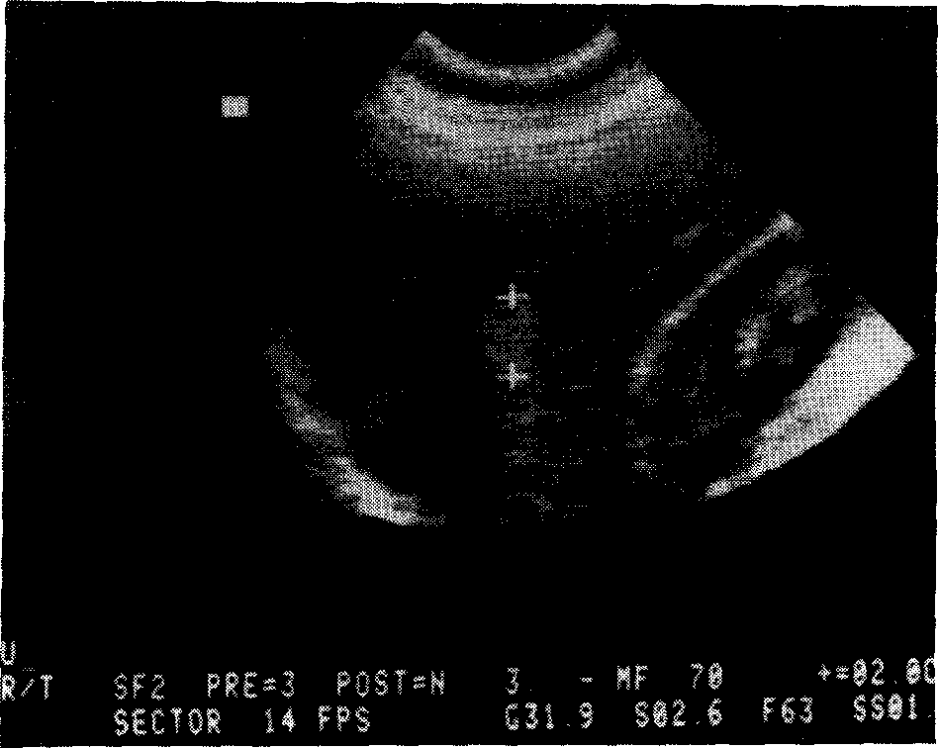
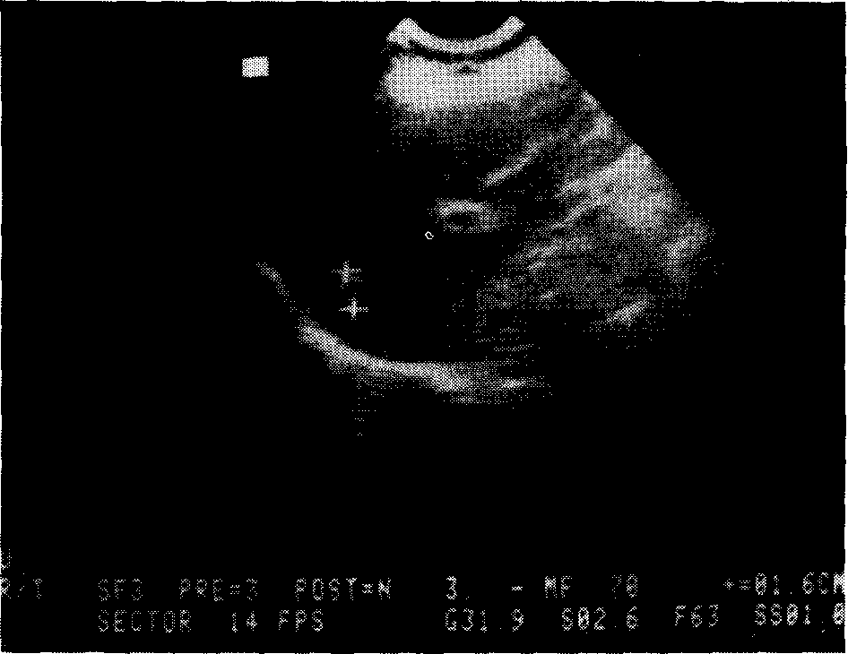

Fig. 2, 3

T. Clara, 46 years old, in 1985 ultrasound scanning, as well as AP examination, detected two liver haemangiomas. The smaller one was not found out, however, by previous ultrasound, carried out 9 months before.

Moreover, digital pressure on the skin projection of focal liver lesion, brings about the mentioned pathological reflexes, so that it can be not only exactly delineated, but also quite precisely evaluated during the changes caused by the boxer's test. Consequently, the test is also of great value to the doctor both in diagnosis and differential diagnosis (see discussion). All patients, presenting in our surgery in a long praxis, suffering from whatever disorders, were carefully investigated in order to ascertain focal liver lesions, even clinically silent ones.

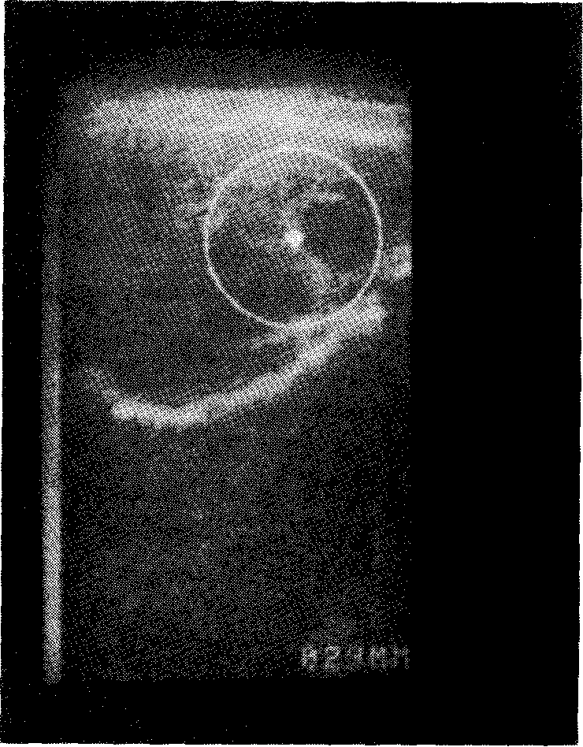

Fig. 4

Maria, 59 years old. AP allowed to diagnose chronic cholecystitis (confirmed by both surgical and histological examination) and two hepatic cysts. Ultrasound scanning detected only the two latter ones, misdiagnosing the diseased gall-bladder.

Results

The most common focal liver lesions, personally observed, are cysts, haemangiomas and meta-stases from malignancies of other organs. Our series includes: 4 cases of liver cyst (3 of them undiagnosed up to the time of physical examination); 4 haemangiomas (2 unknown); 8 cases of liver metastases (all unknown). M=6; F=10, ranging in age from 35 to 85 years. Interestingly in a female, 46 year old, already involved by haemangioma in the left hepatic lobe, a second small (1,5 cm. in diametre) haemangioma was detected with the aid of AP.
Subsequently, the clinical diagnosis was confirmed by ultrasound scanning (Fig. 2 and 3). A cyst of 2 cm. in diametre was detected in a patient, 67 year old, who presented with inguinal hernia, hiatus hernia and colonic diverticuli - the two latter also diagnosed by AP - (gall-bladder stones were absent, however: Saint's syndrome); such an association is not actually rarity.
In a female, aged 59 years, with upper abdominal symptoms and inguinal hernia, AP allowed to find out chronic cholecystitis, interstitial oedematous acute pancreatitis and two focal liver lesions, cystic in origin. Ultrasound scanning confirmed (3 weeks later) both liver cysts but not the chronic cholecystitis. Nevertheless, surgical as well as histological investigation confirmed the clinical diagnosis of chronic diseased gall-bladder (Fig. 4).
All AP diagnoses of focal lesions in the liver, were followed, as soon as posssible, by common routine investigations: full blood count with differential white cell count; glicaemia; uraemia; creati-ninaemia; electrophoresis; liver function tests, including alch. phosphatase, gamma GT, SGPT and SGOT, proteinemia; CEA; chest X-ray and plain abdominal X-ray film; ultrasound scanning and sometimes scintigraphy and CT.
Both biopsy and angiography were carried out in no patient of the personal series. All cysts I have met, have been congenital in origin. Two false positive findings, still under examination, occurred.

Discussion and conclusions

At least during a long period of time, focal liver lesions may occur without upper abdominal symptoms. In other words, the majority of focal lesions of the liver are clinically silent, so that an increasing numbers of patients, with no symptoms related to their hepatic disorders, has been identified by wider application of ultrasound and computed tomography (24).
Although there is no widely accepted protocol for assessing these lesions, both sophysticated examinations are definetly included in various suggested algorithms (5, 12). Small or involuting haemangiomas and some hydatid cysts, however, have atypical computed tomography and ultrasound appearances (7, 8, 24).
On the other hand, hepatic haemangioma represents the most common benign tumour of the liver and its clinical instrumental diagnosis is often difficult (1, 3, 6). The lack of diagnostic accuracy of echoscintigraphic detection, furthermore, in assessing a solitary hepatic lesion is well known (3, 24). As a matter of fact, with only the aid of echothomography, for example, is not possible the differential diagnosis between hepatic abscess and solid lesion. On the contrary, ultrasound scanning permits early separation into cystic or solid lesions in almost alia cases and also excludes large bile ducts obstruction. It may also identify multiple hepatic lesions (24).
However, technical difficulties with ultrasound scanning may arise in some patients, due, for instance, to obesity and/or overlying bowel-gas and is then necessary CT, which has an increased overall accuracy compared with ultrasound (2, 13, 24). All patients, observed in the past year, were routinely assessed by means of AP for evidence of hepatic tumour, first by detecting CAEMH, B, II, conditio sine qua non of tumours both benign and malignant, solid or liquid (16, 17, 18, 19, 21); then the "boxer's test" was carefully examined in order to ascertain the cystic syndrome, in particular starting 4 sec. after test beginning.
As regards the detection of cystic syndrome, we prefer to evaluate the upper third ureteral reflex. In all positive cases AP of the liver was then carried out to find one (or more) suspected area. In the patients of the series, finger pressure on cutaneous projection area of focal suspected lesions, induced gastric aspecific reflex and cystic syndrome, thus allowing the clinical evaluation of lesion shape and size. Hepatic neoplasms, primary or secondary, must be taken into account in differential diagnosis, even when primary localization is yet unknown.
AP differential diagnosis between benign and malignant liver tumours is based also on the positivity ofRHSH "complete type" and autoimmune syndrome, both of them present exclusively in the malignancies. Moreover, "simulated defecation test", as well as "simulated micturation test", has proved useful in localizing focal lesions respectively in abdominal organs and urinary tract (unpublished work). When there are abdominal symptoms in the right upper quadrant, among other differential diagnoses, also appendicitis - in atypical retrocecal and/ or subhepatic localization - must be kept in mind, in order to avoid a misdiagnosis full of risk (14, 19).
On the other hand, a patient with a focal lesion in the liver can be also involved by an appendicitis. From the auscultatory percussion point of view, despite its position, appendicitis is characterized by RESH "complete type" and especially by "tonic gastric contraction sign" (tgc), induced by both simulated defecation test (19, 22, 23) and digital pressure on skin projection of diseased appendix, exactly localized by AP of the cecum. The intensity of the specific sign, furthermore, is directly related to the severity of the illness. On the contrary, the latency time before tgc enhancing is inversely correlated with the seriousness of underlying disease (e.g. from 4 to 8 sec.). As a result of these observations, AP appears to be very useful in diagnosing and differential diagnosing - of course - as well as in monitoring the evolution of appendicitis, apart from any atypical localization.
To return to hepatic focal lesions, it seems easy to separate by mean of AP haemangiomas from both cysts and neoplasms (only in the letter ones there is RESH and autoimmune syndrome). In fact, during the boxer's test, haemangioma size increases, whereas cyst diametre clearly decreases for 3 sec. Obviously, solid focal lesions of the liver do not vary their size during the test.
The above remarks are quite important, because haemangiomas and occasionally hydatid cysts - as a wide literature reports - may have atypical apperarances on initial investigation, and percutaneous biopsy may result in life-threatening hemor-rage, anaphylaxis or hydatic dissemination (3, 24).
In conclusion, in the last year, AP revealed to be useful in detecting as well as in diagnosing and differential diagnosing focal liver lesions, even clinically silent. Moreover, AP appeared to be of great help to doctor also in bed-side monitoring the evolution of focal hepatic lesions, avoiding unnecessary overinvestigation, sometimes life-threatening owing to complications, as in case of perforated haemangioma during biopsy (3), and selecting those patients who might benefit from high quality specialistic semeiotics. Thus, we hope that Biophysical Semeiotics, based on auscultatory percussion as well as AP reflex-diagnostics, widely applied, will prove helpful to doctors dealt with similar situations.

References

1) Adam Y.G., Huvos A.G., Fortner J.C., Giant hemangioma of the liver, Ann. Surg., 1970, 172, 239.
2) Clark R.A., Matsui 0., CT of the liver tumours, Semin. Roentgenol., 1983, 18, 149.
3) Greco A.V., Grieco A., Caradonna P., Barone C., Cenci F., L'emangioma epatico: limiti della diagnosi ecoscintigrafica, Min. Med., 1982, 73, 3029.
4) Guarino J.R., Auscultatory percussion of the head, Brit. Med. J., 1982, 284, 1075.
5) Hegarty J.E., Williams R., Liver biopsy: techniques, clinical applications and complications, Brit. Med. J., 1984, 288, 1254.
6) Ishak K.G., Rabin L., Benign tumours og the liver, Med. Clin. North. Amer., 1975, 59, 995.
7) Johnson C.M., Sheedy P.P., Stanson A.W., Stephens D.H., Hattery R.R., Adson M.A., Computed tomography and angiography of cavernous hemangiomas of the liver, Radiology, 1981, 138, 115.
8) Katton Y.B., Intrabiliary rupture of hydatid cyst of the liver, Ann. R. Coll. Surg. Engl., 1977, 59, 108.
9) Linder U.K., Ergometrie in der Praxis. Zur Diagnositk und Verlauf-Kontrolle der Hypertonie, Med. Klin., 1984, 79, 326.
10) Margaria R., De Caro L., Fisiologia Umana, Vallardi, Milano, 1967.
11) Melleowicz H., Der heutige Stand der Ergometrie, Med. Klin., 1983, 78, 250.
12) Scheible W., A diagnostic algorhitm for liver masses, Semin. Roemtgenol., 1983, 18, 84.
13) Snow J.H., Goldstein H.M., Wallace S., Comparison of scintigraphy, sonography and computed tomography in the evolution of hepatic neoplasm, A.T.R., 1979, 132, 915.
14) Stagnaro S., Rivalutazione e nuovi sviluppi di un fondamentale metodo diagnostico: la percussione ascoltata, Atti Accad. Lig. Sci. Lett., 1977, 34, 176.
15) Stagnaro S., Ascultatory percussion of rheumatic diseases, Comunication Europ. Congr. Rheumatology, Moscow 1983.
16) Stagnaro S., Percussione ascoltala degli attacchi ischemici transitori. Ruolo dei potenziali cerebrali evocati, Min. Med., 1985, 76, 1211. Stagnaro S., Sindrome percusso-ascoltatoria di Iperfunzione del Sistema Reticolo-Istiocitario. Min. Med. 74, 479 [Pub-Med indexed for MEDLINE].
17) Stagnaro S., Ascultatory percussion of cerebral tumor. Diagnostic importance of cerebral evoked potentials, Biol. Med., 1985, 7, 171.
18) Stagnaro S., Valutazione percusso-ascoltatoria delta microcircolazione cerebrale, globale e regionale, Gazz. Med. It., Arch. Sc. Med., 1986, 145, 163.
19) Stagnaro S., Ruolo delta percussione ascoltata nella "difficile diagnosi" di appendicite, Biol. Med., 1986, 8, 71.
20) Stagnaro S., Valutazione percusso-ascoltatoria del diabete mellito. Aspetti teorici e pratici, Epatologia, 1986, 32, 131.
21) Stagnaro S., Polimialgia reumatica acula benigna va-riante, Clin. Terap. 1986, 118, 193.
22) Stagnaro Neri M., Stagnaro S., La sindrome dispeptica funzionale da discinesia delle vie biliari, Clin. Ter., 1988, 727, [Pub-Med indexed for MEDLINE].
23) Stagnaro S., Stagnaro Neri M., Una patologia mitocondriale ignorata: I'istangiopatia congenita acidosica enzimo-metabolica, Gazz. Med. It.-Arch. Sc. Med., 1990, 149, 67.
24) Thompson J.N., Gibson R., Czerniack A., Blumgart L.H., Focal liver lesions: a plan for management, Brit. Med. L, 1985, 290, 1643.
25) Walters J .H., Systemic infections and the liver, The Pract., 1973, 270, 618.

