Biophysical-Semeiotic Bedside Assessing Parathyroid Activity by Means of Dynamic Methods.

(By Sergio Stagnaro)

Introduction.
In a previous article, I’ve described for the first time clinical, biophysical-semeiotic evaluation of parathyroid gland activity in healthy at rest (1). Such as method proved to be reliable and “quantitative” in a long well established experience.
In this paper, I illustrate original methods usefull in quick, and bedside assessing parathyroid activity in a dynamic way (stress-tests), which give information on bone calcium metabolism. As a matter of fact, if calcium ion concentrations in extracellular fluid and blood fall below normal, pathyroid gland hormone brings them back within the normal range, causing efflux of calcium from bone: from biophysical-semeiotic microcirculatory viewpoint, parathyroid microcirculation is activated, according to I type, associated, microcirculatory activation, wherein bone interstitium appears statistically larger than basal, at rest, value (NN = 0,5 cm.), indicating secretion state (≥ 1 cm.) (See http://www.semeioticabiofisica.it/microangiologia.it.).
On the contrary, if calcium ion concentrations in extracellular fluid and blood raises above normal, the secretion of pathyroid gland hormone decreases promptly: parathyroid microcirculation is dysactivated, bone interstitium is small (0,5 cm.), typical of absorption and rest state, but, in the former case,showing the characteristic type of upper and lower ureteral intense fluctuations.
Parathyroid hormone accomplishes its job by stimulating at least three processes, Biophysical Semeiotics allows doctors to evaluate bedside accurately all these events, also in a dynamic way by stimulating hormone secretion, by means of Apnoea Test lasting about 7 sec. (= the subject is invited to breath-hold) and with the aid of Valsalva’s Manoeuvre, which bring about alcalosis and, respectively acidosis.
Under alcalosis condition the secretion of pathyroid gland hormone increases, soon thereafter microcirculatory activation in the bene; bone calcium is increasingly absorbt bringing about parathormone reactive secretion.
On the contrary, apnea-test-dependent tissue acidosis firstly brings about bone calcium increased absorptin, and after 1-2 min. the secretion of pathyroid gland hormone results clearly increased.
Finally, TSH-RH stimulation by mean intense digital pressure on itl trigger point causes stimulation of both thyroid and parathyroid hormone secretion: parathyroid glands are less stimulated (See later on).

Methods.

To both understand and bedside apply perfectly what follows, steady knowledge of Biophysical Semeiotics is unavoidable. In fact, gastric aspecific reflex parameters and diverse types of microcirculation in parathyroid glands play a pivotal role in recognizing pathyroid glands physiology and disorders (See the above-cited website).
As regards the trigger points of four parathyroid glands, upper gland trigger points are located normally just under cricoid cartilage, at right and left, respectively, 3 cm. about from middle line, whereas the inferior gland trigger points are localized 3 cm. under the formers.
Interestingly, “mean-intense” prolonged cutaneous pintching of these four sites causes fluctuation of upper (= vasomotility) and lower (= vasomotion) ureteral reflex, while radio and ulna bone shows type I, associated, microcirculatory activation, lasting all the time of pintching; analogously, intestine and kidney micorcirculation behave in the same way (Fig. 1).
In healthy, parathyroid trigger-points stimulation of “mean” intensity brings about gastric aspecific reflex after latency time of 8 sec. exactly, with a duration < 4 sec. (= parameter value of greatest diagnostic significance, because it is inversily related to Microcirculatory Functional Reserve).
In addition parathyroid biophysical-semeiotic preconditioning (See in the website) ameliorates significantly such as latency time, reaching the value of 12 sec. (Fig. 2).

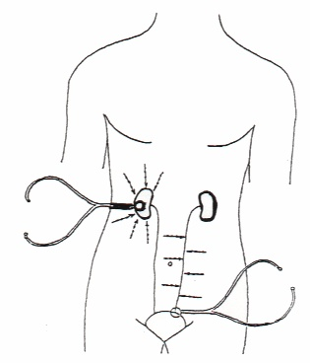
Fig. 1
Auscultatory Percussion of kidney and ureter.

Futhermore, small stimulation of the same trigger points brings about chaotic-deterministic oscillations of upper and lower ureteral reflexes (Fig. 3).

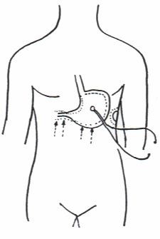
Fig. 2
Gastric Aspecific Reflex.

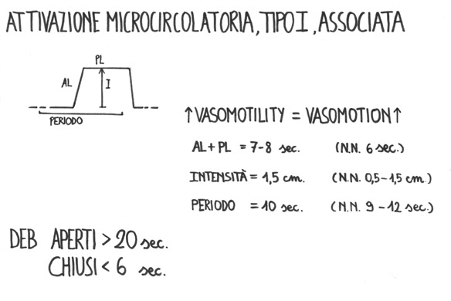
Fig. 3

In case of adenoma, a parathyroid gland is mainly enlarged, showing microcirculatory activation type I associated, indicating an enhanced hormone secretion: “in toto” ureteral reflex is ≤ 0,5 cm. (Fig. 3). In addition, latency time of parathyroid-gastric aspecific reflex is > 8 sec. in direct relation to severity of underlyining disorder.
On the contrary, all other three glands appear at rest, showing characteristic microcirculatory disactivation.
As referred above, in presence of parathyroid adenoma also kidney, gastrointestine, and bone (e.g., radio, ulna, vertebrae) present type I, associated, microcirculatory activation. In practice, in healthy at rest, the stimulation of related (gastrointestine, kidney, and bone) trigger points brings about gastric aspecific reflex after 8 sec. latency time, lasting < 4 sec.
By contrast, in case of parathyroid adenoma latency time appears 9-12 sec. in direct relation with the underlying disorder, facilitating the diagnosis (Tab. 1).
From the above remarks, thanks to Biophysical Semeiotics doctor can nowadays evaluate at the bedside parathyroid activity in a selective way, recognizing gland dysfunction, even in symptomless patients.

Parathyroid dysfunction diagnosis

One gland enlargement: type I microcirculatory activation, and
local Parathyroid-gastric aspecific Reflex: latency time > 8 sec.

Bone, Kidneys, Gastrointestin Microcirculation activated according to type I.

Biophysical-Semeiotic Preconditioning pathological

Tab. 1

Biophysical semeiotics allows doctor to recognize also the “real risk” of parathyroid gland disorders, like all other glands: in healthy, latency time of parathyroid-gastric aspecific reflex is 8 sec. with a duration < 4 sec. In addition, biophysical semeiotic preconditioning (after exactly 5 sec. intervall, doctor evaluate a second time the same parameter) results physiological: latency time raises to 12 sec.
On the contrary, in case of “real risk” localized in a glang, e.g., reflex latency time is ≥ 8 sec., but the duration is pathologically prolonged (≥ 4 sec.), indicating clearly Microcirculatory Funcional Reserve impairement, and then silent parenchymal abnormality, according to Angiobiopathy theory (3).
Finally, biophysical semeiotic preconditioning is significantly pathological: latency time either does not change or it worsen decreasing to a value lower than the basal one, in inverse relation to risk severity.

In order to assess parathyroid function under stress test, firstly doctor may utilize Apnoea test (the subject is invited to breath-hold for about 7 sec.), which brings about tissue acidosis: in healthy, after 2-3 sec. one observes type I, associated, microcirculatory activation in bone (mean digital pressure on whatever bone, e.g., radius, cubitus, causes intense fluctuations of upper and lower ureteral reflexes, while “in toto” ureteral reflex is large (> 1 cm.), indicating calcium secretion.
Interestingly, after further 3-4 sec. parathyroid microcirculation appears clearly dysactivated (= relative trigger point stimulation provokes identical, small fluctuations of 0,5 cm. of intensity lasting only 5 sec. (= 6 sec.), with a period of exact 10 sec.).

A second method reliable of parathyroid evaluation under stress test is the following: the subject is invited either to take deep breath persistengly or – really more practical – to perform Valsalva’s Manoeuvre, causing tissue alcalosis: in healthy, after 2-3 sec. firstly bone microcirculatory results activated, according to type I, associated. Interestingly, “in toto” ureteral reflex appears significantly reduced (≤ 0,5 cm.), indicating calcium absorption in the bone. Subsequently, after further 3 sec., also parathyroid glands present type I, associated, microcirculatory activation, showing an increased hormone secretion, as a consequence of lowered blood calcium level.
Finally, a third biophysical semeiotic stress – test, which proved to be a reliable method in evaluating also parathyroid glands besides thyroid, untill now unknown as regards my knowledge, is based on the secretion of TSH-RH by digital pressure of mean intensity upon its related trigger-point (2, 3) (Fig. 4).

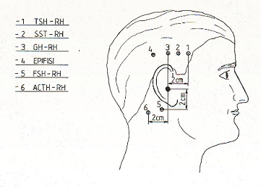
Fig. 4

Figure indicates the trigger points of the numerous neuronal centers of realising hormones.

In healthy, mean-intense digital pressure on TSH-RH trigger point (Fig. 4) brings about an intense fluctuation of thyroid microvessels, according to I type associated activation (AL + PL increases from 6 sec., basal line, to 8 sec.), while parathyroid glands are less stimulated (AL + PL increases to 7 sec.), showing that TSH stimulate physiologically both thyroid and parathyroid glands, although in a quantitatively different way.
Interestingly, clinical evidence demonstrates that myxoedema in individuals involved by “osteoporotic constitution” (4) (See in the website, Constitutions), but not in those without predisposition to osteoporosis, is associated with increasing TSH-RH secretion and consequently parathyroid stimulation, which causes loss of bone calcium, worsening possibly a present osteoporosis. Such as pathological condition ameliorates finally under thyroid hormone treatment.

In conclusion, the above-illustrated stress-tests, useful and reliable in bedside evaluating parathyroid activity, allow doctor to recognize inherited parathyroid impairment, even not too severe, as well as initial, asymptomatic parathyroid disorders.

1) Stagnaro S. Biophysical-Semeiotics Bedside Evaluation of Hyperparathyroidism.
http://www.semeioticabiofisica.it, URL: http://www.semeioticabiofisica.it/semeioticabiofisica/Documenti/Eng/Hyperparathyroidism%20BS%20Diagnosis%20eng.doc
2) Stagnaro-Neri M., Stagnaro S., Semeiotica Biofisica: valutazione clinica del picco precoce della secrezione insulinica di base e dopo stimolazione tiroidea, surrenalica, con glucagone endogeno e dopo attivazione del sistema renina-angiotesina circolante e tessutale – Acta Med. Medit. 13, 99, 1997.
3) Stagnaro-Neri M., Stagnaro S. Introduzione alla Semeiotica Biofisica. Il Terreno Oncologico. Travel Factory, Roma, 2004. http://www.travelfactory.it/semeiotica_biofisica.htm
4) Stagnaro S., Stagnaro-Neri M., Le Costituzioni Semeiotico-Biofisiche.Strumento clinico fondamentale per la prevenzione primaria e la definizione della Single Patient Based Medicine. Travel Factory, Roma, 2004. http://www.travelfactory.it/libro_costituzionisemeiotiche.htm.

