SINGLE PATIENT BASED MEDICINE AND PRIMARY PREVENTION OF CARDIOVASCOLOPATHY.
(Sergio Stagnaro)
Introduction. 1
Present Primary Prevention of Cardiovascolopathy. 1
Cardiovascolopathy: Biophysical-Semeiotic View-Point of Primary Prevention and Diagnosis 3
SPBM and silent Coronary Artery Disease. 4
Vasomotility e Vasomotion. 5
Biophysical-Semeiotic Heart Preconditioning. 6
Conclusion. 7
References. 8

Introduction.

In two previous papers, I illustrated the bases and the practical application of Single Patient Based Medicine (1, 2), a theory that does not oppose to evidence based medicine (EBM) (3), but really complete it with favorable consequences upon the treatment, in the interest of patients, and, then, of attending physician, as well as National Health Service.
SPBM can be defined as medicine based on precise knowledge of function and structure of individual’s biological systems, which represent the present result of complex interaction between genotype (“biophysical-semeiotic constitutions”) and environment, investigated by Biophysical-Semeiotics from physical and psychical view-point (2).
As regards the cardiovascolopathy, nowadays at least 300 risk factors are known, besides those, recognized thanks to Biophysical Semeiotics (5, 12).
EBM underlines correctly the importance of the need to consider the risk factors not separately, but as a whole, since their effects, when associated, play notoriously an exponential effect on both morbidity and mortality.
In this paper, I underscore the paramount benefits of applying SPBM, in addition to EBM, in the primary prevention of cardiovascolopathy (CVD), on the base of researches performed during last decades, to a large extent, from biophysical-semeiotic view-point (5-15) (See www.semeioticabiofisica.it).

Present Primary Prevention of Cardiovascolopathy.

The principle goal of primary prevention actions is modifying all behaviours, which can facilitate the onset of some disorders, and precise activities that oppose their negative influence on the popolation. It is clear that the application of primary prevention actions in the field of CVD results particularly useful, considering its great impact on present society, and expecially in developed industrialezed countries, because of the greatest relevance of classic and “variant” metabolic syndrome incidence (See in the cited site). Characterizing risk factors has stimulated a large number of studies and researches aiming to ascertain the intervention actions, which can oppose to their negative effects on people’s health.
In order to recognize such risk factors, at least 300 at the moment, have been emploied observational studies, while intervention of modifying them, as well as strategies to bringing them under controll, are assessed by epidemiological stydies and clinical trials case-controll.
From these experiences, have been recently introduced the so-called “vascular risk documents”, wherein individual risk is evaluated totally, considering risk factors of a single subject. By means of such instruments, certainly expensive, one can recognize people at high risk, i.e., those who will be probably involved by CVD in the next 10 years (probability above 20%).
As regards such as argument, the most recent “vascular risk documents” show that the co-presence of more risk factors influence in esponential way, and not in additive manner, the global risk (e.g., sigarette smoking + arterial hypertension + diabetes mellitus + sedentary life).
From the above remarks, one can calculate the average risk of a population, by which assess possible preventive interventions, as well as clinical approaches on all people, rather than on single individual, modifying clearly the influence on people’s morbidity and mortality.
There is a large number of published articles, which have demonstrated the importance of these interventions as primary and secondary prevention, pointing out the pivotal role played by attending physician, as far as risk factors are concerned.
In some epidemiological studies authors tried to evaluate the role of the prevention, performed by attending doctor, in reducing the incidence of a single risk factor in a well-defined population; intervening efficaciously, e.g., on smoking, the simple advice reached the reduction in 2% of all cases, in the general population, whereas it was 36% in a “sensible” population, like a patient involved by myocardial infarct.
Sedentary life is another risk factor easy to modify. Although lack of physical exercise is notoriously recognized as risk factor of CVD, a lot of attending physicians pay scarse attention on advicing single patient the proper and particular life style. Physical exercise benefits are directed, besides blood pressure lowering, obviously in hypertensive patient, to body weight, amelioration of hemodinamics, augmented endothelial activity, glycemia normalization in individuals with impaired glucose tollerance, to significantly increasing of HDL blood-level, so that it plays an important role in CVD primary prevention in both a single individual and in the whole population.
Although more than 300 studies demonstrated this protective effect (wherein, among other resuls, a more intense action has been revealed in patients involved by CVD) in the U:S:A 60% of people do not undergo physical exercise at all.
Among risk factors that can be ameliorated, without any doubt, a paramount role is played by total cholesterol, LDL cholesterol, and non-HDL cholesterol, because the correlation between high blood levels of these substances and the risk of CVD has been largely demonstrated in a lot of epidemiological studies.
Such as risk factor (as arterial pressure) act independently of treshold value, although in general the decision to threat the patient with drugs derives from limit value, considered as cut-off. It is generally admitted that a proper intervention on patient’s diet can lower blood cholesterol level of 10%, and consequently, it reduces mortality for CVD from 50% (people about 40 years old) to 20% (people 70 years old).
Statines use, lowering efficaciously blood cholesterol levels, has modified enormously the approach to such as primary prevention; however, we must emphasize that an early intervention of attending physician on dietary behaviour his patients, can play a pivotal role in decreasing CVD incidence as well as the related expense.
Important clinical trials (e.g., WOSCOPS ed HPS) have demonstrated in more than 20.000 at high, but without former coronary disorder, an intense decrease of risk in primary prevention, without efficiency differences among men and women (HPS Study), and independently of basal cholesterol blood levels.
The efficiency in primary prevention of aspirin therapy has been corroborated by PPP study (Primary Prevention Project), wherein 4.495 patients age above 50 years, and with at least a major risk factor, at random underwent aspirin treatment (l00mg/die) and E vit (300 mg/die). After a follow-up of 3,6 years only in the groop treated with aspirin, a significant decrease of both cardiovascular mortality and incidence of major cardiovascolar events (non-fatal myocardial infarction, transitory ischemic attack, non-fatal ictus, angina pectoris, and revascularization interventions).
Also other interventions of primary prevention proved to be efficacious in decreasing major cardiovascolar events in patients at high risk; in particular, the use of ACE-inhibitors has demonstrated interesting results. In the HOPE study(Heart Outcome Prevention Evaluation Study) have been enrolled both patient at high risk (with at least one major risk factor and diabetes) without former CVD, and patients with CVD.
A reduction of cardiac mortality incidence, myocardial infarct, and ictus has been observed equally significant in patients, whose history was positive for CVD, and in those without former CVD. These favorable results came before other intervention studies on high risk patients.
The ONTARGET study (Ongoing Telmisartan Alone and in combination with Ramipril Global Endpoint Trial, 29.000 patients) and NAVIGATOR study (Natenglinide and Valsartan in Impaired Glucose Toleranc Outcomes Research, 7.500 expecte patients) will be performed on patients at high risk, to assess the efficiency of preventive treatment with angiotensin II inhibitors drugs on diabetes evolution a CVD.

Cardiovascolopathy: Biophysical-Semeiotic View-Point of Primary Prevention and Diagnosis.

The vascular biological system, which includes macro-, and micro-scopic coronary vessels, play physiologically a function, characterized by deterministic-chaotic behaviour, typical of all biological systems, secondary to the complex interaction of numerous control mechanisms at feed-back, that enable these structures to adapt themselves to unforseable requests and modifications of everyday life.
The behaviour of haematic vessel walls - vasa publica and vasa privata, according to Ratscow – has been investigated “clinically” by means of Biophysical Semeiotics also at coronary level (5, 13, 14), studying local non-linear dynamics, where, under physiological conditions, in-put and out-put are not directly correlated, i.e., the first does not parallel the second. In other words, autonomous and autoctonous oscillations show the typical chaotic-deterministic behaviour, characteristic of all biological systems, independently of heart systoles and diastoles. Their complexity decreases in realation to the evolution of underlying disorder, as, in our case, CAD or aging, during which fractal dimension of biological system progressively lowers (16, 17).
By the aid of Biophysical Semeiotics, the study of fractal dimension or dimensionality of coronary deterministic chaos, gives doctor the possibility of recognizing, investigating, analyzing, and “quantifying” structural damage, as well as altered function of such blood vessels, and therefore, in rational and rapid way, directing the patient to undergo the collaboration of sophysticated semeiotics, utilized in preciselly selected patients.
It is well known, and generally admitted since a long time, that patients with CAD can be symptomless over a period of year or decades. On the other hand, typical ECG abnormalities, characteristic of ischaemia, can be caused by physical excersise in the absolute absence of angina pectoris.
Consequently, “silent” ischaemia represents an important trait of Coronary Artery Disease. Its prevalence is obviously not known, although a quarter of MI are not recognized and an half is not accompanied by clinical symptomatology.
From the simple considerations, referred above, well-known to physicians, one can understand the need of an efficacious physical semeiotics, that allows doctor the practical and proper selection of patients to early undergo instrumental, sophisticated, sometime surgical, investigations, certainly expensive (5).
The reality is that, in total absence of clinical phenomenology, the very initial stages of Coronary Artery Disease occur in the two first life decades (“real coronary risk”), analogously to what happens in all other arteriosclerosis localizations, as generally admitted, as permit to state clinical cases, we have gathered in our former research (5, 16) (See in the site: “Constitutions”).
In my opinion, initial arteriosclerotic alterations present as anatomo-functional microcirculatory modifications particularly of microvessel structures, which provide Functional Microcirculatory Reserve (MFR), including that of adventitial vessels. In these events, a primary role is played by Endothelial Blocking Devices (EBD) (Fig.1), as allows to state our above- mentioned research, performed in the ’80 (6, 18).
(For further information about EBD physiology and pathology, See the site www.semeioticabiofisica.it/microangiologia).

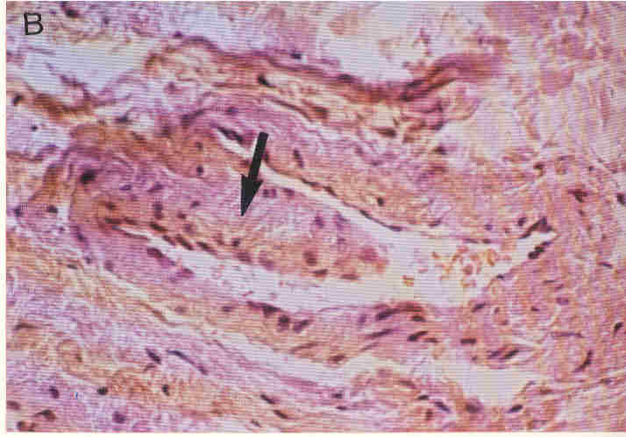

Fig.1

A typical “elephant trunk” EBD, characterized by large base of origine. Its contraction brings about a more intense blood-flow along nutritional capillaries, while its dilation causes a decrease of capillary blood supplay.
(Thanks to kind permission of Prof. S.B.Curri: Le microangiopatie, by Inverni della Beffa, Arte Grafica S.p.A., Verona, 1986.

In following, the diagnostic biophysical-semeiotic iter, reliable, sensitive, and specific in recognizing coronary artery disease, even silent, since the very initial phase of “real coronary risk”, is described.

SPBM and silent Coronary Artery Disease.

The patient involved by silent ischaemia does not present obviously angorsymptomatology; sometimes he (she) refers a clinical phenomenology very difficult to be properly recognized at the bed-side. For example, there are numeorus cases of “silent” CAD, wherein the symptoms are vertigo, particularly during stress, even small, performed after meals (13, 14). These individuals are correctly diagnosed with the aid of Biophysical Semeiotics, in two ways: by means of direct, “clinical” evaluation of ventricle (right and left) coronary vasomotion or by heart preconditioning.

Vasomotility e Vasomotion.

The reader, who has read former papers on Biophysical Semeiotics, knows certainly all necessary operations unavoidable in pointing out and studying both coronary vasomotility and vasomotion by means of ureteral reflexes. “Light” digital pressure on cutaneous projection areas of two ventricles brings about upper, middle, and lower ureteral reflexes, whose oscillations permit the assessment of basal coronary “vasomotion” as well as during numerous stress tests (See in the site: Technical Pages) (Fig. 2).

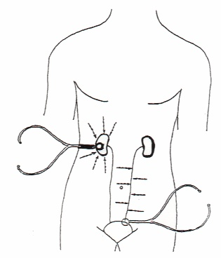

Fig. 2

The bell-pice of a sthetoscope (bps) is located upon lateral abdominal region, right or left, and percussion is applyied on parallell and orizontal lines, in “delicate and direct way” on the skin. Doctor perceives a clearly modified sound, that is hypofonetic, and intense, indicating that percussion occurs directly on ureter. If bps pressure increases, ureter dilates for about 5 sec., corroborating the accuracy of performed auscultatory percussion.

In case of CAD, even initial, Phase AL + PL of vasomotion appears allways, more or less, altered (Fig.3) : duration lowers to 5 sec. (NN = 6 sec.); fluctuations intensity is varying from about 0,5 to 1 cm. (NN = 0,5 – 1,5) (6, 7, 8, 9).
On the contrary, vasomotility is allways activated, although by different intensity: microcircultory dissociated activation, wherein Endoarterial Blocking Devices (EBD) show a prolonged “closure” phase (NN = 6 sec.), and a smaller “openness” phase (NN = 20 sec.). Vasomotily appears compromised exclusively in the stage of serious coronary insufficiency : failure of “peripheral heart” (Fig.3)-

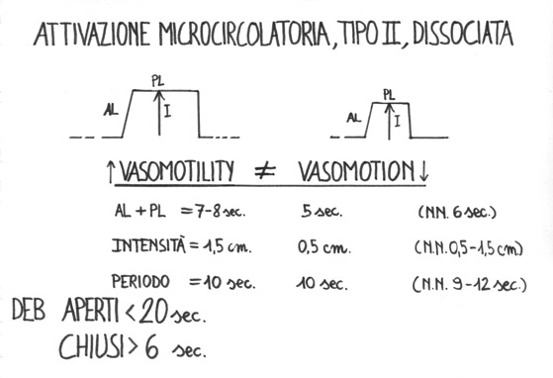
Fig.3

Besides apnea test and Valsalva’s manoeuvre, the coronary vasomotion diagram gives a lot of information when, assessed at rest, doctor invites the subject (to examine) to “think about run quickly”: simulated movement test. In fact, in healthy, under such as condition, type I, associated, activation of local coronary microcirculatory bed occurs, and, then, myocardial oxygenation augments significantly: latency time (lt) of cardio-caecal and aspecific gastric reflex ≥ 8 sec. (NN = 8 sec.) (Fig.4).
By contrast, in presence of coronary artery disease, even symptomless, lt does not modify or becomes smaller in relation to the seriousness of underlying disease.

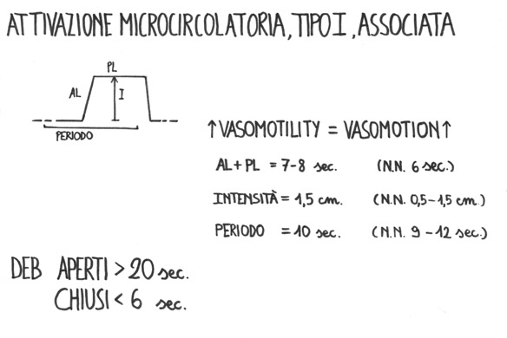
Fig.4

Biophysical-Semeiotic Heart Preconditioning.

Notoiously a precise correlation exists between dermatomeres and related viscermeres, as we described in former papers with the aid of Biophysical Semeiotics (1-9).
Coronary artery disease causes, therefore, alterations at the level of th₁ and th₂ dermatomeres, easily detected by palpation (7). In addition, outlined both ventricles with the aid of auscultatory percussion, mean intense digital pressure of the bell-piece of sthetoscope on their cutaneous projection area increases coronary vessel tone – sympathetic reflex – in direct relation to pressure intensity, in a perfect agreement with the sympathetic regulation, generally admitted by authors.
It follows that, in healthy, mean digital pressure – see above – brings about only the contraction of correlated coronaries (= reduced vasomotion) and, subsequently, after a lt of about 3 sec., left ventricle dilates for exactly 6 sec.; both the dilation and the return to basal value happen quickly. Finally, after a lt of 4 sec. Doctor observes a third ventricular dilation, lasting only 4 sec.
It appears pleanly that in healthy sympathetic stimulation of mean intensity provokes in the heart the so-called preconditioning phenomenon – FMR activation – one can quantifies in a few seconds with the aid of Biophysical Semeiotics: in healthy, sympathetic heart stimulation activates local tissue-microvascular units.
In practice, it is enough to evaluate the decrease of duration of ventricular dilation, right or left, which from initial value of 6 sec. lowers to 4 sec.
Ischaemic heart preconditioning can be assesed also by a different way, we use in practice (20): mean intense digital pressure, applied upon cutaneous projection area of heart, under physiological condition brings about cecal reflex (= cecal dilation) after a lt of 8 sec., indicating histangic acidosis. After exact 5 sec of intervall, performed the manoeuvre for the second time, mean digital pressure causes cecal reflex after a longer time than the basal one: ≥ 9 sec.
Finally, applied for the third time after an intervall of 5 sec., digital pressure (as described above) provokes the same reflex, after a time longer than the former ones.
Contemporaneously also all other parameters of cecal reflex modify: duration becomes smaller and differential lt. or fractal dimansion, by contrast, increases.
In healthy, preconditioning provokes type I, associated, coronary microcirculatory activation, wherein both arterioles and capillaries fluctuate more intensively (= ureteral reflexes).
It follows that, in this way, internal and external coherence of biophysical-semeiotic theory, concerning these important biological events, i.e. preconditioning, which physiologically improves myocardial O₂ supply, is outlined (5, 13, 14, 15).
As far as the other biophysical-semeiotic methods are concerned, the reader can consult the articles referred in references.
At this point, in order to underscore SPBM importance, when applied to CAD, even in very early phases, it is enough what has been referred above.

Conclusion.

Important clinical articles have demonstrated that primary prevention strategies of CVD, in favour of which there are valid demonstrations, both epidemiological and clinical, are those who can lower the specific risk factors (either modifying life stile or with the aid of drugs useful in pharmaceutical prevention).
From the above remarks it appears clear the importance of assessing together all risk factors, even those not the greater ones as well as other, ignored before Biophysical semeiotics, because their contemporaneous presence increases significantly morbidity and mortality of CVD. With regard to this argument, a paramount role is played by general practitioner, who could intervene early in correcting the risk factors (“real risk” of CVD), and co-operating with cardiological departments, realize the most efficacious therapeutic strategies in prevention.
The practice of primary prevention represents, however, an issue difficult to perform, and with scarse satisfactions, due to the fact that such action is “clinically” silent, not accompanied by sudden results (as a prompt recovery of a patient), but consisting in a day-to-day, persistent, methodical, activity, followed sometime by patients gratitude. Certainly, such as work can be in the future the most precious activity of general practitioner.
As I underlined it in former papers (1, 2), nowadays one have to discuss more and more about guide lines, which are to be applied particularly in therapeutical field: diagnosis, however, must come allways before therapy. Clearly the guide lines for diagnosis and treatment of different disorders, realized by authrorities in a complete, synthethic, objective and hopefully indipendent way, are geiven by EBM. Guide lines, that one can define statements, expressed in an ordinate manner, which help doctor in bed side deciding the proper diagnosis and suitable therapies under a particular situation (19, 20).
As I wrote in former papers (1, 2), independently of criticism, more or less constructive, really some times absurd, which derive from crass, a-critical acceptance, due to blinkered attitude of doctor, of a paradigm of EBM (3), theaching this theory has surely benefit by its practical application. In my opinion, however, to reach further and remarkable advantages, as I referred above as regards CVD, in clinical decision, therapy, in programming clinical reaserches, and to avoid usless procedures due to the ignorane of both biophysical-semeiotics constitutions and syndromes, it is unavoidable “also” utilize usefully SPBM, nowadays an useful reality thanks to Biophysical Semeiotics (5).
In this article the whole of suggestions as well as the sure benefits of applying SPBM in case of a well defined, frequent, and serious disease, which is very often symptomless during a long time, but that can abruptly occur as acute myocardial infarction, and heart arrest in individual only apparently healthy. Applying SPBM, in a contemporaneous and “rationalized” way, besides EBM and guide lines, doctor can make a more rapid and proper diagnosis, and, then, an appropriate therapy and perform an efficious therapeutic monitoring.
In conclusion, data of SPBM, rather than set themselves against EBM, complete those of EBM, since this method is performed in rationally selected patients, in the interest of patient, physician, and Health National Service.

References.
- Stagnaro S. Single Patient Based Medicine. Le Basi. www.piazzetta.sfera.net. URL ; www.semeioticabiofisica.it
- Stagnaro S. Single Patient Based Medicine. Innovazioni nell’applicazione clinica delle linee guida. www.semeioticabiofisica.it
- Greenhalgh T. Evidence Based Medicine. Le basi. Infomedica S.r.l. Sigma Tau. Pianezza (Torino) 1998.
- Gabriele C. L’importanza di chiamarsi…prevenzione. www.aspam.org.
- Stagnaro-Neri M., Stagnaro S. Deterministic Chaos, Preconditioning and Myocardial Oxygenation evaluated clinically with the aid of Biophysical Semeiotics in the Diagnosis of ischaemic Heart Disease even silent. Acta Med. Medit. 13, 109, 1997.
- Stagnaro-Neri M., Stagnaro S. Auscultatory Percussion Evaluation of Arterio-venous Anastomoses Dysfunction in early Arteriosclerosis. Acta Med. Medit. 5, 141, 1989.
- Stagnaro-Neri M., Stagnaro S. Il diagramma venoso nelle arteriopatie obliteranti periferiche. Atti Congr. Naz. Soc. It. Flebologia Clinica e Sperimentale. Firenze 10-12 Dicembre 1990. A cura di G. Nuzzaci, pg. 169, Monduzzi Ed. Bologna, 1990.
- Stagnaro-Neri M., Stagnaro S. Importanza della proprietà antiossidante della amlodipina nella ipertenzione arteriosa. Atti. Congr. Naz. Soc. It. Patol. Vascolare. 7-11 Giugno 1992, Roma. Min. Angiol. 17, Suppl. 3 al N. 223, 58, 1992.
- Stagnaro-Neri M., Stagnaro S. Stadio pre-ipertensivo e monitoraggio terapeutico della ipertensione arteriosa. Omnia Medica Therapeutica. Archivio, 1-13, 1989-90.
- Stagnaro-Neri M., Stagnaro S. Modificazioni della viscosità ematica totale e della riserva funzionale microcircolatoria in individui a rischio di arteriosclerosi valutate con la percussione ascoltata durante lavoro muscolare isometrico. Acta Med. Medit. 6, 131-136, 1990. 11)
- Stagnaro-Neri M., Stagnaro S. Semeiotica Biofisica: valutazione della compliance arteriosa e delle resistenze arteriose periferiche. Atti del XVII Cong. Naz. Soc. Ital. Studio Microcircolazione, Firenze Ott. 1995, Biblioteca Scient. Scuola Sanità Militare, 1995, 2, 93.
- Stagnaro S. A clinical efficacious maneouvre, reliable in bed-side diagnosing coronary artery disease, even initial or silent, as well as “heart coronary risk”. III Virtual Congress Argentino of Cardiologia, 2003.
- Stagnaro S. Cardiopatia Ischemica.
http://www.semeioticabiofisica.it/semeioticabiofisica/Documenti/Ita/Cardiopatia ischemica.doc.
- Stagnaro S. Genetica e Cardiopatia Ischemica.
http://www.semeioticabiofisica.it/semeioticabiofisica/Documenti/Ita/A Genes CAD.doc.
- Stagnaro S. Arteriopatia Obliterante Arteriosclerotica Periferica.
http://www.semeioticabiofisica.it/semeioticabiofisica/Documenti/Ita/AOPA ital lavoro.doc.
- Stagnaro-Neri M., Moscatelli G. Stagnaro S. Biophysical Semeiotics: deterministic Chaos and biological Systems. Gazz. Med. It. Arch. Sc. Med. 155, 125, 1996.
- Stagnaro-Neri M., Stagnaro S. Deterministic chaotic biological system: the microcirculatoory bed. Theoretical and practical aspects. Gazz. Med. It. – Arch. Sc. Med. 153, 99, 1997.
- Stagnaro-Neri M., Stagnaro S. Indagine clinica percusso-ascoltatoria delle unità microvascolotessutali della plica ungueale. Acta Med. Medit. 4, 91, 1988.
- Field MJ., Lohr KN. Clinical practice guidelines: direction of a new agency. Whashington DC: Institute of Medicne, 1990.
- Stagnaro S. A clinical efficacious maneouvre, reliable in bed-side diagnosing coronary artery disease, even initial or silent, as well as “heart coronary risk”. 3rd TCVC Argentine Congress of Cardiology, September 2003 (accepted, 15 July, 2003).

and

