Technical Page of Biophysical Semeiotics. N° 1

The first “Technical Page of Biophysical Semeiotics, after which others are going to follow, contains the auscultatory percussion of stomach, that playes a primary role in the original physical semeiotics, as demonstrated by a large number of articles, reader can consult in Referencees, Home-Page. Auscultatory Percussion of the stomach, illustrated somehow in famous acàdemic books of physical semeiotics, is really easy to performe: in any case, the difficult of today will become routine tomorrow, due to the fact that tody is allways coming. Doctor who knows properly and safely this application of the method, can observe, in easy manner at the bed-side, a very large number of both signs and reflexes, among them those that permit doctor to recognize appendicitis (See: Practical Applications in Home-Page): notoriously, two gastric nervous plexes innervate the stomach, linked to celiac plexus, where ends a large number of reflexes, originating from almost every tissue and organs.
Interestingly, if one stimulates by digital nail pressure or otherwise by pintching cutaneous trigger-points, in the stomach occur obviously volume and form modifications, termed as gastric aspecific reflex, vagal and sympathetic, and tonic gastric contraction, as in case of appendicitis (Fig.1 and 2). Therefore, at this point, for the doctor not jet expert in biophysical-semeiotic technique, some signs or reflexes, gathered with the aid of auscultatory percussion of the stomach, are briefly illustrated in following.

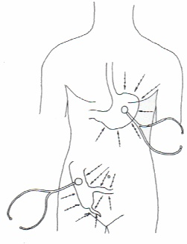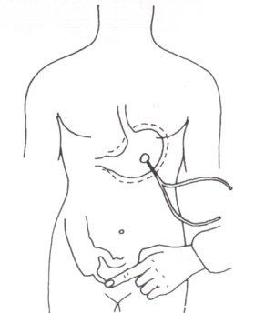
Fig. 1 Fig. 2

From the practical point of view, a short piece of gastric great curvature in its inferior segment is ascertained (Fig. 1, arrowes): patient fixes the bell-piece of sthetoscope on cutaneous abdominal wall with a finger-pulp, located correctly in the left upper quadrant of abdomen, as indicates Fig.1, and doctor performe the auscultatory percussion with middle finger, bended like a little hammer, directly and gently, on the skin, two time susequently on the same point before moving on, towards the bell-piece of sthetoscope (1 cm. away), along centripetal and radial lines.
When digital percussion beats “directly” the stomach projection (or the cutaneous projection area of whatever viscera, of course) percussory sound is perceived clearly modified, more loud, and it appears as “originating near doctor’s ears”. At this point, it is advisable to perform the auscultatory percussion for the second time, at least in initial stages, when there is no great experience, in order to avoid some mistakes, for instance, due to peristaltic wave.
Aiming to corroborate proper application of the method, doctor can use the apnea test (healthy subject does not breath) or boxer’s test (healthy individual clenches fists) or the Restano’s manoeuvre (simultaneous performance of both tests) (See: Glossary in Home-Page); these tests bring about sympathetic hypertone, that induces gastric aspecific reflex, before of “sympathetic” and than (only appearently) of “vagal” type, in any case short lasting: in later one, in the stomach, fundus and body are dilated, whereas antral-pyloric region contracts. In facts, in healthy, there is a perfect balance also in nervous system, On the contrary, during sympathetic hypertone antral-pyloric region is dilated,too.
In case of infiltrative disorder, the site involved by cancer, obviously, does not dilate, whereas all parts dilate intensively in acute diffuse gastritis, e.g., related to the seriousness of disorder.
As concerns the primary role played by auscultatory percussion in both diagnosing appendicitis and in ascertaining a lot of interesting biophysical-semeiotic syndromes, e.g. Reticulo-Endothelial Hyperfunction Syndrome (RESHS) and Antibodies Synthesis Syndrome, See: Practical Applications in Home-Page

