Technical Page N° 3

Auscultatory Percussion of the Spleen.

The knowledge of spleen auscultatory percussion (AP) allows doctor to obtain at the bed-side, easily and in a few minutes, information useful and reliable in diagnosing a large number of disorders (see later on). In an individual, psycho-physically relaxed, who lies down in supine position, placed the bell-piece of stethoscope (bps) exactly upon the cutaneous projection area of the spleen (immidiately above links costal margin along mean axillary line), the doctor applies digital percussion; it is necessary to beat the slightly bent middle finger, with “low” intensity, i.e. “delicately”, and correctly upon centripetal lines, as indicated in Fig.1, as regards the stomach. Through the bell-piece of a sthetoscope, properly placed as indicated above, in a patient lying down in supine position, it is possible to perceive the variations of the percussion sound. Clinical and experimental evidence suggests that the principles of sounds transmission in this method enable the doctor to recognize precisely spleen margins in whatever subject.
It is possible, really, to recognize with the aid of AP the cutaneos projection area of the spleen in another way, too: the subject is sitting down on the bad with dangling legs and doctor perfoms AP of spleen, as illustrated above.
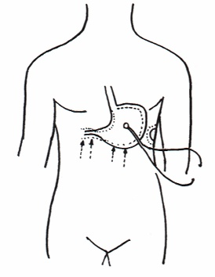
Fig.1

The percussion of the spleen must be applied upon radial lines, from the outer side towards the bps, as usually in a “delicate” and gentle manner, two times on the same point, moving than to the direction of bps, in order to perceive correctly and clearly sound waves, as earlier described in Technical page n° 1. When the percussion is performed directly upon spleen margins, sound is perceived clearly modified, hypofonetic, intense “as it originates near to the doctor ears” (See: Home-Page; Bibliography 1, 85).
In order to ascertain that spleen AP has been properly performed, the subject under examination does not breath (Apnea test) or clenches his fists (Boxer’s test) or performs simultaneously both tests (Restano’s manoeuvre) for about 10 sec., causing sympathetic hypertonus: due to spleen congestion → decongestion, skin projection area appears clearly increased for some seconds and therafter it suddenly decreases.
At this point, in healthy individual, digital pressure of “mean” intensity, applied on detected cutaneous projection area of the spleen brings about the so-called spleen-gastric aspecific reflex (Fig.1) (in the stomach, fundus and body are dilated, whereas antral-pyloric tract contracts) after a latency time (lt) of 10 sec. exactly. On the contrary, in case of infection, rheumatic diseases, tumours, lt appears clearly reduced: 6 sec. Interestingly, lt of spleen-gastric aspecific reflex is inversely related to seriousness of underlying disease, allowing doctor to monitorate objectively the course of this disorder.
Spleen-gastric aspecific reflex is a part of Reticolo Endothelial System Hyperfunction Syndrome (RESHS) (See: Appendicitis in Practical Applications... Home-Page; Glossary), which is identical as regards clinical significance, but more sensitive and specific of both BSR- blood sedimentation rate – and proteins electroforesis.
In addition, spleen-gastric aspecific reflex allows doctor to detecte and evaluate in a “quantitative” manner the so-called Antibodies Synthesis Syndrome, acute and chronic (See: Appendicitis in Practical Applicatios... in Home-Page).
I described in earlier papers, for the first time, spleen chaotic-deterministic fluctuations: physiologically 6 times/min. with a period between 9 and 12 sec. and with variable intensity from 1 to 3 (conventional measure), spleen oscillates in a deterministc chaotic manner, as all other biological systems (See: Home-Page; Presentation and Bibliography). (Fig.2)
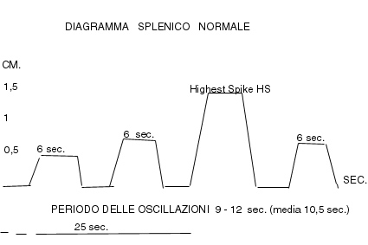
Fig. 2

In a practical manner, every 25 sec. we observe in healty subject a most intense spleen fluctuation (Highest Spikes = HS). However, in case of duodenitis and/or cholecystitis and/or cholelythiasis there is spleen arhytmic behaviour, i.e. the so-called “spleen arrythmia” (See: Bibliography in Home-Page) : it appears a second pathological rhytm, of highest intensity, every 18 sec., which lasts 8 sec., indicating the presence of above-mentioned abdominal disease(s).
Obviously, in pathological conditions all oscillations are HS, i.e. inflammation, rheumatic disorders, neoplasms, a.s.o. In case of infections, caused by Gram negative ( E.coli, H.pylory, e.g.) spleen oscillations are lower than HS. Moreover, spleen-gastric aspecific reflex appears distinctly less intens than those brought about by digital pressure upon middle line of sternum and iliac crests: RESHS “intermediate”. Finally, there is a third type, RESHS, “incomplete” indicating a flu: spleen-gastric aspecific reflex presents a lt 0f 10 sec.,i.e. physiological.
Interestingly, the pathological spleen preconditioning (the evaluation of spleen-gastric aspecific reflex for 2 – 3 times with 5 sec of interruption) does not provokes a more prolonged, greater latency time (in normal individual the lt from 10 sec. becomes 12-14 sec.) indicating the presence of lymphoid disease or at least a particularly predisposed situation, as in patients who suffered in the past beacause of lymphoma of whatever type (See: Home-Page; Bibiography).
Finally, in normal people, digital pressure of discreet intensity, applied upon liver projection area, provokes spleen enlargement, due to passive congestion, that lasts for 5 sec. On the contrary, in liver chyrrosis, since its first stage, in identical experimental condition, spleen congestion lasts more than 5 sec., in relation to the degree of hepatic disorder: Provoked Splenomegalia Signs. For further information: See Hom-Page; Bibliography.

