Technical Page 4
Auscultatory Percussion of the Pancreas.

Notoriously, the principle, wich auscultatory percussion of pancreas is based on, is the same as the common percussion: by beating with the slightly bent middle finger, directly upon the skin and “delicately”, along parallel lines from outer areas towards the bell-piece of a stethoscope, properly located, sound waves originate, wich have different pitches and resonance.
Trough the bell-piece of a stethoscope, properly placed, it is possible to perceive the variations of the percussion sound. For trained people, to perform auscultatory percussion is quite a quick practice, but obviously passion, will and study are nedeed to reach a sufficient experience.
In fact, as regards Biophysical Semeiotics, based on both auscultatory percussion and reflex-diagnostics auscultatory percussion, “there is not any regal way, at all”.

Because of the present poor physical semeiotics of pancreas, auscultatory percussion applied to this gland is of great and irreplaceable value, as a long well established experience allows me to state.
With the subject in a supine position – supine decubitus – the bell-piece of a stethoscope is placed on the left side of the first or second lumbar vertebra (posterior way). The middle finger beats along the middle clavicular line and other parallel lines, starting from the umbilical trasverse one, up to the lower pancreatic margin, which is distinguished rather clearly by a change in the percussion sound: instead of the intestinal hyperfonetic sound (deep, long, intense), we have now the hypophonetic sound of pancreatic low margin (Fig.1 and 2).
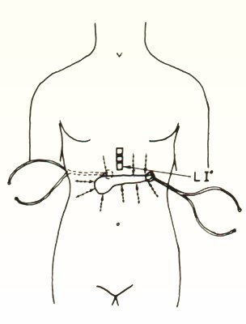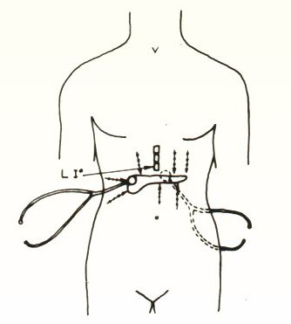
Fig.1 Fig.2

As clearly indicated in Fig.s 1 and 2, the bell-piece of stethoscope can be placed also on anterior abdominal site (anterior way), allowing doctor to carry on auscultatory percussion of pancreas in two manner, the second more practical and therefore advisable.
At this stage, the delimitation of the whole lower margin is completed on parallel and approached lines. If doctor beats radially and in a direction centripetal to the bell-piece of stethoscope, it is easy to trace the profile, which is of the utmost interest from the semeiotic point of view, of pancrea’s head and hocked process.
In order to determine the abdominal projection of the upper margin, auscultatory percussion is carried out from the upper part downward on the hemiclavear and on lines that are parallel to it.
To master this particular aspect of the method, I suggest to carry on it firstly on young and thin people, although an obese abdomen does not represent a difficult situation.
In any case, the percussion has to be delicate, i.e. no intense at all.
Interestingly, during the deep inhalation, the pancreatic tail lowers, in normal, healty individual, from 1 to 2 cm. In addition, when the pressure of the bell-piece of stethoscope increases (sympathehic reflex), pancreatic volume clearly augments.These fact confirms that the investigated organ is really the pancreas.

A 44 years-long experience permits me to state that pancreas auscultatory percussion is of basic importance for studying a gland, the semeiotics of wich is made poor and difficult, as concerns satisfactory results, by its particular anatomic position.
This difficulty is increased by an objective local symptomatology which is complicated and difficult to ascribe to, because of concomitant, reflected and/or organic, primary or secondary intervention of other organs and systems, which have close functional and anatomic connection with pancreas.

The treatises on semeiotics speak of a choledocho-pancreatic zone, of a Desjardin and Calot’s point: every physician knows that the signs are aspecific and sometimes they are not present even in some severe pancreopathies. Also the “direct palpation” suggested by Mallet-Gui has a certain value, but only for pancreatic body.
On the contrary, the enlargement of the pancreas, in case of acute or chronic pancreatitis in an acute phase, with or without gland cyst, does not slip by auscultatory percussion.
Above- mentioned considerations about the old, traditinal physical semeiotics, account for the reason that echotomography, CT, MR, selective arteriography are nowaday so largely and sometime unreasonably employed, also in “healthy” individuals.

In addition, doctor, who performs auscultatory percussion of the pancreas without stopping, i.e. continuously for at least 30 sec., observes interesting episodes of gland enlarging and subsequent decreasing. In a practical manner, doctor observes that lower pancreatic margin fluctuates 6 times per min. with variable intensity from 1 to 3 cm.(conventional measure) and a period oscillating from 9 sec. to 12 sec., mean value: 10,5 , i.e. a fractal number, according to Mandelbrot. Analogously to all other biological systems, pancreas fluctuates in a deterministic chaotic manner. At this point, one must remember the essential role played by fractal geometry in the Biophysical Semeiotic. If doctor translates the values of these dynamics, at least in his mind only, upon cartesian axes (on ordinate: intensity of lowering of pancreatic margin; on abscissa: time in sec.), results an interesting “diagram of pancreas” or “pancreogram”, which provides a large number of information (Fig.3)
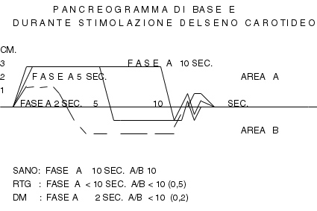

Fig.3

A unique oscillation of the pancreas ( i.e.the loowering of inferior pancreatic margin and its return to basal value) in three different situation is indicated: in healthy, in IGT and DM .

In addition, pancreogram gives useful information about the insulin secretion in a precise state: absorptive- as well as post-absortive-state, pointing out possible insulin-resistence and hyperinsulinemia, in essential way. As illustrated in Practical Application (see: Home-Page), auscultatory percussion of the pancreas and pacreogram play a primary role in biophysical semeiotic diagnose of DM, since its early stage. Furthermore, these parameters, besides many other signs, allow doctor to recognize clinically the so-called Oncological Terraine (See: Home Page).

