Technical Page n° 5
Auscultatory Percussion of the Kidney and Ureter.
As far as kidney’s and ureter’s auscultatory percussion is concerned, a simple method, useful in bed-side detecting cutaneous projection are of both kidney and ureter, is the following: in a subject, psycho-physically relaxed and in supine position, applied the bell-piece of a stethoscope on abdomen lateral anterior region, right and than left, doctor performs digital percussion of slight intensity directly upon centripetal lines, starting from the external area towards the bell-piece of stethoscope (Fig. 1).
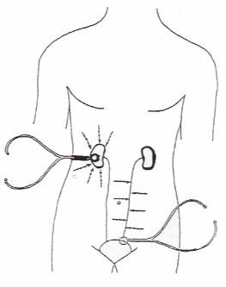
Fig. 1
Figure shows the correct position of bel-piece of sthetoscope in order to perform auscultatory percussion of both kidney and ureter.
When the percussion is applied “directly” on the precise cutaneous projection area of the kidneys, doctor perceives the percussion sound more clear, hypophonetic, and intense, “as originating near to doctor’s ears”.
Really, there are two ways of applying auscultatory percussion (A.P.) of the urinary tract: anterior and posterior, in relation to the location of the bel-piece of stethoscope.
In addition, as regards the posterior way, there is an interesting “variant” form: patient is sitting on visiting-bed with the legs down and doctor performs AP of the kidney, beside that of lung and spleen. In my opinion the useful AP of kidney must be a necessary component of the common physical examination.
The anterior way of kidney AP allows doctor to perform also AP of ureters, which permits to draw cutaneous projection area of the urinary tract, even only in mind.
Thus it is easy to recognize three interesting ureteral reflexes, i.e. upper, middle, and lower ureteral reflex, fundamental on Clinical Microangiology, since their accurate assessement, over the two last decades, have allowed me to found this new branch of Medicine, i.e. bed-side study of the microcirculation in all biological systems with the aid of Biophysical Semeiotics (Fig. 2).

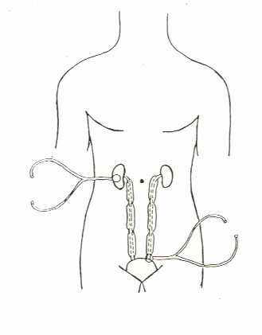

Fig. 2

Figure indicates clearly upper, middle, and lower ureteral reflexes, cause by”light” stimulation of the trigger-points of whatever biological system.

Moreover, kidney’s and ureter’s AP evaluation allows to perform an original bed-side assessment of renal function, related in a satisfactory way to RPF and GFR, i.e. bed-side renal functionality test by water load (See also Medscape: Internal Discussion).
At first, in a indivual in supine position and psycho-physically relaxed, doctor assesses renal diameters, evaluated as minimal degree of renogram, i.e the chaotic-deterministic fluctuations of kidney besides period, duration and intensity of ureteral peristaltic wave.
In healthy, data are observed as follows: 6 cm. x 12 cm., Phase C (kidney congestion) duration 6 sec., oscillation intensity varying between 0,5 cm. and 1,5 cm. in a chaotic-deterministic manner, period fluctuating between 9 sec. and 12 sec.
In addition, the ureteral peristaltic wave period at base-line is 18 sec., intensity < 1 cm. and, finally, duration of ureter dilation is 3 sec. exactly. Soon thereafter, subject is administered 250 cc. water and then, after a latency time of 3 minute, the degree of above- mentioned parameters, are evaluated for a second time. “Minimal” kidney diameters increases (> 6 cm. and respectively > 12 cm.), renogram appears to be of “vagal” type, i.e. Phase C is clearly augmented with 7-8 sec. duration and all fluctuations are identical, as far as intensity and period are concerned.
In addition, ureteral peristaltic wave shows an increased intensity (more than 1 cm.) lasting for 6 sec. (doubled than that at base-line) and a period decreased to 12 sec. exactly. Actually, the degree of the numerous renal parameters are related in a satisfactory manner to RPF, while ureteral parameters are correlated with GFR.

